
RR

Traffic Engineering Accident Analysis System
Release 12.2.0 Public Query User Manual
For
The State of North Carolina
Department of Transportation
Information Systems Technology
September 20, 2023
Version 10.00

Presented by:

Traffic Records Systems AM Team
Raney Building, 104 Fayetteville Street
Raleigh, NC 27601

Table of Contents
1 Revision History 1
2 overview 2
3 getting started 3
3.1 The Toolbar 3
3.2 The Audit Bar 4
3.3 The Navigation Bar 4
4 logon 5
4.1 Launching the Application 5
4.2 Logging On 5
4.3 Changing a Password 6
4.4 About TEAAS dialog box 7
5 Application BROWSER 8
5.1 Application Browser Overview 8
6 Users 11
6.1 Send Alert Message 11
6.2 Users Screen Overview 12
6.3 Searching for a User 14
6.4 Modifying Your Existing User Record 15
6.5 Canceling a User’s Screen Operation 15
6.6 Closing the Users Screen 15
7 street and Feature names 16
7.1 Street and Feature Names Screen Overview 16
7.2 Searching for a Street and Feature Name Record 18
7.3 Canceling a Street and Feature Names Screen Operation 19
7.4 Closing the Street and Feature Names Screen 19
8 inventoried Routes 20
8.1 Inventoried Routes Screen Overview 20
8.2 Searching for an Inventoried Route Record 22
8.3 Canceling an Inventoried Routes Screen Operation 22
8.4 Launching the Features Report 22
8.5 Launching the Highest Order Segments Report 23
8.6 Viewing Boundary Records 23
8.7 Viewing Highest Order Segment Records 23
8.8 Viewing Intersection Records 23
8.9 Viewing Mile Marker Records 23
8.10 Viewing Railroad Crossing Records 24
8.11 Viewing Structure Records 24
8.12 Closing the Inventoried Routes Screen 24
9 Highest order segments 25
9.1 Highest Order Segments Screen Overview 25
9.2 Searching for a Highest Order Segment Record 26
9.3 Canceling a Highest Order Segments Screen Operation 28
9.4 Launching the Highest Order Segments Report 28
9.5 Closing the Highest Order Segments Screens 28
10 Intersections 29
10.1 Intersections Screen Overview 29
10.2 Searching for an Intersection Record 31
10.3 Canceling an Intersections Screen Operation 32
10.4 Launching the Features Report 32
10.5 Closing the Intersections Screen 32
11 Boundaries 33
11.1 Boundaries Screen Overview 33
11.2 Searching for a Boundary Record 35
11.3 Canceling a Boundaries Screen Operation 36
11.4 Launching the Features Report 36
11.5 Closing the Boundaries Screen 36
12 Structures 37
12.1 Structures Screen Overview 37
12.2 Searching for a Structure Record 39
12.3 Canceling a Structures Screen Operation 40
12.4 Launching the Features Report 40
12.5 Closing the Structures Screen 40
13 Mile markers 41
13.1 Mile Markers Screen Overview 41
13.2 Searching for a Mile Marker Record 43
13.3 Canceling a Mile Markers Screen Operation 44
13.4 Launching the Features Report 44
13.5 Closing the Mile Markers Screen 44
14 Railroad crossings 45
14.1 Railroad Crossings Screen Overview 45
14.2 Searching for a Railroad Crossing Record 47
14.3 Canceling a Railroad Crossings Screen Operation 49
14.4 Launching the Features Report 49
14.5 Launching the County Report 49
14.6 Launching the Strip Report 49
14.7 Closing the Railroad Crossings Screen 49
15 Secondary routes 50
15.1 Secondary Routes Screen Overview 50
15.2 Searching for a Secondary Route Record 51
15.3 Canceling a Secondary Routes Screen Operation 51
15.4 Closing the Secondary Routes Screen 51
16 Fiche report 53
16.1 Fiche Report Overview 53
16.2 Beginning a Fiche Report 55
16.3 Road Identification Process 56
16.4 Generating the Fiche Report 56
16.5 Generating the Detailed Fiche CSV 56
16.6 Closing the Fiche Report Screen 57
17 Intersection ANALYSIS report 58
17.1 Intersection Analysis Report Overview 58
17.2 Study Information Tab 59
17.3 Road Identification Tab 62
17.4 Accident Adjustments Tab 69
17.5 Creating a New Intersection Analysis Study 71
17.6 Saving a New Intersection Analysis Study 71
17.7 Searching for an Intersection Analysis Study 72
17.8 Modifying an Intersection Analysis Study 72
17.9 Deleting an Intersection Analysis Study 72
17.10 Canceling an Intersection Analysis Study Operation 72
17.11 Closing the Intersection Analysis Report Screen 73
18 Strip ANALYSIS report 74
18.1 Strip Analysis Report Overview 74
18.2 Study Information Tab 75
18.3 Road Identification Tab 78
18.4 Accident Adjustments Tab 84
18.5 Feature Inclusions Tab 87
18.6 Creating a New Strip Analysis Study 88
18.7 Saving a New Strip Analysis Study 88
18.8 Searching for a Strip Analysis Study 88
18.9 Modifying a Strip Analysis Study 89
18.10 Deleting a Strip Analysis Study 89
18.11 Canceling a Strip Analysis Study Operation 89
18.12 Closing the Strip Analysis Report Screen 89
19 Generate Collision Diagram File 90
19.1 Generate Collision Diagram File Overview 90
19.2 Generating a Collision Diagram Data File 92
20 Fiche, intersection, and strip reports code index 95
20.1 Fiche, Intersection, and Strip Reports Code Index Overview 95
21 Features report 96
21.1 Features Report Overview 96
22 Highest order segments report 97
22.1 Highest Order Segments Report Overview 97
23 Incorporated municipalities report 98
APPENDIX A : System Contact Information 99
APPENDIX B : Alternate System Controls 100
APPENDIX C : Wildcard Searching 101
APPENDIX D : Operating Actuate Formula One E.Report Designer 102

Revision History
Document Version | Description of Change
3.0 | Initial Creation.
4.0 | Updated document to accompany all changes associated with Release 3.1.
4.0 | Changed all dates and Release numbers accordingly throughout document.
4.0 | Updated all screen prints.
4.0 | Modified text as appropriate to accommodate new screen appearances; applicable to Boundary (new field for Boundary Name), Intersection (new field for Intersecting Route Name), Intersection Analysis Report (Sort button for Included Accidents; able to search on UserID field), Strip Analysis Report (Sort button for Included Accidents; Max length of Feature Inclusion text increased from 20 to 35; able to search on UserID field).
6.2 | Updated the Manual to reflect the changes due to 4.1 release.
6.3 | Updated the Manual to reflect the changes due to 4.2 release.
6.4 | Updated the Manual to reflect User Information changes due to 4.3 release.
6.5 | Made changes as needed by the TEAAS release 4.3. Added additional information for Generate Study in Intersection and Strip Analysis reports.
6.6 | Updated the manual to reflect changes due to 5.0 release.
6.7 | Updated the manual to reflect changes due to 5.1 release.
6.8 | Updated the manual to reflect changes due to 5.2 release.
6.9 | Updated the manual to reflect changes due to 5.3 release.
6.10 | Updated the manual to reflect changes due to 5.5 release.
6.11 | Updated the manual to reflect changes due to 6.0.0 release
6.12 | Updated the manual to reflect changes due to 7.0.0 release
6.13 | Updated the manual to reflect changes due to 9.0.0 release
6.14 | Updated the manual to reflect changes due to 9.1.0 release
6.15 | Incorporated 10.2.0 release changes
6.16 | Incorporated 10.3.0 release changes
6.17 | Incorporated 10.6.0 release changes
7.00 | Incorporated 10.8.0 release changes
8.00 | Incorporated 11.0.0 release changes
9.00 | Incorporated 11.5.0 release changes
10.00 | Incorporated TEAAS T12.2.0 Detailed Fiche Parameters changes

overview
The Traffic Engineering Accident Analysis System (TEAAS) provides the North Carolina Department of Transportation (NCDOT) Traffic Safety Systems Management Unit (TSSMU) with an automated system to analyze and produce information on accidents occurring throughout the state of North Carolina.
This document provides the reader with an overview of TEAAS Release 11.0 and instructions regarding its use.
Before continuing with this manual, it is recommended that the reader have the following information available:
- TEAAS User ID
- TEAAS Password.

getting started
User administration and application access is controlled by the TEAAS System Administrator(s). The System Administrator is responsible for creating and maintaining User IDs, Passwords, and Roles. Contact the DOT Help Desk for any issues regarding access to the application. Appendix A contains a listing of system contact information.

The Toolbar
Toolbar icons are used for illustrative purposes throughout this document. The table below describes the toolbar icons.
Toolbar Icon | Function | Description
 | New | Presents a blank form for data entry of a new record.
 | Modify | Permits modification of the current record.
 | Delete | Permits deletion of the current record.
 | Save | Either saves changes to the record being modified, or saves the newly created record.
 | Cancel | Cancels a New, Modify, or Search operation.
 | Search | Allows the User to specify the desired search criteria.
 | Go | Initiates a search based on the User-specified criteria.
 | Close | Closes the screen.

Appendix B describes alternate methods of enacting toolbar commands, including menu options, Alt commands, and Ctrl commands.

The Audit Bar
The audit bar appears at the bottom of the TEAAS screens that permit data entry. It identifies the User who last updated the current record, as well as the date and time of update.
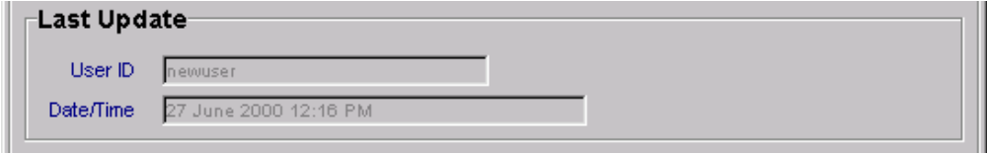
The Audit Bar

The Navigation Bar
When the User executes a search, the results are returned and displayed one record at a time. The navigation bar at the bottom of the screen identifies the total number of records returned and the User’s current position within that set. In the example below, the User is viewing the 18th record in a set of 500. The arrow buttons permit the User to navigate through the records. The keyboard letters H (first record), J (previous record), K (next record), and L (last record) permit keyboard navigation through the records.
Navigation Buttons

logon

Launching the Application
The TEAAS application may be launched from the Desktop Icon or the Start, All Programs, NCDOT menu Icon. After TEAAS has been installed on the workstation, a shortcut icon should be present on the desktop or the All Programs NCDOT menu. Double click the TEAAS icon  to launch the application. When TEAAS is launched, a Welcome screen will appear.
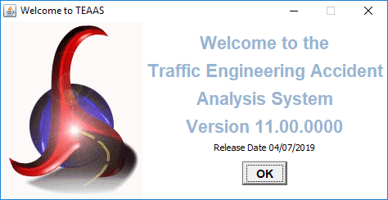
Welcome Screen
Click the OK button to close the Welcome screen. The Welcome screen will close automatically after approximately 10 seconds if OK is not clicked. After the Welcome screen closes, the Logon screen appears.
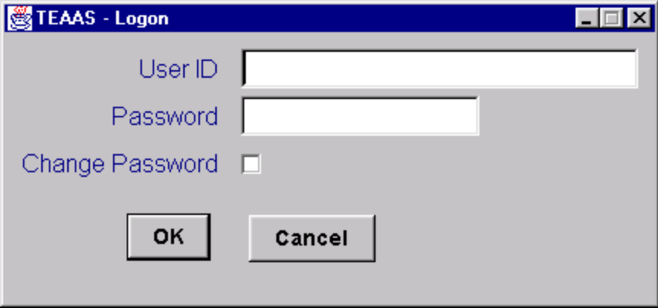
Logon Screen

Logging On
The Logon screen controls access to the application by requiring a User ID and Password. The following table describes the requirements for each field.
Field | Field Requirements
User ID | Must be a valid User ID between 4 and 20 alphanumeric characters. User ID is case sensitive.
Password | Must be a valid Password between 4 and 12 alphanumeric characters. Password is case sensitive.

Contact the DOT Help Desk if the User ID or Password is not known.
Because the User ID and Password are case sensitive, use caution to ensure they are entered exactly as assigned, and then click the OK button. If the User ID and Password combination is incorrect, an error message will be displayed. A maximum of three logon attempts is allowed for any given TEAAS session. If the maximum number of attempts is exceeded, the User will be exited from TEAAS automatically.
To exit without logging on, click the Cancel button.
After logging on successfully, the Application Browser screen will appear. The Application Browser is discussed in more detail in the Application Browser section.

Changing a Password
To change the Password at logon, enter User ID and Password, click the Change Password check box, then click the OK button. The following Password Change screen will appear.
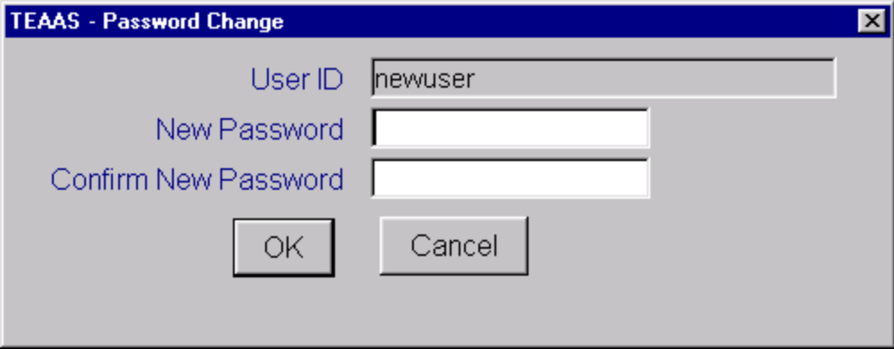
Password Change Screen

Two fields on the Password Change screen must be completed to change the Password. The following table describes the requirements for each field.
Field | Field Requirements
New Password | Must be between 4 and 12 alphanumeric characters and cannot be the same as the existing Password.
Confirm New Password | Must be identical to the New Password entry.

Make note of upper/lower case characters since Password fields are case sensitive.
After the Password fields have been entered, click the OK button. A message will confirm that the Password has been changed. If the New Password conflicts with the above business rules, an error message will appear.
To close the Password Change screen without changing the Password, click the Cancel button.
The Application Browser screen will appear after the Password Change screen is closed. The Application Browser is discussed in more detail in the Application Browser section.

About TEAAS dialog box
From any of the User Interfaces, clicking on menu Help + About shows the following dialog box:
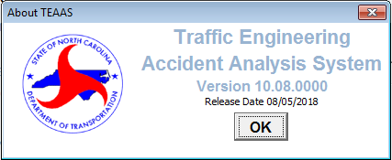
About TEAAS Screen

Application BROWSER

Application Browser Overview
The Application Browser is the control center for TEAAS. Major functions are displayed vertically on the left side of the screen as graphical buttons. When a button is selected, a text description of the function is displayed just below the Open and Exit buttons. At the same time, the list box on the right displays the sub-functions available to the User. When an item is selected from this list box, a description of the User’s privileges to that sub-function is displayed at the bottom of the screen.
The Application Browser screen that appears after logon is displayed:
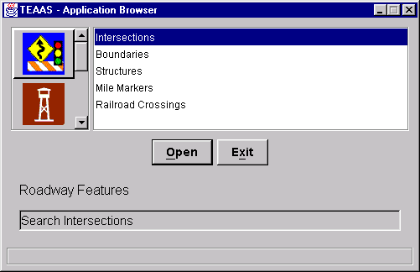
Application Browser Screen

The following table describes each function and associated sub-function(s).
Function Button | Function Name | Sub-Functions
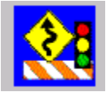 | Roadway Features | Intersections  Boundaries  Structures  Mile Markers  Railroad Crossings
 | Feature Names, Secondary Routes and Exceptions | Street and Feature Names  Secondary Routes  Street Name Exceptions  Municipality Name Exceptions  Municipality Names
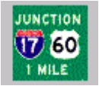 | Inventoried Routes and Highest Order Segments | Highest Order Segments  Inventoried Routes
 | Generate Public Reports | City-Wide Accident Reports  County-Wide Accident Reports
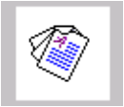 | Generate Reports | Fiche Report  Intersection Analysis Report  Strip Analysis Report  Generate Collision Diagram File  Fiche, Intersection, and Strip Reports Code Index  Features Report  Highest Order Segments Report  Ordinance Exception Report: On Road/HO Route  Ordinance Exception Report: Overlap  Ordinance Exception Report: No Milepost  Highest Order Segment Gap Report  Sliding Scale Report
 | Ordinances | Ordinances  Milepost Ordinances  Ordinance Type Maintenance
 | User Information | Users  Send An Alert Message
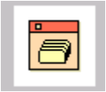 | System Administration | Error Log Report  Milepost Items
Application Browser Functions/Sub-Functions

To navigate to a particular sub-function, select that item from the list box and click the Open button. The appropriate screen or report will be displayed.
To exit the application from the Application Browser, ensure all other TEAAS screens have been closed, and then click the Exit button.

Users

Send Alert Message
Users with an Administrator role will be able to see the “Send An Alert Message” subfunction.
To access the Send An Alert Message screen, select the User Information button on the Application Browser, select Send An Alert Message from the list box, and click the Open button.
Function Button | Function Name | Sub-Function
 | User Information | Send An Alert Message

When the user logs on a popup dialog will display an alert message from a TEAAS System Administrator to all users if there is a message waiting. Administrators can send an alert message by selecting the “Send An Alert Message” entry and then clicking on the Open button.
The screen that follows is displayed, though its appearance may differ slightly from the figure below.
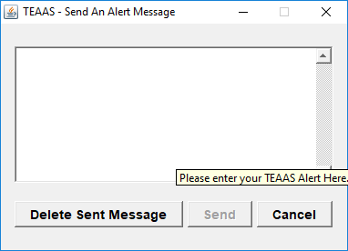

The alert message user interface consists of a multi-line text editor field where Administrators can type in the message and a Send button and a Cancel button beneath the message text field. Administrators cannot recall previously sent messages. By default, a message expires when another replaces. In the absence of a new message, the existing message will expire in 72 hours. Alternatively, administrators can delete a previously sent message by clicking on the Delete Sent Message button.

Users receive the alert message by way of a modal dialog that pops up. A new message can pop up as often as every 5 minutes and it always replaces a previous one.

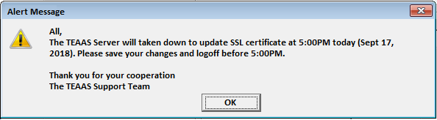

Users Screen Overview
The Users screen is used to search for and view User information.
To access the Users screen, select the User Information button on the Application Browser, select Users from the list box, and click the Open button.
Function Button | Function Name | Sub-Function
 | User Information | Users

The screen that follows is displayed:
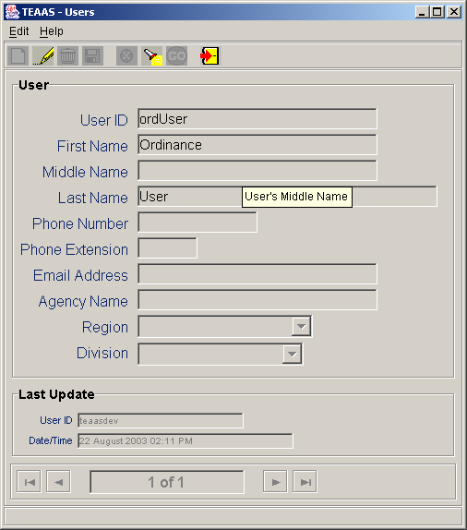
Users Screen

Searching for a User
To search for Users, click the Search icon on the toolbar. A blank screen will be presented for entering search criteria. The following table describes the search criteria allowed.
Field | Search Criteria
User ID | Enter a specific User ID or use wildcard characters to search for one or more User ID. Refer to Appendix C for a description on the use of wildcard characters. Leave User ID empty if this field is not part of the search criteria. Search is non case sensitive.
First Name | Enter a specific First Name or use wildcard characters to search for one or more First Name. Leave First Name empty if this field is not part of the search criteria. Search is non case sensitive.
Middle Name | Enter a specific Middle Name or use wildcard characters to search for one or more Middle Name. Leave Middle Name empty if this field is not part of the search criteria. Search is non case sensitive.
Last Name | Enter a specific Last Name or use wildcard characters to search for one or more Last Name. Leave Last Name empty if this field is not part of the search criteria. Search is non case sensitive.
Phone Number | Enter a specific Phone Number or use wildcard characters to search for one or more Phone Number. Leave Phone Number empty if this field is not part of the search criteria.
Phone Extension | Enter a specific Phone Extension or use wildcard characters to search for one or more Phone Extension. Leave Phone Extension empty if this field is not part of the search criteria.
Email Address | Enter a specific Email Address or use wildcard characters to search for one or more Email Address. Leave Email Address empty if this field is not part of the search criteria. Search is non case sensitive.
Agency Name | Enter a specific Agency Name or use wildcard characters to search for one or more Agency Name. Leave Agency Name empty if this field is not part of the search criteria. Search is non case sensitive.
Division | Select a specific Highway Division for a Division Ordinance User. This field can be selected only for users having a Division User role; for all other users it will be empty. Leave Division empty if this field is not part of the search criteria.
Region | Select a specific Region for a Region Ordinance User. This field can be selected only for users having a Region Ordinance User role; for all other users it will be empty. Leave Region empty if this field is not part of the search criteria.

After all desired search criteria have been entered, click the Go icon on the toolbar. A dialog box will appear indicating the number of records returned. Click the OK button on the dialog box to view the records retrieved. Returned records are displayed in view mode.
If no records are returned, a dialog box will appear indicating such. If records were expected to be retrieved, verify that the search criteria are correct. A new search may be executed by adjusting the search criteria and clicking the Go icon.
It is recommended that the search criteria be as specific as possible to prevent the retrieval of too many records, which could contribute to local memory concerns and slower system performance. Currently, TEAAS will display a maximum of 500 records for any given search, although more than 500 records may actually meet the search criteria.

Modifying Your Existing User Record
A user can modify their existing User record when the record is displayed on the screen. To modify your User record, search for your record (see Searching for a User), click the Modify icon on the toolbar. The Phone Number, Phone Extension, Email Address, and Agency Name fields are enabled for modification.
After changes are made to the record, click the Save icon on the toolbar. All business rule conditions are verified before the modified record is saved. If all conditions are satisfied, the modified User record is saved and displayed on the screen in view mode.

Canceling a User’s Screen Operation
A Search operation may be canceled before a Go action is invoked by clicking the Cancel icon on the toolbar. A Modify operation may be canceled before a Save action is invoked by clicking the Cancel icon on the toolbar. Cancel will return the Users screen to its previous state.

Closing the Users Screen
To close the Users screen, click the Close icon on the toolbar.

street and Feature names

Street and Feature Names Screen Overview
The Street and Feature Names screen is used to search for and view 8-digit codes and associated text for primary and secondary routes, local city streets, and political boundaries.
To access the Street and Feature Names screen, select the Feature Names and Secondary Routes button on the Application Browser, select Street and Feature Names from the list box, and click the Open button.
Function Button | Function Name | Sub-Function
 | Feature Names and Secondary Routes | Street and Feature Names

The screen that follows is displayed:
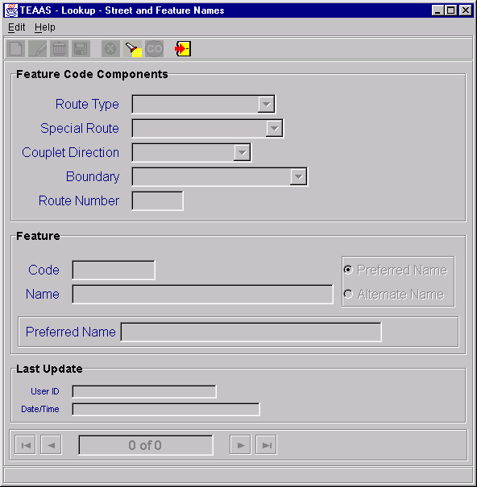
Street and Feature Names Screen

Searching for a Street and Feature Name Record
To search, click the Search icon on the toolbar. A blank screen will be presented for entering search criteria. The following table describes the search criteria allowed.
Field | Search Criteria
Route Type | Select a specific Route Type from the Route Type combo box or leave empty if this field is not part of the search criteria.
Special Route | Select a specific Special Route from the Special Route combo box or leave empty if this field is not part of the search criteria.
Couplet Direction | Select a specific Couplet Direction from the Couplet Direction combo box or leave empty if this field is not part of the search criteria.
Boundary | Select a specific Boundary from the Boundary combo box or leave empty if this field is not part of the search criteria.
Route Number | Enter a specific Route Number by entering the appropriate road code (length depends on the Route Type selected). Wildcard characters may be used to search for one or more routes. Refer to Appendix C for a description on the use of wildcard characters. Leave Route Number empty if this field is not part of the search criteria.
Name | Enter a specific Name or use wildcard characters to search for one or more Name. Leave Name empty if this field is not part of the search criteria. Search is non case sensitive.
Code | Enter a specific Code by entering the 8-digit Code. For boundary features, the code will be an 8-character alphanumeric value with one of the prefixes BS (state boundary), BC (county boundary), or BM (municipality boundary) followed by a 6-digit number. For example, the code for the state of Georgia will be BS000901 and the code for Wake County is BC000092. Wildcard characters may be used to search for one or more Code. Leave Code empty if this field is not part of the search criteria. Search is non case sensitive.
Preferred/Alternate Name | Enable Preferred Name or Alternate Name radio button. Leave disabled to retrieve both Preferred and Alternate spellings.

After all desired search criteria have been entered, click the Go icon on the toolbar. A dialog box will appear indicating the number of records returned. Click the OK button on the dialog box to view the records retrieved. Returned records are displayed in view mode.
If no records are returned, a dialog box will appear indicating such. If records were expected to be retrieved, verify that the search criteria are correct. A new search may be executed by adjusting the search criteria and clicking the Go icon.
It is recommended that the search criteria be as specific as possible to prevent the retrieval of too many records, which could contribute to local memory concerns and slower system performance. Currently, TEAAS will display a maximum of 500 records for any given search, although more than 500 records may actually meet the search criteria.

Canceling a Street and Feature Names Screen Operation
A Search operation may be canceled before a Go action is invoked by clicking the Cancel icon on the toolbar. Cancel will return the Street and Feature Names screen to its previous state.

Closing the Street and Feature Names Screen
To close the Street and Feature Names screen, click the Close icon on the toolbar.

inventoried Routes

Inventoried Routes Screen Overview
The Inventoried Routes screen is used to search for and view information on county routes and local streets that have been inventoried either for features or roadway characteristics.
To access the Inventoried Routes screen, select the Inventoried Routes and Highest Order Segments button on the Application Browser, select Inventoried Routes from the list box, and click the Open button.
Function Button | Function Name | Sub-Function
 | Inventoried Routes and Highest Order Segments | Inventoried Routes

The screen that follows is displayed:
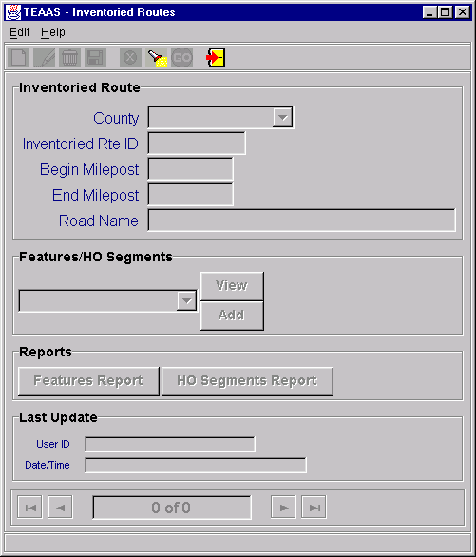
Inventoried Routes Screen

Searching for an Inventoried Route Record
To search for Inventoried Route records, click the Search icon on the toolbar. A blank screen will be presented for entering search criteria. The following table describes the search criteria allowed.
Field | Search Criteria
County | Select a specific County from the County combo box or leave empty if this field is not part of the search criteria.
Inventoried Rte ID | Enter a specific Inventoried Rte ID by entering the 8-digit road code. Wildcard characters may be used to search for one or more Inventoried Rte ID. Refer to Appendix C for a description on the use of wildcard characters. Leave Inventoried Rte ID empty if this field is not part of the search criteria.
Begin Milepost | Enter a specific Begin Milepost value or leave empty if this field is not part of the search criteria.
End Milepost | Enter a specific End Milepost value or leave empty if this field is not part of the search criteria.
Road Name | Road Name is not allowed as a search parameter.

After all desired search criteria have been entered, click the Go icon on the toolbar. A dialog box will appear indicating the number of records returned. Click the OK button on the dialog box to view the records retrieved. Returned records are displayed in view mode.
If no records are returned, a dialog box will appear indicating such. If records were expected to be retrieved, verify that the search criteria are correct. A new search may be executed by adjusting the search criteria and clicking the Go icon.
It is recommended that the search criteria be as specific as possible to prevent the retrieval of too many records, which could contribute to local memory concerns and slower system performance. Currently, TEAAS will display a maximum of 500 records for any given search, although more than 500 records may actually meet the search criteria.

Canceling an Inventoried Routes Screen Operation
The Search operation may be canceled before a Go action is invoked by clicking the Cancel icon on the toolbar. Cancel will return the Inventoried Routes screen to its previous state. For example, if some values have been entered after clicking the Search icon on the toolbar, clicking the Cancel icon will revert the record to its previous values, displaying it in view mode.

Launching the Features Report
The Features report may be launched from the Inventoried Routes screen by clicking the Features Report button after an existing Inventoried Route record appears in view mode. The report will take the displayed County, Inventoried Route, and Begin Milepost as its selection criteria. Refer to the Features Report section for more information regarding this report.

Launching the Highest Order Segments Report
The Highest Order Segments report may be launched from the Inventoried Routes screen by clicking the HO Segments Report button after an existing Inventoried Route record appears in view mode. The report will take the displayed County, Inventoried Route, and Begin Milepost as its selection criteria. Refer to the Highest Order Segments Report section for more information regarding this report.

Viewing Boundary Records
The Boundaries screen may be launched from the Inventoried Routes screen when an existing Inventoried Route record appears in view mode. Select Boundaries from the Features/HO Segments combo box and click the View button. The Boundaries screen is launched and a search is automatically performed to retrieve all Boundary records for the specified County, Inventoried Route, and Begin Milepost combination. Refer to the Boundaries section for more information regarding the Boundaries screen.

Viewing Highest Order Segment Records
The Highest Order Segments screen may be launched from the Inventoried Routes screen when an existing Inventoried Route record appears in view mode. Select Highest Order Segments from the Features/HO Segments combo box and click the View button. The Highest Order Segments screen is launched and a search is automatically performed to retrieve all Highest Order Segment records for the specified County, Inventoried Route, and Begin Milepost combination. Refer to the Highest Order Segments section for more information regarding the Highest Order Segments screen.

Viewing Intersection Records
The Intersections screen may be launched from the Inventoried Routes screen when an existing Inventoried Route record appears in view mode. Select Intersections from the Features/HO Segments combo box and click the View button. The Intersections screen is launched and a search is automatically performed to retrieve all Intersection records for the specified County, Inventoried Route, and Begin Milepost combination. Refer to the Intersections section for more information regarding the Intersections screen.

Viewing Mile Marker Records
The Mile Markers screen may be launched from the Inventoried Routes screen when an existing Inventoried Route record appears in view mode. Select Mile Markers from the Features/HO Segments combo box and click the View button. The Mile Markers screen is launched and a search is automatically performed to retrieve all Mile Marker records for the specified County, Inventoried Route, and Begin Milepost combination. Refer to the Mile Markers section for more information regarding the Mile Markers screen.

Viewing Railroad Crossing Records
The Railroad Crossings screen may be launched from the Inventoried Routes screen when an existing Inventoried Route record appears in view mode. Select Railroad Crossings from the Features/HO Segments combo box and click the View button. The Railroad Crossings screen is launched and a search is automatically performed to retrieve all Railroad Crossing records for the specified County, Inventoried Route, and Begin Milepost combination. Refer to the Railroad Crossings section for more information regarding the Railroad Crossings screen.

Viewing Structure Records
The Structures screen may be launched from the Inventoried Routes screen when an existing Inventoried Route record appears in view mode. Select Structures from the Features/HO Segments combo box and click the View button. The Structures screen is launched and a search is automatically performed to retrieve all Structure records for the specified County, Inventoried Route, and Begin Milepost combination. Refer to the Structures section for more information regarding the Structures screen.

Closing the Inventoried Routes Screen
To close the Inventoried Routes screen, click the Close icon on the toolbar.

Highest order segments

Highest Order Segments Screen Overview
The Highest Order Segments screen is used to search for and view the Highest Order Route coinciding with the Inventoried Route for any given segment of the roadway.
To access the Highest Order Segments screen, select the Inventoried Routes and Highest Order Segments button on the Application Browser, select Highest Order Segments from the list box, and click the Open button.
Function Button | Function Name | Sub-Function
 | Inventoried Routes and Highest Order Segments | Highest Order Segments

Highest Order Segments can also be accessed from the Inventoried Routes screen. Refer to the Inventoried Routes section for a description on accessing the Highest Order Segments screen in that manner.
The screen that follows is displayed:
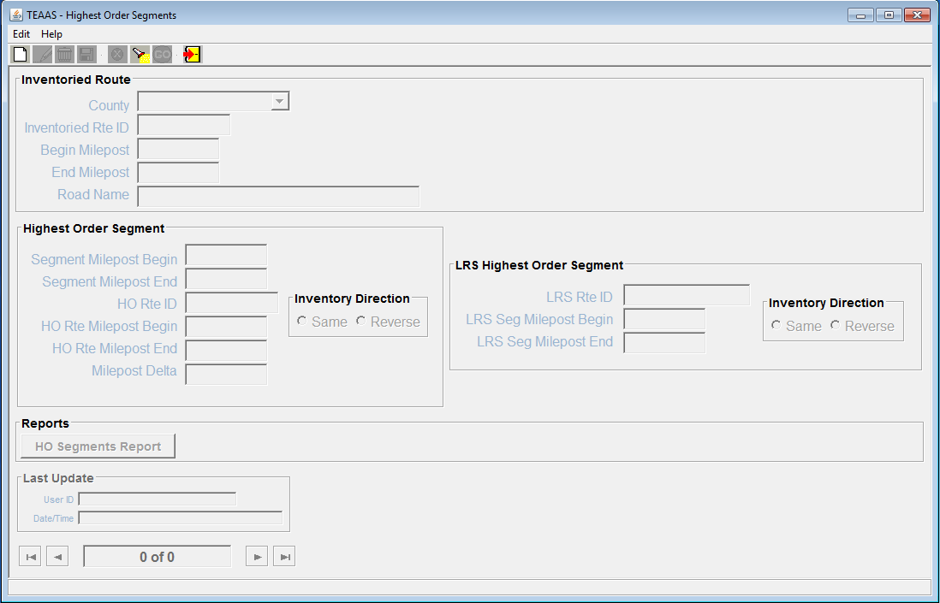
Highest Order Segments Screen

Searching for a Highest Order Segment Record
To search for Highest Order Segment records, click the Search icon on the toolbar. A blank screen will be presented for entering search criteria. The following table describes the search criteria allowed.
Field | Search Criteria
County | Select a specific County from the County combo box or leave empty if this field is not part of the search criteria.
Inventoried Rte ID | Enter a specific Inventoried Rte ID by entering the 8-digit road code. Wildcard characters may be used to search for one or more Inventoried Rte ID. Refer to Appendix C for a description on the use of wildcard characters. Leave Inventoried Rte ID empty if this field is not part of the search criteria.
Begin Milepost | Enter a specific Begin Milepost value or leave empty if this field is not part of the search criteria.
End Milepost | End Milepost is not allowed as a search parameter.
Road Name | Road Name is not allowed as a search parameter.
Segment Milepost Begin | Enter a specific Segment Milepost Begin value or leave empty if this field is not part of the search criteria.
Segment Milepost End | Enter a specific Segment Milepost End value or leave empty if this field is not part of the search criteria.
HO Rte ID | Enter a specific HO Rte ID by entering an 8-digit road code. Wildcard characters may be used to search for one or more HO Rte ID. Leave HO Rte ID empty if this field is not part of the search criteria.
HO Rte Milepost Begin | Enter a specific HO Rte Milepost Begin value or leave empty if this field is not part of the search criteria.
HO Rte Milepost End | HO Rte Milepost End is not allowed as a search parameter.
Milepost Delta | Milepost Delta is not allowed as a search parameter.
Inventoried Direction | Inventoried Direction is not allowed as a search parameter.
LRS Rte ID | Enter a specific LRS Rte ID linked to the HO Segment
LRS Seg Milepost Begin | Enter a specific LRS Segment begin milepost number
LRS Seg Milepost End | Enter a specific LRS Segment end milepost number
LRS Inventory Direction | LRS Inventory Direction is not allowed as a search parameter.

After all desired search criteria have been entered, click the Go icon on the toolbar. A dialog box will appear indicating the number of records returned. Click the OK button on the dialog box to view the records retrieved. Returned records are displayed in view mode.
If no records are returned, a dialog box will appear indicating such. If records were expected to be retrieved, verify that the search criteria are correct. A new search may be executed by adjusting the search criteria and clicking the Go icon.
It is recommended that the search criteria be as specific as possible to prevent the retrieval of too many records, which could contribute to local memory concerns and slower system performance. Currently, TEAAS will display a maximum of 500 records for any given search, although more than 500 records may actually meet the search criteria.

Canceling a Highest Order Segments Screen Operation
A Search operation may be canceled before a Go action is invoked by clicking the Cancel icon on the toolbar. Cancel will return the Highest Order Segments screen to its previous state.

Launching the Highest Order Segments Report
The Highest Order Segments report may be launched from the Highest Order Segments screen by clicking the HO Segments Report button after an existing Highest Order Route record appears in view mode. The report will take the displayed County, Inventoried Route, and Begin Milepost as its selection criteria. Refer to the Highest Order Segments Report section for more information regarding this report.

Closing the Highest Order Segments Screens
To close the Highest Order Segments screen, click the Close icon on the toolbar.

Intersections

Intersections Screen Overview
The Intersections screen is used to search for and view location information for Intersections on the Inventoried Route.
To access the Intersections screen, select the Roadway Features button on the Application Browser, select Intersections from the list box, and click the Open button.
Function Button | Function Name | Sub-Function
 | Roadway Features | Intersections

Intersections can also be accessed from the Inventoried Routes screen. Refer to the Inventoried Routes section for a description on accessing Features screens in that manner.
The screen that follows is displayed:
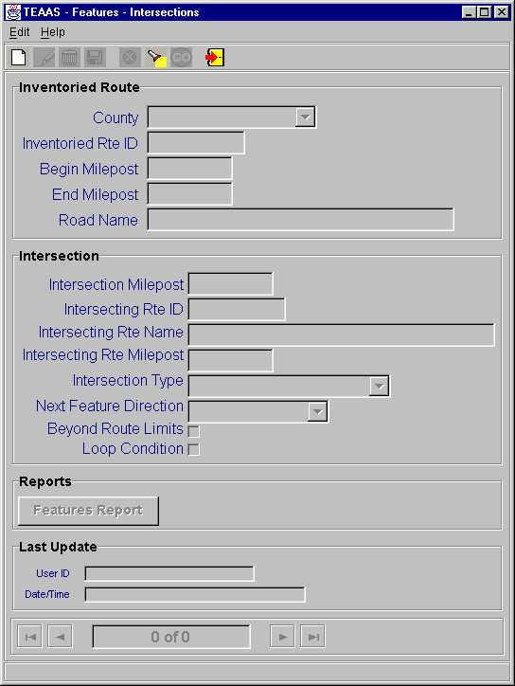
Intersections Screen

Searching for an Intersection Record
To search for Intersection records, click the Search icon on the toolbar. A blank screen will be presented for entering search criteria. The following table describes the search criteria allowed.
Field | Search Criteria
County | Select a specific County from the County combo box or leave empty if this field is not part of the search criteria.
Inventoried Rte ID | Enter a specific Inventoried Rte ID by entering the 8-digit road code. Wildcard characters may be used to search for one or more Inventoried Rte ID. Refer to Appendix C for a description on the use of wildcard characters. Leave Inventoried Rte ID empty if this field is not part of the search criteria.
Begin Milepost | Enter a specific Begin Milepost value or leave empty if this field is not part of the search criteria.
End Milepost | End Milepost is not allowed as a search parameter.
Road Name | Road Name is not allowed as a search parameter.
Intersection Milepost | Enter a specific Intersection Milepost value or leave empty if this field is not part of the search criteria.
Intersecting Rte ID | Enter a specific Intersecting Rte ID by entering an 8-digit road code. Wildcard characters may be used to search for one or more Intersecting Rte ID. Leave Intersecting Rte ID empty if this field is not part of the search criteria.
Intersecting Rte Name | Intersecting Rte Name is not allowed as a search parameter.
Intersecting Rte Milepost | Intersecting Rte Milepost is not allowed as a search parameter.
Intersection Type | Select a specific Intersection Type from the Intersection Type combo box or leave empty if this field is not part of the search criteria.
Next Feature Direction | Select a specific Next Feature Direction from the Next Feature Direction combo box or leave empty if this field is not part of the search criteria.
Beyond Route Limits | Beyond Route Limits indicator is not allowed as a search parameter.
Loop Condition | Loop Condition indicator is not allowed as a search parameter.

After all desired search criteria have been entered, click the Go icon on the toolbar. A dialog box will appear indicating the number of records returned. Click the OK button on the dialog box to view the records retrieved. Returned records are displayed in view mode.
If no records are returned, a dialog box will appear indicating such. If records were expected to be retrieved, verify that the search criteria are correct. A new search may be executed by adjusting the search criteria and clicking the Go icon.
It is recommended that the search criteria be as specific as possible to prevent the retrieval of too many records, which could contribute to local memory concerns and slower system performance. Currently, TEAAS will display a maximum of 500 records for any given search, although more than 500 records may actually meet the search criteria.

Canceling an Intersections Screen Operation
A Search operation may be canceled before a Go action is invoked by clicking the Cancel icon on the toolbar. Cancel will return the Intersections screen to its previous state.

Launching the Features Report
The Features report may be launched from the Intersections screen by clicking the Features Report button after an existing Intersection record appears in view mode. The report will take the displayed County, Inventoried Route, and Begin Milepost as its selection criteria. Refer to the Features Report section for more information regarding this report.

Closing the Intersections Screen
To close the Intersections screen, click the Close icon on the toolbar.

Boundaries

Boundaries Screen Overview
The Boundaries screen is used to search for and view location information for political boundaries that cross the Inventoried Route.
To access the Boundaries screen, select the Roadway Features button on the Application Browser, select Boundaries from the list box, and click the Open button.
Function Button | Function Name | Sub-Function
 | Roadway Features | Boundaries

Boundaries can also be accessed from the Inventoried Routes screen. Refer to the Inventoried Routes section for a description on accessing Features screens in that manner.
The screen that follows is displayed:
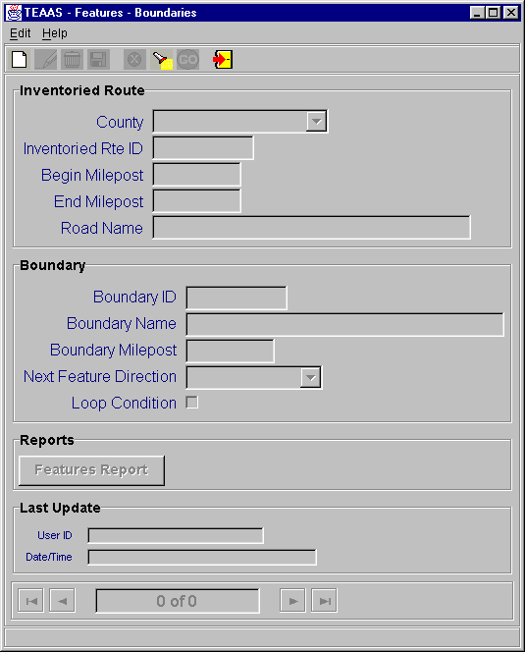
Boundaries Screen

Searching for a Boundary Record
To search for Boundary records, click the Search icon on the toolbar. A blank screen will be presented for entering search criteria. The following table describes the search criteria allowed.
Field | Search Criteria
County | Select a specific County from the County combo box or leave empty if this field is not part of the search criteria.
Inventoried Rte ID | Enter a specific Inventoried Rte ID by entering the 8-digit road code. Wildcard characters may be used to search for one or more Inventoried Rte ID. Refer to Appendix C for a description on the use of wildcard characters. Leave Inventoried Rte ID empty if this field is not part of the search criteria.
Begin Milepost | Enter a specific Begin Milepost value or leave empty if this field is not part of the search criteria.
End Milepost | End Milepost is not allowed as a search parameter.
Road Name | Road Name is not allowed as a search parameter.
Boundary ID | Enter a specific Boundary ID by entering 8-character alphanumeric Boundary code. Boundary codes start with one of the prefixes BS (state boundary), BC (county boundary), or BM (municipality boundary) and end with a 6-digit number. For example, the boundary code for the state of Georgia is BS000901; for Wake County, the code is BC000092. Wildcard characters may be used to search for one or more Boundary IDs. Leave Boundary ID empty if this field is not part of the search criteria. Search is non case sensitive.
Boundary Name | Boundary Name is not allowed as a search parameter.
Boundary Milepost | Enter a specific Boundary Milepost value or leave empty if this field is not part of the search criteria.
Next Feature Direction | Select a specific Next Feature Direction from the Next Feature Direction combo box or leave empty if this field is not part of the search criteria.
Loop Condition | Loop Condition indicator is not allowed as a search parameter.

After all desired search criteria have been entered, click the Go icon on the toolbar. A dialog box will appear indicating the number of records returned. Click the OK button on the dialog box to view the records retrieved. Returned records are displayed in view mode.
If no records are returned, a dialog box will appear indicating such. If records were expected to be retrieved, verify that the search criteria are correct. A new search may be executed by adjusting the search criteria and clicking the Go icon.
It is recommended that the search criteria be as specific as possible to prevent the retrieval of too many records, which could contribute to local memory concerns and slower system performance. Currently, TEAAS will display a maximum of 500 records for any given search, although more than 500 records may actually meet the search criteria.

Canceling a Boundaries Screen Operation
A Search operation may be canceled before a Go action is invoked by clicking the Cancel icon on the toolbar. Cancel will return the Boundaries screen to its previous state.

Launching the Features Report
The Features report may be launched from the Boundaries screen by clicking the Features Report button after an existing Boundary record appears in view mode. The report will take the displayed County, Inventoried Route, and Begin Milepost as its selection criteria. Refer to the Features Report section for more information regarding this report.

Closing the Boundaries Screen
To close the Boundaries screen, click the Close icon on the toolbar.

Structures

Structures Screen Overview
The Structures screen is used to search for and view location information on Structures (bridges, culverts, tunnels, overhead signs, pedestrian overpasses, and ferry landings) on the Inventoried Route.
To access the Structures screen, select the Roadway Features button on the Application Browser, select Structures from the list box, and click the Open button.
Function Button | Function Name | Sub-Function
 | Roadway Features | Structures

Structures can also be accessed from the Inventoried Routes screen. Refer to the Inventoried Routes section for a description on accessing Features screens in that manner.
The screen that follows is displayed:
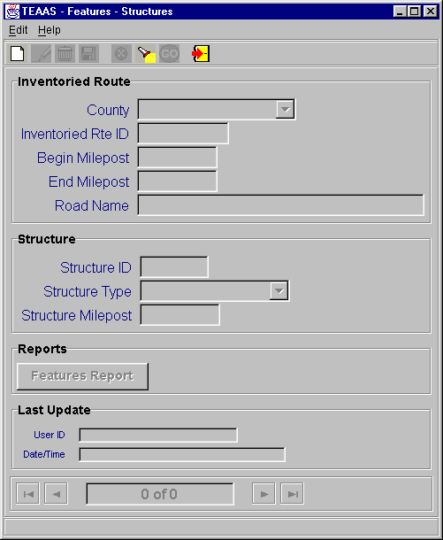
Structures Screen

Searching for a Structure Record
To search for Structure records, click the Search icon on the toolbar. A blank screen will be presented for entering search criteria. The following table describes the search criteria allowed.
Field | Search Criteria
County | Select a specific County from the County combo box or leave empty if this field is not part of the search criteria.
Inventoried Rte ID | Enter a specific Inventoried Rte ID by entering the 8-digit road code. Wildcard characters may be used to search for one or more Inventoried Rte ID. Refer to Appendix C for a description on the use of wildcard characters. Leave Inventoried Rte ID empty if this field is not part of the search criteria.
Begin Milepost | Enter a specific Begin Milepost value or leave empty if this field is not part of the search criteria.
End Milepost | End Milepost is not allowed as a search parameter.
Road Name | Road Name is not allowed as a search parameter.
Structure ID | Enter a specific Structure ID. Wildcard characters may be used to search for one or more Structure IDs. Leave Structure ID empty if this field is not part of the search criteria. Search is non case sensitive.
Structure Type | Select a specific Structure Type from the Structure Type combo box or leave empty if this field is not part of the search criteria.
Structure Milepost | Enter a specific Structure Milepost value or leave empty if this field is not part of the search criteria.

After all desired search criteria have been entered, click the Go icon on the toolbar. A dialog box will appear indicating the number of records returned. Click the OK button on the dialog box to view the records retrieved. Returned records are displayed in view mode.
If no records are returned, a dialog box will appear indicating such. If records were expected to be retrieved, verify that the search criteria are correct. A new search may be executed by adjusting the search criteria and clicking the Go icon.
It is recommended that the search criteria be as specific as possible to prevent the retrieval of too many records, which could contribute to local memory concerns and slower system performance. Currently, TEAAS will display a maximum of 500 records for any given search, although more than 500 records may actually meet the search criteria.

Canceling a Structures Screen Operation
A Search operation may be canceled before a Go action is invoked by clicking the Cancel icon on the toolbar. Cancel will return the Structures screen to its previous state.

Launching the Features Report
The Features report may be launched from the Structures screen by clicking the Features Report button after an existing Structure record appears in view mode. The report will take the displayed County, Inventoried Route, and Begin Milepost as its selection criteria. Refer to the Features Report section for more information regarding this report.

Closing the Structures Screen
To close the Structures screen, click the Close icon on the toolbar.

Mile markers

Mile Markers Screen Overview
The Mile Markers screen is used to search for and view location information on Mile Markers posted on the Inventoried Route.
To access the Mile Markers screen, select the Roadway Features button on the Application Browser, select Mile Markers from the list box, and click the Open button.
Function Button | Function Name | Sub-Function
 | Roadway Features | Mile Markers

Mile Markers can also be accessed from the Inventoried Routes screen. Refer to the Inventoried Routes section for a description on accessing Features screens in that manner.
The screen that follows is displayed:
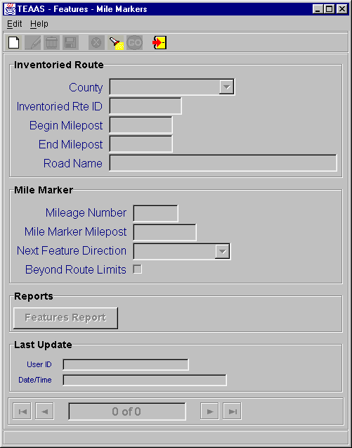
Mile Markers Screen

Searching for a Mile Marker Record
To search for Mile Marker records, click the Search icon on the toolbar. A blank screen will be presented for entering search criteria. The following table describes the search criteria allowed.
Field | Search Criteria
County | Select a specific County from the County combo box or leave empty if this field is not part of the search criteria.
Inventoried Rte ID | Enter a specific Inventoried Rte ID by entering the 8-digit road code. Wildcard characters may be used to search for one or more Inventoried Rte ID. Refer to Appendix C for a description on the use of wildcard characters. Leave Inventoried Rte ID empty if this field is not part of the search criteria.
Begin Milepost | Enter a specific Begin Milepost value or leave empty if this field is not part of the search criteria.
End Milepost | End Milepost is not allowed as a search parameter.
Road Name | Road Name is not allowed as a search parameter.
Mileage Number | Enter a specific Mileage Number value or leave empty if this field is not part of the search criteria.
Mile Marker Milepost | Enter a specific Mile Marker Milepost value or leave empty if this field is not part of the search criteria.
Next Feature Direction | Select a specific Next Feature Direction from the Next Feature Direction combo box or leave empty if this field is not part of the search criteria.
Beyond Route Limits | Beyond Route Limits indicator is not allowed as a search parameter.

After all desired search criteria have been entered, click the Go icon on the toolbar. A dialog box will appear indicating the number of records returned. Click the OK button on the dialog box to view the records retrieved. Returned records are displayed in view mode.
If no records are returned, a dialog box will appear indicating such. If records were expected to be retrieved, verify that the search criteria are correct. A new search may be executed by adjusting the search criteria and clicking the Go icon.
It is recommended that the search criteria be as specific as possible to prevent the retrieval of too many records, which could contribute to local memory concerns and slower system performance. Currently, TEAAS will display a maximum of 500 records for any given search, although more than 500 records may actually meet the search criteria.

Canceling a Mile Markers Screen Operation
A Search operation may be canceled before a Go action is invoked by clicking the Cancel icon on the toolbar. Cancel will return the Mile Markers screen to its previous state.

Launching the Features Report
The Features report may be launched from the Mile Markers screen by clicking the Features Report button after an existing Mile Marker record appears in view mode. The report will take the displayed County, Inventoried Route, and Begin Milepost as its selection criteria. Refer to the Features Report section for more information regarding this report.

Closing the Mile Markers Screen
To close the Mile Markers screen, click the Close icon on the toolbar.

Railroad crossings

Railroad Crossings Screen Overview
The Railroad Crossings screen is used to search for and view location information on Railroad Crossings that occur on the Inventoried Route.
To access the Railroad Crossings screen, select the Roadway Features button on the Application Browser, select Railroad Crossings from the list box, and click the Open button.
Function Button | Function Name | Sub-Function
 | Roadway Features | Railroad Crossings

Railroad Crossings can also be accessed from the Inventoried Routes screen. Refer to the Inventoried Routes section for a description on accessing Features screens in that manner.
The screen that follows is displayed:
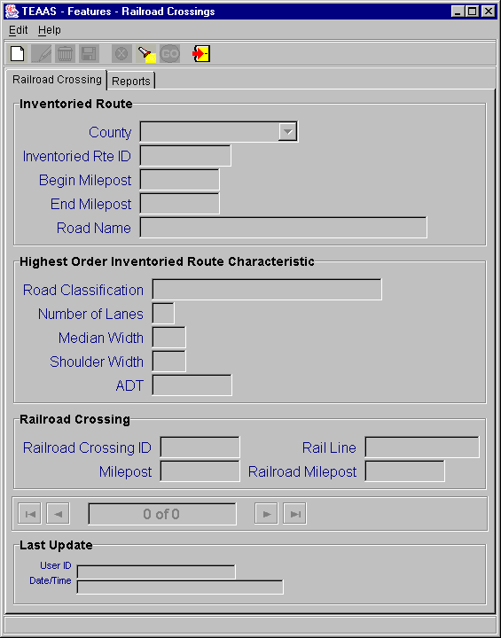
Railroad Crossings Screen

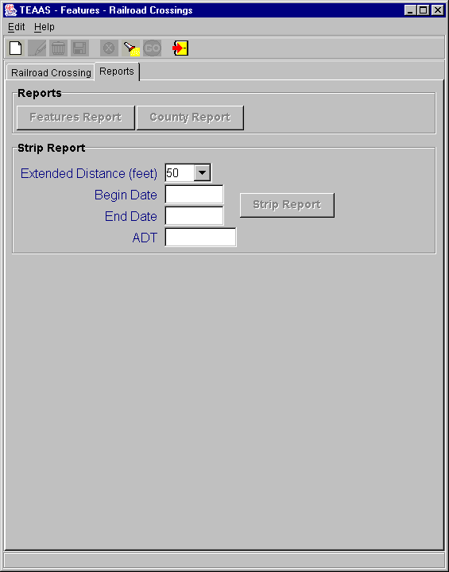
Railroad Crossings Report Screen

Searching for a Railroad Crossing Record
To search for Railroad Crossing records, click the Search icon on the toolbar. A blank screen will be presented for entering search criteria. The following table describes the search criteria allowed.
Field | Search Criteria
County | Select a specific County from the County combo box or leave empty if this field is not part of the search criteria.
Inventoried Rte ID | Enter a specific Inventoried Rte ID by entering the 8-digit road code. Wildcard characters may be used to search for one or more Inventoried Rte ID. Refer to Appendix C for a description on the use of wildcard characters. Leave Inventoried Rte ID empty if this field is not part of the search criteria.
Begin Milepost | Enter a specific Begin Milepost value or leave empty if this field is not part of the search criteria.
End Milepost | End Milepost is not allowed as a search parameter.
Road Name | Road Name is not allowed as a search parameter.
Railroad Crossing ID | Enter a specific Railroad Crossing ID. Wildcard characters may be used to search for one or more Railroad Crossing ID. Leave Railroad Crossing ID empty if this field is not part of the search criteria. Search is non case sensitive.
Milepost | Enter a specific Milepost value or leave empty if this field is not part of the search criteria.
Rail Line | Enter a specific Rail line value or leave empty if this field is not part of the search criteria. Search is non case sensitive.
Railroad Milepost | Enter a specific Railroad Milepost value or leave empty if this field is not part of the search criteria.

After all desired search criteria have been entered, click the Go icon on the toolbar. A dialog box will appear indicating the number of records returned. Click the OK button on the dialog box to view the records retrieved. Returned records are displayed in view mode.
If no records are returned, a dialog box will appear indicating such. If records were expected to be retrieved, verify that the search criteria are correct. A new search may be executed by adjusting the search criteria and clicking the Go icon.
It is recommended that the search criteria be as specific as possible to prevent the retrieval of too many records, which could contribute to local memory concerns and slower system performance. Currently, TEAAS will display a maximum of 500 records for any given search, although more than 500 records may actually meet the search criteria.

Canceling a Railroad Crossings Screen Operation
A Search operation may be canceled before a Go action is invoked by clicking the Cancel icon on the toolbar. Cancel will return the Railroad Crossings screen to its previous state.

Launching the Features Report
The Features report may be launched from the Railroad Crossing Report screen by clicking the Features Report button in the Reports Tab after an existing Railroad Crossing record appears in view mode. The report will take the displayed County, Inventoried Route, and Begin Milepost as its selection criteria. Refer to the Features Report section for more information regarding this report.

Launching the County Report
The County report may be launched from the Railroad Crossing Report screen by clicking the County Report button in the Reports Tab after county has been selected in view mode. The report will be displayed using County as its selection criteria.

Launching the Strip Report
The Strip report may be launched from the Railroad Crossing Report screen by clicking the Strip Report button in the Reports Tab after county and railroad crossing id has been selected in view mode. The County, railroad crossing id, Extended Distance Feet, Begin Date, End Date, and report ADT (use Highest Order Inventoried Route Characteristic ADT) will be used as the report generation criteria.
A Strip report will be generated for every route that is coinciding at the Railroad Crossing ID. The routes will be determined by performing a search on the Railroad Crossing table using the County and the Railroad Crossing ID. If there is more than one route is retrieved an information box similar to this will be displayed, indicating multiple Strip Reports will be generated.
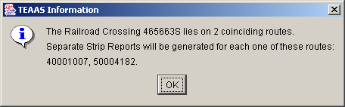
TEAAS – Railroad Crossing coinciding routes TEAAS information dialog box
Refer to the Strip Analysis Report section for more information regarding this report.

Closing the Railroad Crossings Screen
To close the Railroad Crossings screen, click the Close icon on the toolbar.

Secondary routes

Secondary Routes Screen Overview
The Secondary Routes screen is used to search for and view local street names attached to Secondary Routes within each county.
To access the Secondary Routes screen, select the Feature Names and Secondary Routes button on the Application Browser, select Secondary Routes from the list box, and click the Open button.
Function Button | Function Name | Sub-Function
 | Feature Names and Secondary Routes | Secondary Routes
The screen that follows is displayed:
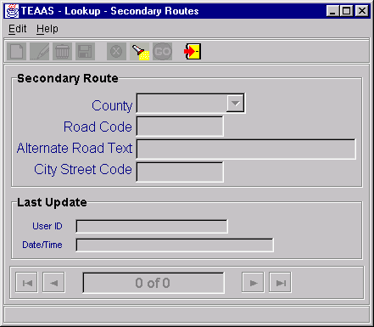
Secondary Routes Screen

Searching for a Secondary Route Record
To search for Secondary Route records, click the Search icon on the toolbar. A blank screen will be presented for entering search criteria. The following table describes the search criteria allowed.
Field | Search Criteria
County | Select a specific County from the County combo box or leave empty if this field is not part of the search criteria.
Road Code | Enter a specific Road Code by entering the 8-digit road code of the Secondary Route. Wildcard characters may be used to search for one or more Road Code. Refer to Appendix C for a description on the use of wildcard characters. Leave Road Code empty if this field is not part of the search criteria.
Alternate Road Text | Enter a specific Alternate Road Text spelling. Wildcard characters may be used to search for one or more Alternate Road Text spellings. Leave Alternate Road Text empty if this field is not part of the search criteria. Search is non case sensitive.
City Street Code | Enter a specific City Street Code by entering the 8-digit road code of the city street. Wildcard characters may be used to search for one or more City Street Code. Refer to Appendix C for a description on the use of wildcard characters. Leave City Street Code empty if this field is not part of the search criteria.

After all desired search criteria have been entered, click the Go icon on the toolbar. A dialog box will appear indicating the number of records returned. Click the OK button on the dialog box to view the records retrieved. Returned records are displayed in view mode.
If no records are returned, a dialog box will appear indicating such. If records were expected to be retrieved, verify that the search criteria are correct. A new search may be executed by adjusting the search criteria and clicking the Go icon.
It is recommended that the search criteria be as specific as possible to prevent the retrieval of too many records, which could contribute to local memory concerns and slower system performance. Currently, TEAAS will display a maximum of 500 records for any given search, although more than 500 records may actually meet the search criteria.

Canceling a Secondary Routes Screen Operation
A Search operation may be canceled before a Go action is invoked by clicking the Cancel icon on the toolbar. Cancel will return the Secondary Routes screen to its previous state.

Closing the Secondary Routes Screen
To close the Secondary Routes screen, click the Close icon on the toolbar.

Fiche report

Fiche Report Overview
The Fiche Report displays information regarding crashes occurring in a specific county, within a specific municipality, during a selected period of time, and on a specific physical roadway.
To access the Fiche Report screen, select the Generate Reports button on the Application Browser, select Fiche Report from the list box, and click the Open button.
Function Button | Function Name | Sub-Function
 | Generate Reports | Fiche Report

The Fiche Report screen below will be displayed. The User input selection criteria and Fiche Report generation processes are described in the sections below.
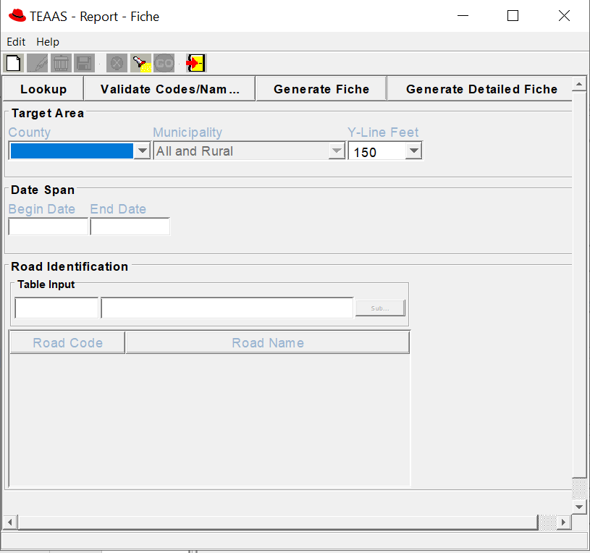

Fiche Report Screen

Beginning a Fiche Report
A blank Fiche Report screen appears when it is initially launched from the Application Browser. Click the New icon on the toolbar at any time to clear the current information or begin a new Fiche Report. The following table describes the requirements for each field.
Field | Field Requirements
County | A County must be selected from the County combo box.
Municipality | To retrieve accidents for a specific municipality within the County, select the municipality name.  To retrieve all accidents occurring outside incorporated municipalities, within the specified County, select ‘Rural’.  To retrieve all accidents occurring in the specified County, select ‘All and Rural’ (the default value).
Y-Line Feet | Select a value from the combo box or enter a whole number between 0 and 9999, inclusive. The default value is 150.
Begin Date | Enter the beginning date for the range of accident dates to be retrieved. The format is MM/DD/CCYY. Leading zeroes for the month and day may be omitted.
End Date | Enter the ending date for the range of accident dates to be retrieved. The format is MM/DD/CCYY. Leading zeroes for the month and day may be omitted. End Date cannot be less than Begin Date.
Road Code/Road Name | At least one Road Code/Road Name is required to generate the Fiche Report. It is recommended the User enter only a Road Code or Road Name to eliminate possible inconsistencies. Refer to the Road Identification Process described below.  Road Code – In the first Table Input box, enter a valid 8-digit code identifying the physical roadway, OR  Road Name – In the second Table Input box, enter a road name of up to 25 alphanumeric characters.

Road Identification Process
After either a Road Code or Road Name has been entered, click the Submit button to add the selection to the Road Code/Road Name table. If there are coinciding routes for the physical roadway, input additional Road Codes or Road Names using the same procedure. All Road Codes/Road Names entered should relate to only one physical roadway.
To delete a row in the Road Code/Road Name table, highlight the row and strike the Delete key on the keyboard.
To modify a row in the Road Code/Road Name table, highlight the row and strike the Enter key on the keyboard. The record will appear in the table input section where modifications can be made. After modifications are made, click the Submit button to add the record back to the Road Code/Road Name table.
To retrieve Alternate Street Names for Secondary Route codes in the Road Code/Road Name table, click the Lookup button. The Secondary Route Names Lookup screen will list the Alternate Street Names for the Secondary Routes in the table. To add a Street Name to the Road Code/Road Name table, highlight the name and click the Include button. Multiple entries may be highlighted using the Ctrl or Shift key.
After all desired Road Codes, Road Names, and Secondary Route Alternate Street Names have been added to the Road Code/Road Name table, validate entries before generating the Fiche Report by clicking the Validate Codes/Names button. If validation is not explicitly selected by the User, it will occur when the Generate Fiche button is clicked. Road Codes may be overwritten by the system for those rows containing both a Road Code and Road Name. After the validation process has been completed, the Fiche Report may be generated as described in the section below.

Generating the Fiche Report
To generate the Fiche Report, click the Generate Fiche button. The Fiche Report will appear in view mode in e.Report Engine. The report may be viewed on the screen, printed, or saved to a file. Refer to Appendix D for an overview of the use of e.Report Engine.

Generating the Detailed Fiche CSV
To generate the Detailed Fiche CSV report, fill in all the required input parameters and click the Generate Detailed Fiche button. Users will be prompted to save a detailed Fiche report on the local machine. Upon Save there will be 2 files generated, first csv contains the detailed fiche report and the second csv file contains the input parameters given to generate the fiche report.
The below snippet shows the two files stored in a folder.
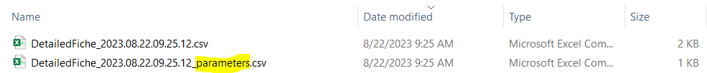

Closing the Fiche Report Screen
The Fiche Report screen may be closed at any time except while report creation is in progress. To close the Fiche Report screen, click the Close icon on the toolbar.

Intersection ANALYSIS report

Intersection Analysis Report Overview
The Intersection Analysis Report displays information regarding crashes occurring within a selected period of time at a specified intersection.
To access the Intersection Analysis Report screen, select the Generate Reports button on the Application Browser, select Intersection Analysis Report from the list box, and click the Open button.
Function Button | Function Name | Sub-Function
 | Generate Reports | Intersection Analysis Report

The screen that appears is comprised of three tabs:
- The Study Information tab collects information about the Study Area and the person or organization who requested the Study.
- The Road Identification tab allows the User to identify the primary road used to generate a Fiche Report, and to specify the Intersection road combinations to be used in the Study.
- The Accident Adjustments tab allows the User to include or exclude accidents from the next Study generated.
The use of each tab is discussed in more detail in the following sections.

Study Information Tab
The Study Information tab below is initially displayed after the Open button is clicked on the Application Browser.
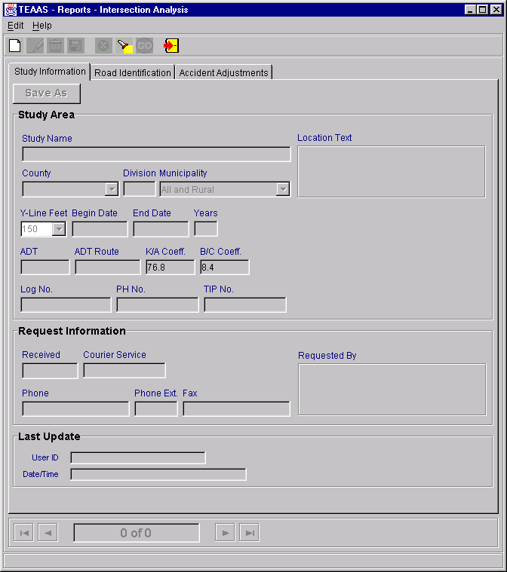
Intersection Analysis Report: Study Information Tab
The Study Information tab collects information about the Study Area and the person or organization who requested the Study. The following table describes the requirements for each field.
Field | Req’d  To  Save | Req’d  for  Fiche | Req’d  for  Study | Field Requirements
Study Name | X |  |  | A unique name of up to 30-alphanumeric characters given to the Study criteria. Search is non case sensitive.
Location Text |  |  |  | A text description of up to 160 alphanumeric characters. Search is non case sensitive.
County |  | X | X | A County must be selected from the County combo box.
Municipality |  | X | X | To retrieve accidents for a specific municipality within the County, select the municipality name.  To retrieve all accidents occurring outside incorporated municipalities, within the specified County, select ‘Rural.’  To retrieve all accidents occurring in the specified County, select ‘All and Rural’ (the default value).
Y-Line Feet |  | X | X | Select a value from the combo box or enter a whole number between 0 and 9999, inclusive. The default value is 150 feet.
Begin Date |  | X | X | Enter the beginning date for the range of accident dates to be retrieved. The format is MM/DD/CCYY. Leading zeroes for the month and day may be omitted.
End Date |  | X | X | Enter the ending date for the range of accident dates to be retrieved. The format is MM/DD/CCYY. Leading zeroes for the month and day may be omitted. End Date cannot be less than Begin Date.
ADT |  |  | X | The Average Daily Traffic (ADT) count must be entered in the range 1-999999.
ADT Route |  |  |  | The 8-digit code identifying the route on which the ADT was taken.
K/A Coeff |  |  | X | The K/A Coefficient in the format 99.9 must be entered. K/A Coefficient has a default value that will be retrieved from the FTV_MASTER_LOOKUP table. The default value should not be altered if no other value is known.
B/C Coeff |  |  | X | The B/C Coefficient in the format 99.9 must be entered. B/C Coefficient has a default value that will be retrieved from the FTV_MASTER_LOOKUP table. The default value should not be altered if no other value is known.
Log No. |  |  |  | The number assigned by the User to identify the Study. May be up to 11 alphanumeric characters. Search is non case sensitive.
PH No. |  |  |  | The number used by the Highway Safety Improvement Program to track potentially hazardous (PH) areas. May be up to 10 alphanumeric characters. Search is non case sensitive.
TIP No. |  |  |  | The number assigned by the Division of Highways to track Transportation Improvement Program (TIP) projects. May be up to 10 alphanumeric characters. Search is non case sensitive.
Received |  |  |  | The date that the request for the Study was received may be entered in the format MM/DD/CCYY. Leading zeroes for the month and day may be omitted.
Courier Service |  |  |  | The courier address for the requestor may be entered, up to 10 alphanumeric characters.
Requested By |  |  |  | The person or organization requesting the Study may be entered, up to 60 alphanumeric characters.
Phone |  |  |  | The requestor’s phone number may be entered, up to 13 characters. Parentheses and the hyphen character may be used in the phone number.
Phone Ext. |  |  |  | A Phone Extension with a maximum of 5 characters may be entered.
Fax |  |  |  | The requestor’s fax number may be entered, up to 13 characters. Parentheses and the hyphen character may be used in the phone number.
User ID |  |  |  | User ID of the person who last updated the report. Search is non case sensitive.
Date/Time |  |  |  | Date and time the report was last updated.

Road Identification Tab
The Road Identification tab appears as displayed below.
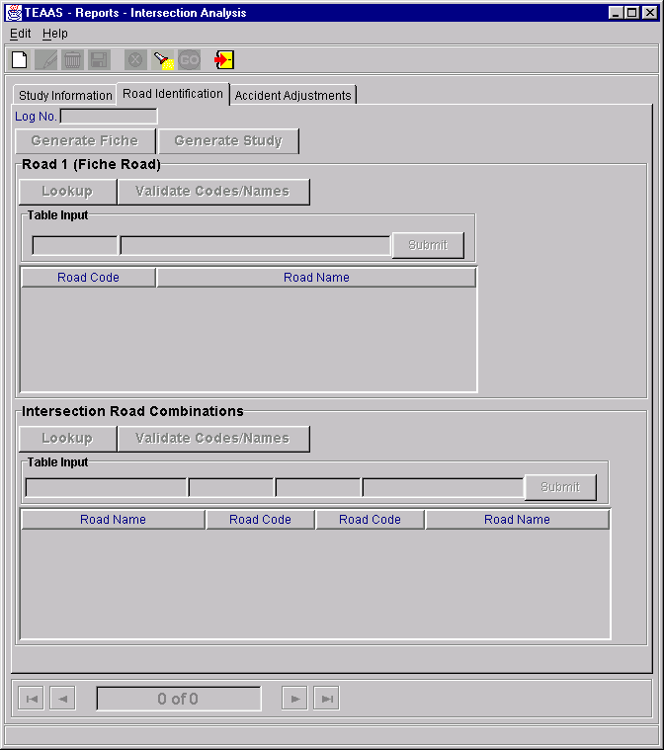
Intersection Analysis Report: Road Identification Tab
The Road Identification tab contains two subsections: Road 1 (Fiche Road) and Intersection Road Combinations. The use of each subsection is described below.

Road 1 (Fiche Road)
At least one Road Code/Road Name is required to generate the Fiche report. It is recommended the User enter only a Road Code or Road Name to eliminate possible inconsistencies. In the first Table Input box, enter a valid 8-digit code identifying the physical roadway; or in the second Table Input box, enter a road name of up to 25 alphanumeric characters.
After either a Road Code or Road Name has been entered, click the Submit button to add the selection to the Road Code/Road Name table. If there are coinciding routes for the physical roadway, input additional Road Codes or Road Names using the same procedure. All Road Codes/Road Names entered should relate to only one physical roadway.
To delete a row in the Road Code/Road Name table, highlight the row and strike the Delete key on the keyboard.
To modify a row in the Road Code/Road Name table, highlight the row and strike the Enter key on the keyboard. The record will appear in the table input section where modifications can be made. After modifications are made, click the Submit button to add the record back to the Road Code/Road Name table.
To retrieve Alternate Street Names for Secondary Route codes in the Road Code/Road Name table, click the Lookup button. The Secondary Route Names Lookup screen will list the Alternate Street Names for the Secondary Routes in the table. To add a Street Name to the Road Code/Road Name table, highlight the name and click the Include button. Multiple entries may be highlighted using the Ctrl or Shift key.
After all desired Road Code, Road Name, and Secondary Route Alternate Street Name entries have been added to the Road Code/Road Name table, validate entries before generating the Fiche Report by clicking the Validate Codes/Names button. If validation is not explicitly selected by the User, it will occur when the Generate Fiche button is clicked. Road Codes may be overwritten by the system for those rows containing both a Road Code and Road Name. After the validation process has been completed, the Fiche Report may be generated by clicking the Generate Fiche button. The Fiche report will be created and will appear in view mode in e.Report Engine. The report may be viewed on the screen, printed, or saved to a file. Refer to Appendix D for an overview of the use of e.Report Engine.

Intersection Road Combinations
The User must specify at least one Intersection Road Combination to generate a Study. It is recommended the User enter only a Road Code or Road Name to eliminate possible inconsistencies.
If the intersecting roads are thought of as the combination of A and B:
- For Road A, in the first Table Input box, enter a road name of up to 25 alphanumeric characters; or in the second Table Input box, enter a valid 8-digit code identifying the road.
- For Road B, in the third Table Input box, enter a valid 8-digit code identifying the road; or in the fourth Table Input box, enter a road name of up to 25 alphanumeric characters.
After an Intersection Road Combination has been entered, click the Submit button to add the selection to the Combination table. If there are coinciding routes for either road, input additional combinations using the same procedure, though an intersection combination need only be entered once. For example, if Main and First streets have been entered as an intersection combination, the combination of First and Main is not required.
To delete a row in the Combination table, highlight the row and strike the Delete key on the keyboard.
To modify a row in the Combination table, highlight the row and strike the Enter key on the keyboard. The record will appear in the table input section where modifications can be made. After modifications are made, click the Submit button to add the record back to the Combination table.
To retrieve Alternate Street Names for Secondary Route codes in the Combination table, click the Lookup button. The Secondary Route Names Lookup screen will list the Alternate Street Names for the Secondary Routes in the table. To add a Street Name to the Combination table, highlight the name and click the Include button. Multiple entries may be highlighted using the Ctrl or Shift keys. Intersecting roads must be specified for any Secondary Route Alternate Street Names included in this manner by modifying the appropriate row(s).
After all desired intersection combinations have been added to the table, validate entries before generating the Study by clicking the Validate Codes/Names button. If the User does not explicitly select validation, it will occur when the Generate Study button is clicked. Road Codes may be overwritten by the system for those rows containing both a Road Code and Road Name. After the validation process has been completed, the Study may be generated by clicking the Generate Study button.
The following “TEAAS – Crash Lists” dialog box will appear and ask the User if they want to save the Crash ID list, or the Detailed Crash ID list.

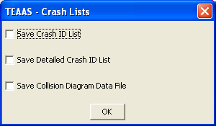
TEAAS – Crash Lists dialog box
If no selection is desired, just click the OK button. If one or all of the files are desired, check the appropriate check box and click on the OK button.
If the “Save Crash ID List” dialog box were selected, the following “Save Crash ID List” dialog box will appear.

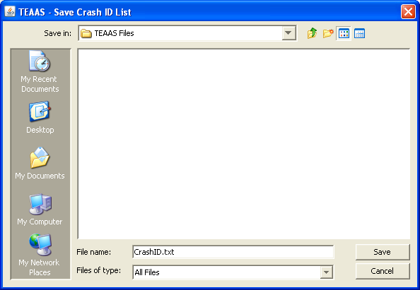
Save Crash ID List dialog box
Identify the directory in which to store the file, and click the Save button or Cancel button to skip. The data will be saved.
If the “Save Detailed Crash ID List” dialog box were selected, the following “Save Detailed Crash ID List” dialog box will appear.

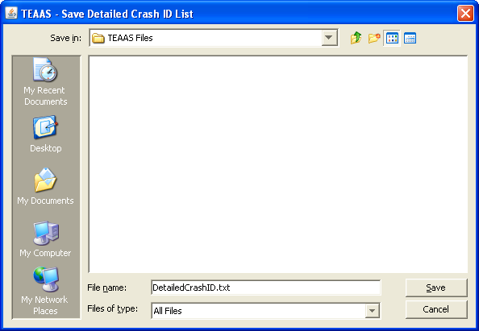
Save Detailed Crash ID List dialog box
Identify the directory in which to store the file, and click the Save button or Cancel button to skip. The data will be saved.
If the “Save Collision Diagram data File” dialog box were selected, the following “Save Collision Diagram Data” dialog box will appear.
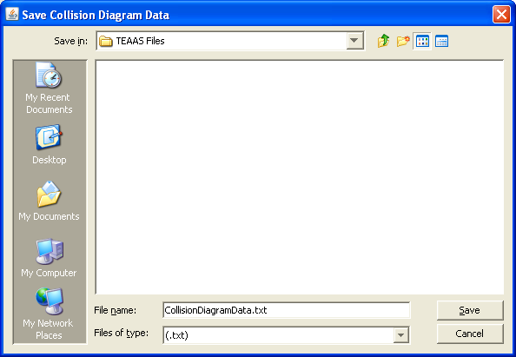
Save Collision Diagram Data dialog box
The Study will be created and will appear in view mode in e.Report Engine. The report may be viewed on the screen, printed, or saved to a file. Refer to Appendix D for an overview of the use of e.Report Engine.

Accident Adjustments Tab
The Accident Adjustments tab appears as displayed below.
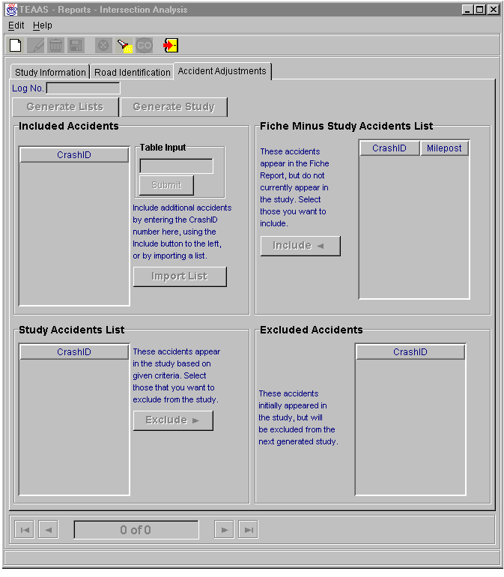Intersection Analysis Report: Accident Adjustments Tab
The Accidents Adjustments Tab contains four subsections: Fiche Minus Study Accidents List, Included Accidents, Study Accidents List, and Excluded Accidents. The use of each subsection is described below.
Inclusions and/or exclusions are not required to generate a Study; however, they allow the User to refine the next Study generated.

Fiche Minus Study Accidents List
The Fiche Minus Study Accidents List is populated only after the Generate Lists button has been clicked. The accidents appearing in this table are contained within the Fiche Report but do not currently appear in the Study. To include accidents in the next Study generated, highlight the Crash ID in the Fiche Minus Study Accidents List and click the Include button. The highlighted Crash ID will be copied to the Included Accidents table to the right. The Ctrl and Shift keys may be used to highlight multiple records. Continue this process until all desired accidents have been selected and copied to the Included Accidents table. After all inclusion activity has been completed, a new Study may be generated by clicking the Generate Study button.

Included Accidents
This table may be populated in any combination of three ways:
- Crash IDs may be included from the Fiche Minus Study Accidents List, as described above.
- A specific Crash ID may be added to the Included Accidents table by entering a Crash ID in the Table Input field and clicking the Submit button.
- Multiple Crash IDs may be added from a text file by clicking the Import List button. A Get Import List dialog box will appear to allow the User to specify the text file to be imported. After the file name has been specified, click the Import button to import the file. The Crash IDs contained in the text file will appear in the Included Accidents table. Click the Cancel button on the Get Import List dialog box to cancel the import process. The text file must contain only Crash IDs, one per line.
Crash IDs contained in the Included Accidents table may be deleted by highlighting the Crash ID in the Included Accidents table and striking the Delete key. The Ctrl and Shift keys may be used to highlight multiple records.
Crash IDs contained in the Included Accidents table may be sorted (ascending) by clicking the Sort button.
The Crash IDs contained in the Included Accidents table will be validated to make sure that the Accident Date of the Crash ID is within the Study Date range. An error will be shown with the Crash ID. To clear this error, remove this Crash ID from the Included Accidents table and click the Generate Study button again,
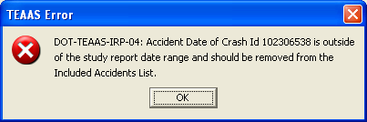
Error Message when the Crash ID Accident Date is not within the Study Date Range

After all inclusion activity has been completed, a new Study may be generated by clicking the Generate Study button. Study Accidents List
The Study Accidents List is populated only after the Generate Lists button has been clicked. The accidents appearing in this table are contained in the Study. To exclude Crash IDs for the next Study generated, highlight the Crash ID in the Study Accidents List and click the Exclude button. The highlighted Crash ID will be copied to the Excluded Accidents table to the right. The Ctrl and Shift keys may be used to highlight multiple records. Continue this process until all desired Crash IDs have been selected and copied to the Excluded Accidents table. After all exclusion activity has been completed, a new Study may be generated by clicking the Generate Study button.

Excluded Accidents
The Excluded Accidents table can be populated only by excluding accidents in the manner described in the Study Accidents List section above. Crash IDs contained in the Excluded Accidents table may be deleted by highlighting the Crash ID in the Excluded Accidents table and striking the Delete key. The Ctrl and Shift keys may be used to highlight multiple records. After all exclusion activity has been completed, a new Study may be generated by clicking the Generate Study button.

Creating a New Intersection Analysis Study
The Intersection Analysis Report screen appears in view mode when it is initially launched from the Application Browser. Click the New icon on the toolbar to begin a new Intersection Analysis Study. When modifying an existing Study, either save the Study, or cancel changes, then click the New icon. Refer to the Study Information Tab, Road Identification Tab, and Accident Adjustments Tab subsections for descriptions of input requirements.

Saving a New Intersection Analysis Study
After all desired information and criteria have been added, click the Save icon on the toolbar. If business rule conditions are not satisfied, a message will indicate the problem encountered. If all conditions are satisfied, the new Study is saved and displayed on the screen in view mode.

Searching for an Intersection Analysis Study
Existing studies may be used as a starting point for creating a new Study. Click the Search icon on the toolbar. The Study Name, Location Text, Log No., PH No.,TIP No., County, and User ID fields will be enabled for search criteria to be entered. Enter the information you want to search by, or use wildcard characters to search for one or more Study. After search criteria are entered, click the Go icon on the toolbar to retrieve all studies satisfying the search criteria. The navigation bar may be used to view the studies returned by the search. Note that the report cannot be generated without clicking the Modify icon on the toolbar. Please refer to Modifying an Intersection Analysis Study, below.

Modifying an Intersection Analysis Study
When an existing Study is displayed on the screen in view mode, the User must click the Modify icon on the toolbar to have the ability to generate the report, regardless of whether the Study criteria will be altered. The User may modify the criteria, generate the report, and close the Study without saving changes
When saving modifications, the following rules apply:
- The User who originally created the Study may save changes to that Study Name by clicking the Save icon on the toolbar.
- The User who originally created the Study may save the modified criteria as another Study Name by clicking the Save As button on the Study Information Tab.
- A User who did not create the Study can save the modified criteria as another Study Name by clicking either the Save icon on the toolbar, or by clicking the Save As button on the Study Information Tab.

Deleting an Intersection Analysis Study
An existing Study may only be deleted by the original creator of the Study, either after conducting a search to retrieve the Study or immediately after saving the Study. To delete a displayed Study, click the Delete icon on the toolbar. A confirmation dialog box will appear. Click the Yes button to proceed with the deletion or the No button to cancel the deletion. If the deleted Study was the only Study previously displayed on the screen, the screen will be cleared after the delete. If multiple Studies were displayed, the next Study will now be displayed. The record count at the bottom of the Intersection Analysis Report screen will be adjusted accordingly after the deletion.

Canceling an Intersection Analysis Study Operation
The New, Modify, and Search operations may be canceled before Save or Go actions are invoked by clicking the Cancel icon on the toolbar. Cancel will return the Intersection Analysis Report screen to its previous state. For example, if a Study is being modified, clicking Cancel will revert the record to its previous values, displaying it in view mode.

Closing the Intersection Analysis Report Screen
The Intersection Analysis Report screen may be closed at any point except while the creation of the report or generation of the lists is in progress. To close the Intersection Analysis Report screen, click the Close icon on the toolbar.

Strip ANALYSIS report

Strip Analysis Report Overview
The Strip Analysis Report displays information regarding crashes occurring within a selected period of time along a specified strip of roadway.
To access the Strip Analysis Report screen, select the Generate Reports button on the Application Browser, select Strip Analysis Report from the list box, and click the Open button.
Function Button | Function Name | Sub-Function
 | Generate Reports | Strip Analysis Report

The screen that appears is comprised of four tabs:
- The Study Information tab collects information about the Study Area and the person or organization who requested the Study.
- The Road Identification tab allows the User to identify the primary road used to generate the Study, as well as any coinciding routes, which are used in combination with the primary road to generate the Fiche Report.
- The Accident Adjustments tab allows the User to include or exclude accidents from the next Study generated.
- The Feature Inclusion tab allows the User to include Features not currently inventoried along the Strip Road.
The use of each tab is discussed in more detail in the following subsections.

Study Information Tab
The Study Information tab below is initially displayed after the Open button is clicked on the Application Browser.
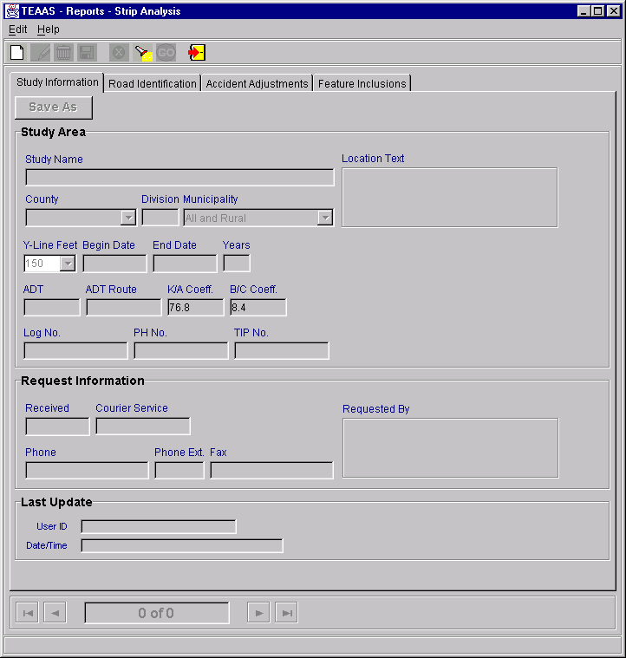
Strip Analysis Report: Study Information Tab

The Study Information tab collects information about the Study Area and the person or organization who requested the Study. The following table describes the requirements for each field.
Field | Req’d  to  Save | Req’d  For  Fiche | Req’d  For  Study | Field Requirements
Study Name | X |  |  | A unique name of up to 30-alphanumeric characters given to the Study criteria. Search is non case sensitive.
Location Text |  |  |  | A text description of up to 160 alphanumeric characters. Search is non case sensitive.
County |  | X | X | A County must be selected from the County combo box.
Municipality |  | X | X | To retrieve accidents for a specific municipality within the County, select the municipality name.  To retrieve all accidents occurring outside incorporated municipalities, within the specified County, select ‘Rural.’  To retrieve all accidents occurring in the specified County, select ‘All and Rural’ (the default value).
Y-Line Feet |  | X | X | Select a value from the combo box or enter a whole number between 0 and 9999, inclusive. The default value is 0 feet.
Begin Date |  | X | X | Enter the beginning date for the range of accident dates to be retrieved. The format is MM/DD/CCYY. Leading zeroes for the month and day may be omitted.
End Date |  | X | X | Enter the ending date for the range of accident dates to be retrieved. The format is MM/DD/CCYY. Leading zeroes for the month and day may be omitted. End Date cannot be less than Begin Date.
ADT |  |  | X | The Average Daily Traffic (ADT) count must be entered in the range 1-999999.
ADT Route |  |  |  | The 8-digit code identifying the route on which the ADT was taken.
K/A Coeff |  |  | X | The K/A Coefficient in the format 99.9 must be entered. K/A Coefficient has a default value that will be retrieved from the FTV_MASTER_LOOKUP table. The default value should not be altered if no other value is known.
B/C Coeff |  |  | X | The B/C Coefficient in the format 99.9 must be entered. B/C Coefficient has a default value that will be retrieved from the FTV_MASTER_LOOKUP table. The default value should not be altered if no other value is known.
Log No. |  |  |  | The number assigned by the User to identify the Study. May be up to 11 alphanumeric characters. Search is non case sensitive.
PH No. |  |  |  | The number used by the Highway Safety Improvement Program to track potentially hazardous (PH) areas. May be up to 10 alphanumeric characters. Search is non case sensitive.
TIP No. |  |  |  | The number assigned by the Division of Highways to track Transportation Improvement Program (TIP) projects. May be up to 10 alphanumeric characters. Search is non case sensitive.
Received |  |  |  | The date that the request for the Study was received may be entered in the format MM/DD/CCYY. Leading zeroes for the month and day may be omitted.
Courier Service |  |  |  | The courier address for the requestor may be entered, up to 10 alphanumeric characters.
Requested By |  |  |  | The person or organization requesting the Study may be entered, up to 60 alphanumeric characters.
Phone |  |  |  | The requestor’s phone number may be entered, up to 13 characters. Parentheses and the hyphen character may be used in the phone number.
Phone Ext. |  |  |  | A Phone Extension with a maximum of 5 characters may be entered.
Fax |  |  |  | The requestor’s fax number may be entered, up to 13 characters. Parentheses and the hyphen character may be used in the phone number.
User ID |  |  |  | User ID of the person who last updated the report. Search is non case sensitive.
Date/Time |  |  |  | Date and time the report was last updated.

Road Identification Tab
The Road Identification tab appears as displayed below.
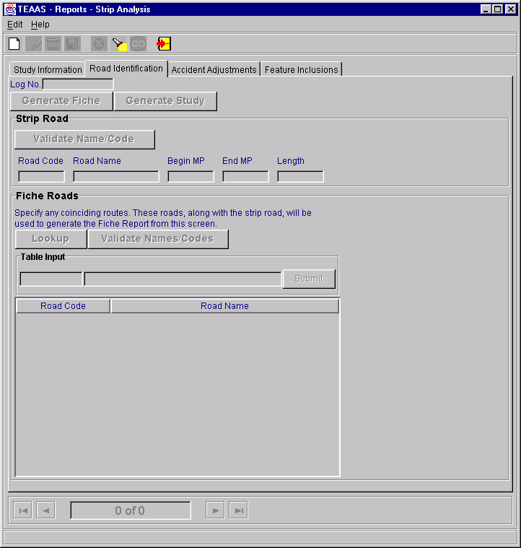
Strip Analysis Report: Road Identification Tab
The Road Identification tab contains two subsections: Strip Road and Fiche Roads. The use of each subsection is described below.

Strip Road
The entry in this section should correspond to the strip under Study. Enter either a Road Code or the Road Name, along with the corresponding milepost range for the strip. This road should represent the most continuous segment for the strip under Study.
It is recommended the User enter only a Road Code or Road Name to eliminate possible inconsistencies. In the first Table Input box, enter a valid 8-digit code identifying the physical roadway; or in the second Table Input box, enter a road name of up to 25 alphanumeric characters. Enter the Begin and End Milepost for the segment under Study.
Validate entries before generating the Study by clicking the Validate Strip Roads button. If the User does not explicitly select validation, it will occur when the Generate Study button is clicked. Road Codes may be overwritten by the system for those rows containing both a Road Code and Road Name. After the validation process has been completed, the Study may be generated by clicking the Generate Study button. The following “TEAAS – Crash Lists” dialog box will appear and ask the User if they want to save the Crash ID list, or the Detailed Crash ID list.

TEAAS – Crash Lists dialog box
If no selection is desired, just click the OK button. If one or more of the files is desired, check the appropriate check box and click on the OK button.
If the “Save Crash ID List” dialog box were selected, the following “Save Crash ID List” dialog box will appear.

Save Crash ID List dialog box
Identify the directory in which to store the file, and click the Save button or Cancel button to skip. The data will be saved.
If the “Save Detailed Crash ID List” dialog box were selected, the following “Save Detailed Crash ID List” dialog box will appear.
Save Detailed Crash ID List dialog box
Identify the directory in which to store the file, and click the Save button or Cancel button to skip. The data will be saved.
If the “Save Collision Diagram data File” dialog box were selected, the following “Save Collision Diagram Data” dialog box will appear.
Save Collision Diagram Data dialog box

The Study will be created and will appear in view mode in e.Report Engine. The report may be viewed on the screen, printed, or saved to a file. Refer to Appendix D for an overview of the use of e.Report Engine.

Fiche Roads
At least one Road Code/Road Name is required to generate the Strip report. It is recommended the User enter only a Road Code or Road Name to eliminate possible inconsistencies. In the first Table Input box, enter a valid 8-digit code identifying the physical roadway; or in the second Table Input box, enter a road name of up to 25 alphanumeric characters.
After either a Road Code or Road Name has been entered, click the Submit button to add the selection to the Road Code/Road Name table. If there are coinciding routes for the physical roadway, input additional Road Codes or Road Names using the same procedure. All Road Codes/Road Names entered should relate to only one physical roadway.
To delete a row in the Road Code/Road Name table, highlight the row and strike the Delete key on the keyboard.
To modify a row in the Road Code/Road Name table, highlight the row and strike the Enter key on the keyboard. The record will appear in the Table Input section where modifications can be made. After modifications are made, click the Submit button to add the record back to the Road Code/Road Name table.
To retrieve Alternate Street Names for Secondary Route codes in the Road Code/Road Name table, click the Lookup button. The Secondary Route Names Lookup screen will list the Alternate Street Names for the Secondary Routes in the table. To add a Street Name to the Road Code/Road Name table, highlight the name and click the Include button. Multiple entries may be highlighted using the Ctrl or Shift key.
After all desired Road Codes, Road Names, and Secondary Route Alternate Street Names have been added to the Road Code/Road Name table, validate entries before generating the Fiche Report by clicking the Validate Names/Codes button. If the User does not explicitly select validation, it will occur when the Generate Fiche button is clicked. Road Codes may be overwritten by the system for those rows containing both a Road Code and Road Name. After the validation process has been completed, the Fiche Report may be generated by clicking the Generate Fiche button. The Fiche report will be created and will appear in view mode in e.Report Engine. The report may be viewed on the screen, printed, or saved to a file. Refer to Appendix D for an overview of the use of e.Report Engine.

Accident Adjustments Tab
The Accident Adjustments tab appears as displayed below.
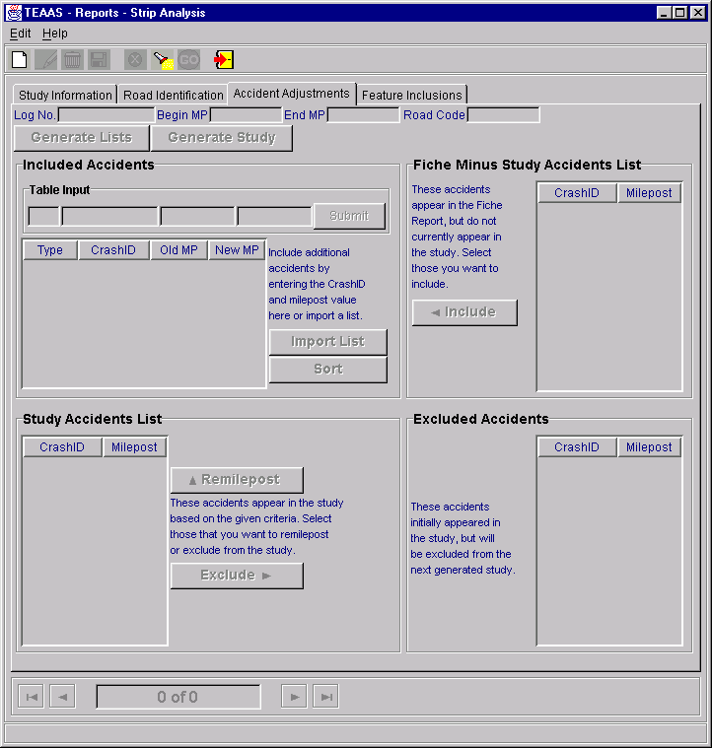
Strip Analysis Report: Accident Adjustments Tab

The Accidents Adjustments Tab contains four subsections: Fiche Minus Study Accidents List, Included Accidents, Study Accidents List, and Excluded Accidents. The use of each subsection is described below.
Inclusions and/or exclusions are not required to generate a Study; however, they allow the User to refine the next Study generated.

Fiche Minus Study Accidents List
The Fiche Minus Study Accidents List is populated only after the Generate Lists button has been clicked. The accidents appearing in this list are contained within the Fiche Report but do not currently appear in the Study. To include accidents in the next Study generated, highlight the Crash ID in the Fiche Minus Study Accidents List and click the Include button. The highlighted Crash ID will be copied to the Included Accidents table to the left. The Ctrl and Shift keys may be used to highlight multiple rows. Continue this process until all desired accidents have been selected and copied to the Included Accidents list. After all accident inclusion activity has been completed, a new Study may be generated by clicking the Generate Study button.

Included Accidents
The Included Accidents table may be populated in any combination of four ways:
- By including accidents from the Fiche Minus Study Accidents List, as described above.
- A specific Crash ID may be added to the Included Accidents list by entering a Crash ID and New MP in the Table Input field and clicking the Submit button. The Crash ID will be validated to ensure that the Accident Date of the Crash ID falls within the Study Date Range.
- Multiple Crash IDs may be added from an existing text file by clicking the Import List button. A Get Import List dialog box will appear to allow the User to specify the text file to be imported. After the file name has been specified, click the Import button to import the file. The Crash IDs contained in the text file will appear in the Included Accidents table. Click the Cancel button on the Get Import List dialog box to cancel the import process. The text file must contain the Crash ID and New MP, separated by the pipe symbol ( | ), one accident per line. For example:
98023718|1.234
98024448|1.570
98044398|3.200
- By including accidents for remileposting from the Study Accident List. This process is described in the Study Accidents List subsection, below.
All accidents added to the Included Accidents table must be given a New MP within the range specified for the Strip Road. To modify a row in the Included Accidents table, highlight the row and strike the Enter key on the keyboard. The record will appear in the table input section where modifications can be made. After modifications are made, click the Submit button to add the record back to the Included Accidents table.
Crash IDs contained in the Included Accidents table may be deleted by highlighting the Crash ID in the Included Accidents table and striking the Delete key. The Ctrl and Shift keys may be used to highlight multiple rows.
Crash IDs contained in the Included Accidents table may be sorted (ascending) by clicking the Sort button.
The Crash IDs contained in the Included Accidents table will be validated to make sure that the Accident Date of the Crash ID is within the Study Date range. An error will be shown with the Crash ID. To clear this error, remove this Crash ID from the Included Accidents table and click the Generate Study button again,

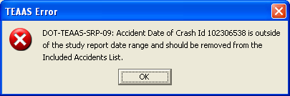
Error Message when the Crash ID Accident Date is not within the Study Date Range
After all accident inclusion activity has been completed, a new Study may be generated by clicking the Generate Study button.

Study Accidents List
The Study Accidents List is populated only after the Generate Lists button has been clicked. The accidents appearing in this table are contained in the Study.
To remilepost specific accidents for the next Study generated, highlight the Crash ID in the Study Accidents List and click the Remilepost button. The highlighted Crash ID will be copied to the Included Accidents table above. The Ctrl and Shift keys may be used to highlight multiple rows. Continue this process until all desired Crash IDs have been selected and copied to the Included Accidents list.
To exclude Crash IDs from the next Study generated, highlight the Crash ID in the Study Accidents List and click the Exclude button. The highlighted Crash ID will be copied to the Excluded Accidents table to the right. The Ctrl and Shift keys may be used to highlight multiple rows. Continue this process until all desired Crash IDs have been selected and copied to the Excluded Accidents list.
After all accident inclusion and exclusion activity has been completed, a new Study may be generated by clicking the Generate Study button.
Note: Modifications to the milepost value do not update the true milepost value for that Crash ID. Rather, the value is modified only for purposes of the study in progress.

Excluded Accidents
The Excluded Accidents table can be populated only by excluding accidents in the manner described in the Study Accidents List subsection above. Crash IDs contained in the Excluded Accidents table may be deleted by highlighting the Crash ID in the Excluded Accidents table and striking the Delete key. The Ctrl and Shift keys may be used to highlight multiple rows. After all exclusion activity has been completed, a new Study may be generated by clicking the Generate Study button.

Feature Inclusions Tab
The Feature Inclusions tab appears as displayed below.
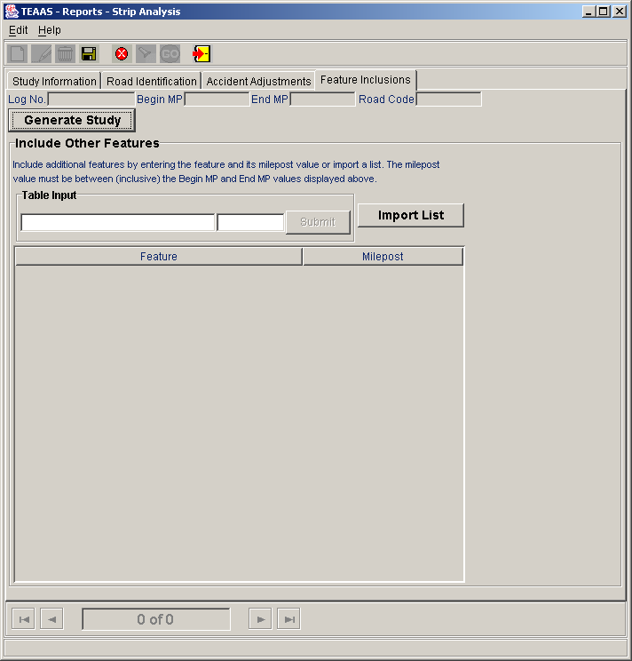
Strip Analysis Report: Feature Inclusions Tab

The Feature Inclusions tab allows the User to include Features that have not been inventoried on the Strip Road. Include additional features by entering the feature and its milepost value or import a list. The milepost value must be between (inclusive) the Begin MP and End MP values of the study route.
Enter the Feature text and Milepost in the Table Input field and click the Submit button. The milepost must be in the range specified for the Strip Road. Repeat this process until all desired additional Features are added to the Include Other Features table.
To modify a row in the Include Other Features table, highlight the row and strike the Enter key on the keyboard. The record will appear in the table input section where modifications can be made. After modifications are made, click the Submit button to add the record back to the Include Other Features table.
Multiple Features may be added from an existing text file by clicking the Import List button. A Get Import List dialog box will appear to allow the User to specify the text file to be imported. After the file name has been specified, click the Import button to import the file. The Features contained in the text file will appear in the Included Accidents table. Click the Cancel button on the Get Import List dialog box to cancel the import process. The text file must contain Feature Name and MP, separated by the pipe symbol ( | ), one feature per line. For example:
Restaurant|1.234
Fire Station|11.570
Strip Mall|20.999
Features contained in the Include Other Features table may be deleted by highlighting the Feature in the Include Other Features table and striking the Delete key. The Ctrl and Shift keys may be used to highlight multiple rows. After all Feature inclusion activity has been completed, a new Study may be generated by clicking the Generate Study button.

Creating a New Strip Analysis Study
The Strip Analysis Report screen appears in view mode when it is initially launched from the Application Browser. Click the New icon on the toolbar to begin a new Strip Analysis Study. When modifying an existing Study, either save the Study, or cancel changes, then click the New icon. Refer to the Study Information Tab, Road Identification Tab, Accident Adjustments Tab, and Feature Inclusions subsections for descriptions of input requirements.

Saving a New Strip Analysis Study
After all desired information and criteria have been entered, click the Save icon on the toolbar. If business rule conditions are not satisfied, a message will indicate the problem encountered. If all conditions are satisfied, the new Study is saved and displayed on the screen in view mode.

Searching for a Strip Analysis Study
Existing studies may be used as a starting point for creating a new Study. Click the Search icon on the toolbar. The Study Name, Location Text, Log No., PH No.,TIP No., County, and User ID fields will be enabled for search criteria to be entered. After search criteria are entered, click the Go icon on the toolbar to retrieve all studies satisfying the search criteria. The navigation bar may be used to view the Studies returned by the search. Note that the report cannot be generated without first clicking the Modify icon on the toolbar. Please refer to the Modifying a Strip Analysis Study subsection below.

Modifying a Strip Analysis Study
When an existing Study is displayed on the screen in view mode, the User must click the Modify icon on the toolbar to have the ability to generate the report, regardless of whether the Study criteria will be altered. The User may modify the criteria, generate the report, and close the Study without saving changes.
When saving modifications, the following rules apply:
- The User who originally created the Study may save changes to that Study Name by clicking the Save icon on the toolbar.
- The User who originally created the Study may save the modified criteria as another Study Name by clicking the Save As button on the Study Information Tab.
- A User who didn’t create the Study can save the modified criteria as another Study Name by clicking either the Save icon on the toolbar, or by clicking the Save As button on the Study Information Tab.

Deleting a Strip Analysis Study
An existing Study may only be deleted by the original creator of the Study, either after conducting a search to retrieve the Study or immediately after saving the Study. To delete a displayed Study, click the Delete icon on the toolbar. A confirmation dialog box will appear. Click the Yes button to proceed with the deletion or the No button to cancel the deletion.

Canceling a Strip Analysis Study Operation
The New, Modify, and Search operations may be canceled before Save or Go actions are invoked by clicking the Cancel icon on the toolbar. Cancel will return the Strip Analysis Report screen to its previous state. For example, if a Study is being modified, clicking Cancel will revert the record to its previous values, displaying it in view mode.

Closing the Strip Analysis Report Screen
The Strip Analysis Report screen may be closed at any point except while the creation of the report is in progress. To close the Strip Analysis Report screen, click the Close icon on the toolbar.

Generate Collision Diagram File

Generate Collision Diagram File Overview
The Generate Collision Diagram File all a user to submit a list of crash ids and have a text file returned with the necessary information required to work with TSU’s collision diagram program.
To access the Generate Collision Diagram File screen, select the Generate Reports button on the Application Browser, select Generate Collision Diagram File from the list box, and click the Open button.
Function Button | Function Name | Sub-Function
 | Generate Reports | Generate Collision Diagram File

The screen that appears is comprised of a Crash Id List data entry area and four buttons.
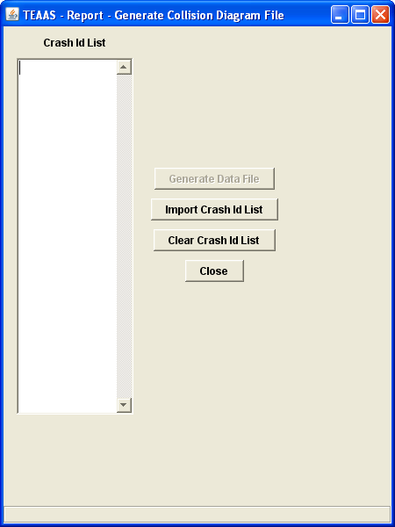
Generate Collision Data File

The following table describes the requirements for each field.
Field | Field Requirements
Crash Id List | This field is used as a data entry field. Users can insert one Crash Id per line. Each Crash Id is validated to ensure that that it is well formed and that there are no duplicates/ A well formed Crash Id is a number that is 8 or 9 digits long.
Generate Data File | Generates a file that contains Collision Data. The user will be prompted for a name and location to save the file.
Import Crash Id List | .Imports a crash id list from a text file. Each Crash Id is on its own line.
Clear Crash Id List | Clear the Crash Id List area.
Close | Closes the Generate Collision Data File window.

Generating a Collision Diagram Data File
The Crash Id List text area will allow entry of crash ids by hand or you can import a list of crash ids from the Import Crash Id List button. There should only be one crash id per line in the text field or in the crash id list that the user will be importing. Importing again will prompt the user if there are Crash Ids in the Crash Id list text area, a pop-up will be shown. Selecting Yes will clear the current list that is shown and the new list will take its place.
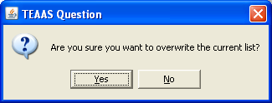
Prompt when overwriting the current Crash Id List
Each crash id will be checked while it is being entered and after the Generate Data File button will be selected. If there are any errors in the crash id list, an error message will be shown with the error(s) found and will abort the process. The user will then be able to fix the list in the Crash Id List text area or fix the error in the file and re-import the list and try again.
Selecting the Clear Crash Id List button will show a pop-up asking to the user if they want to clear the Crash Id List, selecting the Yes button will clear the contents of the Crash Id List text area.
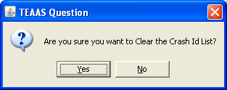
Prompt when clearing the Crash Id List
Selecting the Close button will show a pop-up asking to the user if they want to close the window, selecting the Yes button will close the window.
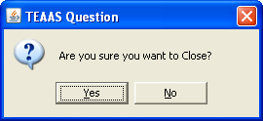
Prompt when closing Generating Collision Diagram File Application
When the Generate Data File button is selected, the crash ids will be checked, if all are valid, a Collision Diagram Crash Data file will be generated, then prompts user to save the file.
Save Collision Diagram Data dialog box
If there are any duplicate Crash Ids that are in the list, the user will be prompted to save these duplicates in a file. If any Crash Ids in the list return no data , the user will be prompted to save them in a file.
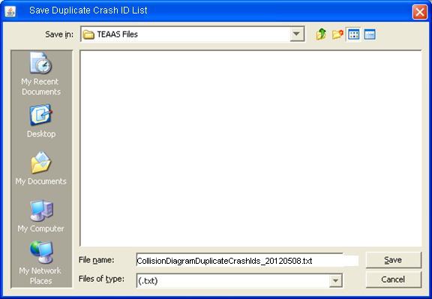
Save Duplicate Crash Id List dialog box

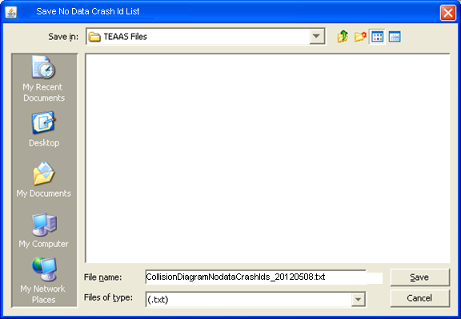
Save No data Crash Id List dialog box
Users will also be able to create the Collision Diagram Data File from the Strip and Intersection Analysis Reports. See the Strip Analysis and Intersection Analysis sections for more information.

Fiche, intersection, and strip reports code index

Fiche, Intersection, and Strip Reports Code Index Overview
The Fiche, Intersection, and Strip Reports Code Index serves as a legend for the Crash DMV-349 codes that appear on the Fiche, Intersection, and Strip reports.
To access the Fiche, Intersection, and Strip Reports Code Index Report, select the Generate Reports button on the Application Browser, select Fiche, Intersection, and Strip Reports Code Index from the list box, and click the Open button.
Function Button | Function Name | Sub-Function
 | Generate Reports | Fiche, Intersection, and Strip Reports Code Index

The Fiche, Intersection, and Strip Reports Code Index are viewed through e.Report Engine. The report may be viewed on the screen, printed, or saved to a file. Refer to Appendix D for an overview of the use of e.Report Engine.

Features report

Features Report Overview
The Features Report identifies all Boundaries, Intersections, Mile Markers, Railroad Crossings, and Structures for a given County, Inventoried Route, and Begin Milepost.
To access the Features Report, select the Generate Reports button on the Application Browser, select Features Report from the list box, and click the Open button.
Function Button | Function Name | Sub-Function
 | Generate Reports | Features Report

The Features report may also be launched from the Inventoried Routes, Intersections, Boundaries, Structures, Mile Markers, or Railroad Crossings screens by clicking the Features Report button after an existing record appears in view mode. The report will take the displayed County, Inventoried Route, and Begin Milepost as its selection criteria.
The Features Report is viewed through e.Report Engine. The report may be viewed on the screen, printed, or saved to a file. Refer to Appendix D for an overview of the use of e.Report Engine.

Highest order segments report

Highest Order Segments Report Overview
The Highest Order Segments Report identifies all Highest Order Segments for a given County, Inventoried Route, and Begin Milepost.
To access the Highest Order Segments Report, select the Generate Reports button on the Application Browser, select Highest Order Segments Report from the list box, and click the Open button.
Function Button | Function Name | Sub-Function
 | Generate Reports | Highest Order Segments Report

The Highest Order Segments Report may only be generated by clicking the HO Segments Report button if an existing Inventoried Route record appears in view mode. It may also be launched directly from the Inventoried Routes screen without first having to select it through the Generate Reports function on the Application Browser.
The Highest Order Segments Report is viewed through e.Report Engine. The report may be viewed on the screen, printed, or saved to a file. Refer to Appendix D for an overview of the use of e.Report Engine.

Incorporated municipalities report
Incorporated Municipalities Report Overview
The Incorporated Municipalities Report identifies all North Carolina incorporated municipalities documented in the Crash system.
To access the Incorporated Municipalities Report, select the Generate Reports button on the Application Browser, select Incorporated Municipalities Report from the list box, and click the Open button.
Function Button | Function Name | Sub-Function
 | Generate Reports | Incorporated Municipalities Report

The Incorporated Municipalities Report is viewed through e.Report Engine. The report may be viewed on the screen, printed, or saved to a file. Refer to Appendix D for an overview of the use of e.Report Engine.
- System Contact Information
The following table lists the appropriate contacts for requests and issues relating to TEAAS.
To | Primary Contact | Secondary Contact
Establish New Users | TEAAS Support  Raleigh  TEAAS_Support@ncdot.gov  919-814-4962 | DOT Help Desk  Raleigh  DOTHelp@ncdot.gov  919-707-7000
Maintain User Passwords | TEAAS Support  Raleigh  TEAAS_Support@ncdot.gov  919-814-4962 | DOT Help Desk  Raleigh  DOTHelp@ncdot.gov  919-707-7000
Maintain User Roles | TEAAS Support  Raleigh  TEAAS_Support@ncdot.gov  919-814-4962 | DOT Help Desk  Raleigh  DOTHelp@ncdot.gov  919-707-7000
Report hardware problems | Local LAN Technician | DOT Help Desk  Raleigh  DOTHelp@ncdot.gov  919-707-7000
Report software problems | DOT Help Desk  Raleigh  DOTHelp@ncdot.gov  919-707-7000 | Local LAN Technician

- Alternate System Controls
TEAAS has been designed to allow alternate methods of invoking most commands. The following table describes alternate methods for the toolbar icons discussed throughout this document.
Function | Toolbar Icon | Menu Option | Alt Command | Ctrl  Command
Cancel |  | Edit→Cancel | Alt+E+Alt+L | Ctrl+L
Close |  | Edit→Close | Alt+E+C | N/A
Delete |  | Edit→Delete | Alt+E+D | Ctrl+D
Go |  | Edit→Go | Alt+E+G | Ctrl+G
Help About | N/A | Help→About | Alt+H+A | Ctrl+A
Modify |  | Edit→Modify | Alt+E+M | Ctrl+M
New |  | Edit→New | Alt+E+N | Ctrl+N
Save |  | Edit→Save | Alt+E+S | Ctrl+S
Search |  | Edit→Search | Alt+E+R | Ctrl+R

- Wildcard Searching
The following describes the use of the asterisk (*) and question mark (?) wildcard characters available in performing searches within TEAAS.
Wildcard Character | Description | Examples
Wildcard Character | Description | Input | Results
* | The asterisk character is used to represent any character or group of characters. | * | Returns all possible values.
* |  | * Avenue | Returns all Street Names ending with the string ‘ Avenue’. For example, First Avenue and Carolina Avenue would be returned.
* |  | Main* | Returns all Street Names beginning with the string ‘Main’. In this example, Main Street, Maine Street, and Mainsail Point all would be returned.
? | The question mark is used to represent any single character. Unlike the asterisk, when using the question mark, all positions must be present for the search to be performed correctly. | Davi? | Returns all Street Names of five characters in length, beginning with the string ‘Davi’. This example would return David, Davie, Davin, and Davis.
? |  | 2?000070 | Returns all variations of eight-digit codes for US 70, excluding couplets. In this example, 20000070, 21000070, 22000070, 27000070, and 29000070 would be returned.
% | The % % allows you to match any string of any length (including zero length). | David% | Returns all Street Names of 5 or more characters beginning with the string ‘David’. This example would return David, David Barker, David Caldwell Dr ...

- Operating Actuate Formula One E.Report Designer
TEAAS Reports are produced and viewed using Actuate Formula One e.Report Designer (e.Report Engine), which may be used to navigate through the report in view mode, print the report, or save the report to a file.
e.Report Engine Toolbar Button | Function
 | Export to a file format. A dialog box is presented to allow the User to choose the export format (PDF, DHTML, HTML, Excel, CSV, XML, and RTF). User is prompted to identify the directory and file name for the export file. The JOI and EMAIL export formats may not work.
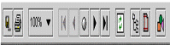 | Print report. Only an entire report may be printed through e.Report Engine. Within the print report screen, depending on the type of printer, the name of the printer, number of copies, paper size, paper source, and print mode may be specified. e.Report Engine also allows you to print specific range of pages.
 | Image resizing. Allows the User to enlarge or reduce the image on the screen.
 | Navigation buttons. The arrow buttons navigate through the pages of the report. The center button permits navigation to a specific page number.
 | Refresh. Only applicable for the Features Report. To utilize, the Features Report button on the Inventoried Routes screen must be clicked first (while the report is still open), then the Refresh button on the e.Report Engine window.
 | Table of contents. Displays a list of the report's sections and permits navigation directly to a specific section.

