

Traffic Engineering Accident Analysis System
Release 11.0 User Manual
For
The State of North Carolina
Department of Transportation
Information Systems Technology
April 4, 2019
Version 8.2

Presented by:

Traffic Records Systems AM Team
Raney Building, 104 Fayetteville Street
Raleigh, NC 27601
Table of Contents
1 Revision History 1
2 overview 4
3 getting started 7
3.1 The Toolbar 7
3.2 The Audit Bar 8
3.3 The Navigation Bar 8
4 logon 9
4.1 Launching the Application 9
4.2 Logging On 10
4.3 Changing the Password 11
4.4 About TEAAS dialog box 12
5 Application BROWSER 13
5.1 Application Browser Overview 13
5.2 Application Browser Functions/Sub-Functions 14
6 Users 16
6.1 Send Alert Message 16
6.2 Users Screen Overview 17
6.3 Searching for a User 20
6.4 Adding a New User 21
6.5 Maintaining User Passwords 22
6.6 Maintaining User Roles 23
6.7 Modifying an Existing User 23
6.8 Deleting an Existing User 23
6.9 Canceling a Users Screen Operation 24
6.10 Closing the Users Screen 24
7 street and Feature names 25
7.1 Street and Feature Names Screen Overview 25
7.2 Searching for a Street and Feature Name Record 27
7.3 Adding a New Street and Feature Name Record 28
7.4 Modifying an Existing Street and Feature Name Record 28
7.5 Deleting an Existing Street and Feature Name Record 29
7.6 Canceling a Street and Feature Names Screen Operation 29
7.7 Closing the Street and Feature Names Screen 29
8 inventoried Routes 30
8.1 Inventoried Routes Screen Overview 31
8.2 Searching for an Inventoried Route Record 32
8.3 Adding a New Inventoried Route Record 33
8.4 Modifying an Existing Inventoried Route Record 34
8.5 Deleting an Existing Inventoried Route Record 34
8.6 Canceling an Inventoried Routes Screen Operation 34
8.7 Launching the Features Report 34
8.8 Launching the Highest Order Segments Report 34
8.9 Viewing Boundary Records 35
8.10 Viewing Highest Order Segment Records 35
8.11 Viewing Intersection Records 35
8.12 Viewing Mile Marker Records 35
8.13 Viewing Railroad Crossing Records 35
8.14 Viewing Structure Records 35
8.15 Adding a Boundary Record 36
8.16 Adding a Highest Order Segment Record 36
8.17 Adding an Intersection Record 36
8.18 Adding a Mile Marker Record 36
8.19 Adding a Railroad Crossing Record 36
8.20 Adding a Structure Record 37
8.21 Closing the Inventoried Routes Screen 37
9 Highest order segments 38
9.1 Highest Order Segments Screen Overview 38
9.2 Searching for a Highest Order Segment Record 39
9.3 Adding a New Highest Order Segment Record 40
9.4 Modifying an Existing Highest Order Segment Record 42
9.5 Deleting an Existing Highest Order Segment Record 42
9.6 Canceling a Highest Order Segments Screen Operation 42
9.7 Launching the Highest Order Segments Report 43
9.8 Closing the Highest Order Segments Screen 43
10 Intersections 44
10.1 Intersections Screen Overview 44
10.2 Searching for an Intersection Record 46
10.3 Adding a New Intersection Record 47
10.4 Modifying an Existing Intersection Record 48
10.5 Deleting an Existing Intersection Record 48
10.6 Canceling an Intersections Screen Operation 48
10.7 Launching the Features Report 48
10.8 Closing the Intersections Screen 48
11 Boundaries 49
11.1 Boundaries Screen Overview 49
11.2 Searching for a Boundary Record 51
11.3 Adding a New Boundary Record 52
11.4 Modifying an Existing Boundary Record 53
11.5 Deleting an Existing Boundary Record 53
11.6 Canceling a Boundaries Screen Operation 53
11.7 Launching the Features Report 53
11.8 Closing the Boundaries Screen 53
12 Structures 54
12.1 Structures Screen Overview 54
12.2 Searching for a Structure Record 55
12.3 Adding a New Structure Record 56
12.4 Modifying an Existing Structure Record 57
12.5 Deleting an Existing Structure Record 57
12.6 Canceling a Structures Screen Operation 57
12.7 Launching the Features Report 58
12.8 Closing the Structures Screen 58
13 Mile markers 59
13.1 Mile Markers Screen Overview 59
13.2 Searching for a Mile Marker Record 60
13.3 Adding a New Mile Marker Record 61
13.4 Modifying an Existing Mile Marker Record 62
13.5 Deleting an Existing Mile Marker Record 63
13.6 Canceling a Mile Markers Screen Operation 63
13.7 Launching the Features Report 63
13.8 Closing the Mile Markers Screen 63
14 Railroad crossings 64
14.1 Railroad Crossings Screen Overview 64
14.2 Searching for a Railroad Crossing Record 66
14.3 Adding a New Railroad Crossing Record 67
14.4 Modifying an Existing Railroad Crossing Record 67
14.5 Deleting an Existing Railroad Crossing Record 67
14.6 Canceling a Railroad Crossings Screen Operation 68
14.7 Launching the Features Report 69
14.8 Launching the County Report 70
14.9 Launching the Strip Report 70
14.10 Closing the Railroad Crossings Screen 70
15 Secondary routes 71
15.1 Secondary Routes Screen Overview 71
15.2 Searching for a Secondary Route Record 72
15.3 Adding a Secondary Route Record 73
15.4 Modifying an Existing Secondary Route Record 74
15.5 Deleting an Existing Secondary Route Record 74
15.6 Canceling a Secondary Routes Screen Operation 74
15.7 Closing the Secondary Routes Screen 74
16 Ordinances 75
16.1 Ordinances Screen Overview 76
16.2 Searching for Ordinances 80
16.3 Importing a List of Ordinances 82
16.4 Batch Updates 84
16.5 Viewing Ordinance Details 85
16.6 Adding an Ordinance 85
16.7 Modifying an Existing Ordinance 90
16.8 Deleting an Existing Ordinance 90
16.9 Canceling an Ordinances Screen Operation 90
16.10 Performing Milepost 90
16.11 Division Approval of an Ordinance 91
16.12 Region Approval of an Ordinance 91
16.13 State Approval of an Ordinance 91
16.14 State Remove Approval of an Ordinance 91
16.15 Division Recommend for Repeal / Revoke Recommendation of an Ordinance 92
16.16 Region Recommend for Repeal / Revoke Recommendation of an Ordinance 92
16.17 State Recommend for Repeal of an Ordinance 93
16.18 State Revoke Repeal Recommendation of an Ordinance 93
16.19 Approvals, Repeals, Revoke Repeals, and Overlaps of Ordinances 93
16.20 Generating the Municipality Certificates 95
16.21 Exporting Ordinances from Search Screen 97
16.22 Generating the Certification of Rulemaking 101
16.23 Generating the Ordinance Report 103
16.24 Closing the Ordinances Screen 104
17 Ordinances TYPes 105
17.1 Ordinances Type Screen Overview 105
17.2 Searching for Ordinances Types 106
17.3 Adding an Ordinance Type 107
17.4 Modifying an Existing Ordinance Type 108
17.5 Deleting an Existing Ordinance Type 108
17.6 Canceling an Ordinances Type Screen Operation 108
17.7 Exporting Ordinance Types 109
18 municipality Names 111
18.1 Municipality Administration Screen Overview 111
18.2 Searching for a Municipality Names Record 112
18.3 Adding a New Municipality Names Record 113
18.4 Modifying an Existing Municipality Names Record 114
18.5 Canceling a Municipality Names Screen Operation 114
18.6 Deleting an Existing Municipality Names Record 115
18.7 Closing the Municipality Names Screen 115
19 STreet name exceptions 116
19.1 Street Name Exceptions Screen Overview 116
19.2 Retrieving Street Name Exceptions 117
19.3 Adding Street Names 119
19.4 Closing the Street Name Exceptions Screen 120
20 MUNICIPALITY name exceptions 121
20.1 Municipality Name Exceptions Screen Overview 121
20.2 Retrieving Municipality Name Exceptions 122
20.3 Modifying Municipality Names 123
20.4 Closing the Municipality Name Exceptions Screen 124
21 Fiche report 125
21.1 Fiche Report Overview 125
21.2 Beginning a Fiche Report 126
21.3 Road Identification Process 127
21.4 Generating the Fiche Report 128
21.5 Closing the Fiche Report Screen 128
22 Intersection ANALYSIS report 129
22.1 Intersection Analysis Report Overview 129
22.2 Study Information Tab 131
22.3 Road Identification Tab 134
22.4 Accident Adjustments Tab 140
22.5 Creating a New Intersection Analysis Study 142
22.6 Saving a New Intersection Analysis Study 142
22.7 Searching for an Intersection Analysis Study 143
22.8 Modifying an Intersection Analysis Study 143
22.9 Deleting an Intersection Analysis Study 143
22.10 Canceling an Intersection Analysis Study Operation 143
22.11 Closing the Intersection Analysis Report Screen 144
23 Strip ANALYSIS report 145
23.1 Strip Analysis Report Overview 145
23.2 Study Information Tab 147
23.3 Road Identification Tab 150
23.4 Accident Adjustments Tab 154
23.5 Feature Inclusions Tab 157
23.6 Creating a New Strip Analysis Study 158
23.7 Saving a New Strip Analysis Study 158
23.8 Searching for a Strip Analysis Study 158
23.9 Modifying a Strip Analysis Study 159
23.10 Deleting a Strip Analysis Study 159
23.11 Canceling a Strip Analysis Study Operation 159
23.12 Closing the Strip Analysis Report Screen 159
24 Generate Collision Diagram File 160
24.1 Generate Collision Diagram File Overview 160
24.2 Generating a Collision Diagram Data File 162
Users will also be able to create the Collision Diagram Data File from the Strip and Intersection Analysis Reports. See the Strip Analysis and Intersection Analysis sections for more information. 164
25 Sliding Scale 165
25.1 Sliding Scale Screen Overview 165
25.2 Searching for an Sliding Scale Study 170
25.3 Adding a New Sliding Scale Study 170
25.4 Modifying an Existing Sliding Scale Study 173
25.5 Deleting an Existing Sliding Scale Study 173
25.6 Applying Filters to a Sliding Scale Study 174
25.7 Launching the Sliding Scale Report 174
25.8 Checking the Status of a Sliding Scale Study 174
25.9 Viewing the Sliding Scale Report 174
25.10 Clearing the Sliding Scale Report 175
25.11 Closing the Sliding Scale Screen 175
26 Fiche, intersection, and strip reports code index 176
26.1 Fiche, Intersection, and Strip Reports Code Index Overview 176
27 Features report 177
27.1 Features Report Overview 177
28 Highest order segments report 178
28.1 Highest Order Segments Report Overview 178
29 Ordinance exception report: On ROad/ho Route 179
29.1 Ordinance Exception Report: On Road/HO Route Overview 179
30 Ordinance exception report: overlap 180
30.1 Ordinance Exception Report: Overlap Overview 180
31 Ordinance exception report: no milepost 181
31.1 Ordinance Exception Report: No Milepost Overview 181
32 Highest Order Segment Gap Report 183
32.1 Highest Order Segment Gap Report Overview 183
33 city-wide ACCIDENT ReportS 184
33.1 City-Wide Accident Reports Overview 184
34 cOUNTY-wide ACCIDENT ReportS 186
34.1 County-Wide Accident Reports Overview 186
35 MILEPOST iTEMS 188
35.1 Milepost Items Screen Overview 188
36 MILEPOST Ordinances 189
36.1 Milepost Ordinances Screen Overview 189
37 GIS Data File Creation/Export 190
APPENDIX A : System Contact Information 193
APPENDIX B : Alternate System Controls 194
APPENDIX C : Wildcard Searching 195
APPENDIX D : Operating Actuate Formula One E.Report Designer 196

Revision History
Document Version | Description of Change
1.0 | Initial Creation.
2.0 | Removed Deliverable number.
2.0 | Added TEAAS Release Number.
2.0 | Removed ‘can authorize installation of the application and’ from section 2.
2.0 | Italicized section names that were not italicized.
2.0 | Updated most screen prints.
2.0 | Added new search fields for Intersection and Strip Reports.
2.0 | Added Features report to Intersections, Boundaries, Structures, Mile Markers, and Railroad Crossings sections. Updated Features Report section to include these screens.
2.0 | Changed ‘Outside County’ to ‘Beyond Route Limits’ on Mile Marker and Intersections sections.
2.0 | In section five, deleted ‘The navigation bar at the bottom of the screen may be used to navigate through the retrieved records.’ Navigation bar discussed earlier in the document.
2.0 | Added ‘Highest Order Segment Gap Report.’
2.0 | Added ‘Milepost Items.’
2.0 | For Fiche, Intersection, and Strip Reports, removed the section about landscape or portrait orientation for printing.
2.0 | Added a screen print and directions to the ‘Ordinance Exception Report: No Milepost’ section.
2.0 | Added keyboard commands of the navigation bar.
2.0 | Updated ‘Street Name Exceptions’ section to include information about the update data bar.
2.0 | Moving all Closing subsections to become the last subsection in each section.
2.0 | Capitalized all occurrences of ‘study’.
2.0 | Removed public query user from Uncoded Roads Report, Uncoded Municipalities Report, and all 3 Ordinance Exception Reports.
2.0 | Removed ‘Applicable Sections by Role’ and ‘Toolbar Icon Descriptions’ table names.
2.0 | Removed the second occurrence of ‘Refer to Appendix D for a description on the use of wildcard characters.’ In ‘Searching for a Street and Feature Name Record.’
2.0 | Under Strip Analysis Section, Road Identification Tab, Strip Road, changed button name from ‘Validate Names/Codes’ to ‘Validate Strip Road.’
3.0 | Moved Change Log to section 1 and renamed to Revision History.
3.0 | “End Milepost” added to Boundary, Intersection, Mile Marker, Railroad Crossing, Structure, Inventoried Routes, and HO Segment screens and relevant text was modified.
3.0 | “Milepost Begin” changed to “Begin Milepost” on Boundary, Intersection, Mile Marker, Railroad Crossing, Structure, and HO Segment screens and relevant text was modified.
3.0 | Added Street Code to Secondary Routes screen.
3.0 | Street Name Exceptions (previously Feature Name Exceptions) updated to allow searches from Secondary Routes that do not have Street Names.
3.0 | On the Strip Report Screen, Accident Adjustments tab, Study Accidents List panel, the button name was changed to “Remilepost” and relevant text was modified.
3.0 | Updated All Screens.
3.0 | Deleted ALT+E+L command for Cancel.
3.0 | Updated System Contact Information.
3.0 | Changed the order of Appendix C and Appendix D.
4.0 | Updated document to accompany all changes associated with Release 3.1.
4.0 | Changed all dates and Release numbers accordingly throughout document.
4.0 | Updated all screen prints.
4.0 | Modified text as appropriate to accommodate new screen appearances; applicable to Boundary (new field for Boundary Name), Intersection (new field for Intersecting Route Name), Intersection Analysis Report (Sort button for Included Accidents; able to search on UserID field), Strip Analysis Report (Sort button for Included Accidents; Max length of Feature Inclusion text increased from 20 to 35; able to search on UserID field).
5.0 | Updated matrices beginning each section relative to PDM and SDM roles to reflect changes made to the application per TSSMS (formerly TSSMU) request.
6.0 | Modified text as appropriate to accommodate new report type; applicable to City-Wide Accident Reports.
6.1 | Modified text as appropriate to accommodate for new user type (Public Report User) and report types; applicable to City-Wide Accident Report and introductory sections.
6.2 | Modified text as appropriate to accommodate for changes in City-Wide Accident Report types that are available to the user; applicable to City-Wide Accident Report and introductory sections.
6.3 | Modified text as appropriate to accommodate for changes in Release 4.2; applicable to Intersection Report Interface: Accident Adjustment panel, Fiche Minus Study table for displaying milepost values; Intersection and Strip Report Interfaces: capability to save Detailed Crash data, and capability to sort by all columns; Generate Public Reports: the addition of 8 County-Wide Reports.
6.4 | Modified text as appropriate to accommodate for changes in User Information.
6.5 | Modified text as appropriate to accommodate for changes in Release 4.3; applicable to the addition of the Municipality Name Exceptions feature.
6.6 | Made changes as needed by the TEAAS release 4.3. Added additional information for Generate Study in Intersection and Strip Analysis reports.
6.7 | Update document for TEAAS 5.0 RRX
6.8 | Update document for TEAAS 5.0 Ordinance and other issues.
6.9 | Updated for TEAAS 5.1 Sliding Scale
7.0 | Updated for TEAAS 5.2
7.1 | Updated for TEAAS 5.3
7.2 | Updated for TEAAS 5.5
7.3 | Updated for TEAAS 6.0 Ordinance Changes
7.4 | Updated for TEAAS Java 1.6 and VisiBroker 8 upgrade
7.5 | Updated for TEAAS 9.0
7.7 | Updated to reflect changes in TEAAS 9.4.0
7.8 | Incorporated TEAAS 10.2.0 changes
7.9 | Incorporated TEAAS 10.3.0 changes
8.0 | Incorporated TEAAS 10.6.0 changes
8.1 | Incorporated TEAAS 10.8.0 changes
8.2 | Incorporated TEAAS 11.0.0 changes

overview
The Traffic Engineering Accident Analysis System (TEAAS) provides the North Carolina Department of Transportation (NCDOT) Traffic Safety System Management Section (TSSMS) with an automated system to analyze and produce information on accidents occurring throughout the state of North Carolina.
This document provides the reader with an overview of TEAAS Release 9.0 and instructions regarding its use.
Users may be assigned one or more TEAAS Roles based on their business needs or responsibilities. The specific Role(s) assigned control what that User can do within TEAAS. TEAAS User Roles are:
- System Administrator (SA)
- Primary Data Maintainer (PDM)
- Secondary Data Maintainer (SDM)
- Technical Query User (TQU)
- Public Query User (PQU)
- Public Report User (PRU)
- DMV Crash User (DCU)
- Features Data Entry User (FDEU)
- Ordinance User (OU)
- Data Entry Ordinance User (DEOU)
- State Data Entry Ordinance User (SDEOU)
- Division Ordinance User (DOU)
- Region Ordinance User (ROU)
- Traffic Engineering Ordinance User (TEOU)
- Ordinance Administrator (OA)
- Ordinance Exception Report (OER)
- Feature User (FU)
- Sliding Scale User (SSU)
Before continuing with this manual, it is recommended that the reader have the following information available:
- TEAAS User ID
- TEAAS Password
- Assigned TEAAS Role(s).
The following table directs the reader to applicable sections of this document based on the Role(s) assigned them.
Section |  |  | Roles
Section | SA | PDM | SDM | TQU | PQU | PRU | DCU | FDEU | OU | DEOU | DOU | ROU | TEOU | SSU | OA | OER | FU | SDEOU
Getting Started | X | X | X | X | X | X |  | X | X | X | X | X | X | X | X |  |  | X
Logon | X | X | X | X | X | X |  | X | X | X | X | X | X | X | X |  |  | X
Application Browser | X | X | X | X | X | X |  | X | X | X | X | X | X | X | X |  |  | X
Send An Alert Message | X
Users | X | X | X | X | X | X |  | X | X | X | X | X | X |  |  |  |  | X
Street and Feature Names |  | X | X | X | X |  |  |  |  |  |  |  |  |  |  |  | X
Inventoried Routes |  | X | X | X | X |  |  |  |  |  |  |  |  |  |  |  | X
Highest Order Segments |  | X | X | X | X |  |  |  |  |  |  |  |  |  |  |  | X
Intersections |  | X | X | X | X |  |  | X |  |  |  |  |  |  |  |  | X
Boundaries |  | X | X | X | X |  |  | X |  |  |  |  |  |  |  |  | X
Structures |  | X | X | X | X |  |  | X |  |  |  |  |  |  |  |  | X
Mile Markers |  | X | X | X | X |  |  | X |  |  |  |  |  |  |  |  | X
Railroad Crossings |  | X | X | X | X |  |  | X |  |  |  |  |  |  |  |  | X
Secondary Routes |  | X | X | X | X |  |  |  |  |  |  |  |  |  |  |  | X
Street Name Exceptions |  | X
Fiche Report |  |  |  | X | X
Intersection Analysis Report |  |  |  | X | X
Strip Analysis Report |  |  |  | X | X
Fiche, Intersection, and Strip Reports Code Index |  |  |  | X | X
Features Report |  | X | X | X | X |  |  |  |  |  |  |  |  |  |  |  | X
Highest Order Segments Report |  | X | X | X | X |  |  |  |  |  |  |  |  |  |  |  | X
City-Wide Report |  |  |  |  |  | X
County-Wide Report |  |  |  |  |  | X
Incorporated Municipalities Report |  |  |  | X | X
Ordinance Exception Report: On Road/HO Route |  |  |  | X |  |  |  |  |  |  |  |  |  |  |  | X
Ordinance Exception Report: Overlap |  |  |  | X |  |  |  |  |  |  |  |  |  |  |  | X
Ordinance Exception Report: No Milepost |  |  |  | X |  |  |  |  |  |  |  |  |  |  |  | X
Highest Order Segment Gap Report |  |  |  | X
Error Log Report | X
Milepost Items | X
Milepost Accidents |  |  |  |  |  |  | X
Municipality Name Exceptions |  | X
Municipality Names |  | X
Milepost Ordinances | X
Alert Message | X | X | X | X | X | X | X | X | X | X | X | X | X | X | X | X | X | X
Send An Alert Message | X
Ordinances |  |  |  |  |  |  |  |  | X | X | X | X | X |  | X |  |  | X
Sliding Scale Report |  |  |  |  |  |  |  |  |  |  |  |  |  | X
Appendix A: System Contact Information | X | X | X | X | X | X | X | X | X | X | X | X | X | X | X |  |  | X
Appendix B: Alternate System Controls | X | X | X | X | X | X | X | X | X | X | X | X | X | X | X |  |  | X
Appendix C: Wildcard Searching | X | X | X | X | X | X | X | X | X | X | X | X | X | X | X |  |  | X
Appendix D: Operating Enterprise Report Writer | X | X | X | X | X | X |  | X | X | X | X | X | X | X | X |  |  | X

getting started
The following table directs the reader to appropriate Getting Started subsections.
Getting Started Subsections |  |  | Roles
Getting Started Subsections | SA | PDM | SDM | TQU | PQU | PRU | DCU | FDEU | OU | DEOU | DOU | ROU | TEOU | SSU | OA | OER | FU | SDEOU
The Toolbar | X | X | X | X | X | X |  | X | X | X | X | X | X | X | X |  |  | X
The Audit Bar | X | X | X | X | X | X |  | X | X | X | X | X | X | X | X |  |  | X
The Navigation Bar | X | X | X | X | X | X |  | X | X | X | X | X | X | X | X |  |  | X

TEAAS System Administrators control the User administration and application access. The System Administrator is responsible for creating and maintaining User IDs, Passwords, and Roles. Contact the DOT Help Desk for any issues regarding access to the application. Appendix A contains a listing of system contact information.

The Toolbar
Toolbar icons are used for illustrative purposes throughout this document. The table below describes the toolbar icons.
Toolbar Icon | Function | Description
 | New | Presents a blank form for data entry of a new record.
 | Modify | Permits modification of the current record.
 | Delete | Permits deletion of the current record.
 | Save | Either saves changes to the record being modified, or saves the newly created record.
 | Cancel | Cancels a New, Modify, or Search operation.
 | Search | Allows the User to specify the desired search criteria.
 | Go | Initiates a search based on the User-specified criteria.
 | Close | Closes the screen.

Appendix B describes alternate methods of enacting toolbar commands, including menu options, Alt commands, and Ctrl commands.

The Audit Bar
The audit bar appears at the bottom of the TEAAS screens that permit data entry. It identifies the User who last updated the current record, as well as the date and time of update.
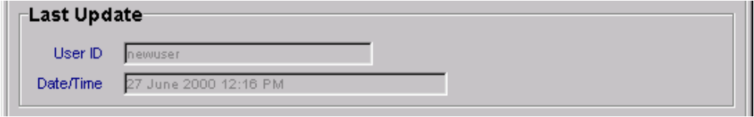
The Audit Bar

The Navigation Bar
When the User executes a search, the results are returned and displayed one record at a time. The navigation bar at the bottom of the screen identifies the total number of records returned and the User's current position within that set. In the example below, the User is viewing the 18th record in a set of 500. The arrow buttons permit the User to navigate through the records. The keyboard letters H (first record), J (previous record), K (next record), and L (last record) permit keyboard navigation through the records.
Navigation Bar

logon
The following table directs the reader to appropriate Logon subsections.
Logon Subsections |  |  | Roles
Logon Subsections | SA | PDM | SDM | TQU | PQU | PRU | DCU | FDEU | OU | DEOU | DOU | ROU | TEOU | SSU | OA | OER | FU | SDEOU
Launching the Application | X | X | X | X | X | X |  | X | X | X | X | X | X | X | X |  |  | X
Logging On | X | X | X | X | X | X |  | X | X | X | X | X | X | X | X |  |  | X
Changing a Password | X | X | X | X | X | X |  | X | X | X | X | X | X | X | X |  |  | X

Launching the Application
The TEAAS application may be launched from the Microsoft Windows 95/NT desktop. If TEAAS has been installed on the workstation, a shortcut icon should be present on the desktop. Double click the TEAAS icon to launch the application.
When TEAAS is launched, a Welcome screen will appear.
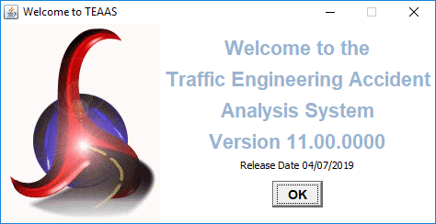
Welcome Screen
Click the OK button to close the Welcome screen. The Welcome screen will close automatically after approximately 10 seconds if OK is not clicked. After the Welcome screen closes, the Logon screen appears.
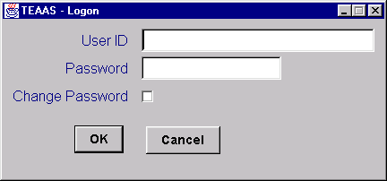
Logon Screen

Logging On
The Logon screen controls access to the application by requiring a User ID and Password. The following table describes the requirements for each field.
Field | Field Requirements
User ID | Must be a valid User ID between 4 and 20 alphanumeric characters. User ID is case sensitive.
Password | Must be a valid Password between 4 and 12 alphanumeric characters. Password is case sensitive.

Contact the DOT Help Desk if the User ID or Password is not known.
Because the User ID and Password are case sensitive, use caution to ensure they are entered exactly as assigned, then click the OK button. If the User ID and Password combination is incorrect, an error message will be displayed. A maximum of three logon attempts is allowed for any given TEAAS session. If the maximum number of attempts is exceeded, the User will be exited from TEAAS automatically.
To exit without logging on, click the Cancel button.
After logging on successfully, the Application Browser screen will appear. The Application Browser is discussed in more detail in the Application Browser section.

Changing the Password
To change the Password at logon, enter User ID and Password, click the Change Password check box, then click the OK button. The following Password Change screen will appear.
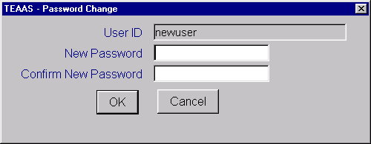
Password Change Screen

Two fields on the Password Change screen must be completed to change the Password. The following table describes the requirements for each field.
Field | Field Requirements
New Password | Must be between 4 and 12 alphanumeric characters and cannot be the same as the existing Password.
Confirm New Password | Must be identical to the New Password entry.

Make note of upper/lower case characters since Password fields are case sensitive.
After the Password fields have been entered, click the OK button. A message will confirm that the Password has been changed. If the New Password conflicts with the above business rules, an error message will appear.
To close the Password Change screen without changing the Password, click the Cancel button.
The Application Browser screen will appear after the Password Change screen is closed. The Application Browser is discussed in more detail in the Application Browser section.

About TEAAS dialog box
From any of the User Interfaces, clicking on menu Help + About shows the following dialog box:
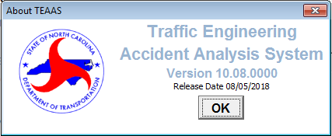
About TEAAS Screen

Application BROWSER
The following table directs the reader to appropriate Application Browser subsections.
Application Browser Subsections |  |  | Roles
Application Browser Subsections | SA | PDM | SDM | TQU | PQU | PRU | DCU | FDEU | OU | DEOU | DOU | ROU | TEOU | SSU | OA | OER | FU | SDEOU
Application Browser Overview | X | X | X | X | X | X |  | X | X | X | X | X | X | X | X |  |  | X

Application Browser Overview
The Application Browser is the control center for TEAAS. Major functions are displayed vertically on the left side of the screen as graphical buttons. When a button is selected, a text description of the function is displayed just below the Open and Exit buttons. At the same time, the list box on the right displays the sub-functions available to the User. When an item is selected from this list box, a description of the User's privileges to that sub-function is displayed at the bottom of the screen.
The Application Browser that appears after logon will resemble the figure below; however, the functions and sub-functions displayed are specific to the Role(s) assigned to the User.
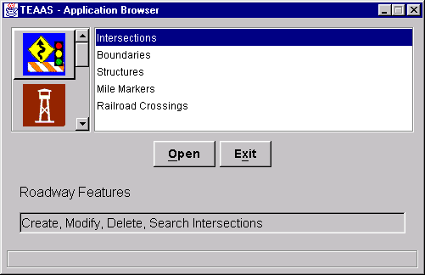
Application Browser Screen

Application Browser Functions/Sub-Functions
The following table describes each function and associated sub-function(s).
Function Button | Function Name | Sub-Functions
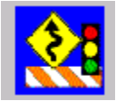 | Roadway Features | Intersections  Boundaries  Structures  Mile Markers  Railroad Crossings
 | Feature Names, Secondary Routes and Exceptions | Street and Feature Names  Secondary Routes  Street Name Exceptions  Municipality Names  Municipality Name Exceptions
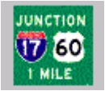 | Inventoried Routes and Highest Order Segments | Highest Order Segments  Inventoried Routes
 | Generate Public Reports | City-Wide Accident Reports  County-Wide Accident Reports
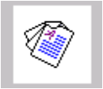 | Generate Reports | Fiche Report  Intersection Analysis Report  Strip Analysis Report  Generate Collision Diagram File  Fiche, Intersection, and Strip Reports Code Index  Features Report  Highest Order Segments Report  Ordinance Exception Report: On Road/HO Route  Ordinance Exception Report: Overlap  Ordinance Exception Report: No Milepost  Highest Order Segment Gap Report  Sliding Scale Report
 | Ordinances | Ordinances  Milepost Ordinances  Ordinance Type Maintenance
 | User Information | Users  Send An Alert Message
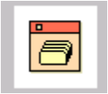 | System Administration | Milepost Items

To navigate to a particular sub-function, select that item from the list box and click the Open button. The appropriate screen or report will be displayed.
To exit the application from the Application Browser, ensure all other TEAAS screens have been closed, then click the Exit button.

Users

Send Alert Message
Users with an Administrator role will be able to see the “Send An Alert Message” subfunction.
To access the Send An Alert Message screen, select the User Information button on the Application Browser, select Send An Alert Message from the list box, and click the Open button.
Function Button | Function Name | Sub-Function
 | User Information | Send An Alert Message

When the user logs on a popup dialog will display an alert message from a TEAAS System Administrator to all users if there is a message waiting. Administrators can send an alert message by selecting the “Send An Alert Message” entry and then clicking on the Open button.
The screen that follows is displayed, though its appearance may differ slightly from the figure below.
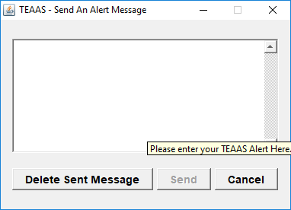

The alert message user interface consists of a multi-line text editor field where Administrators can type in the message and a Send button and a Cancel button beneath the message text field. Administrators cannot recall previously sent messages. By default, a message expires when another replaces. In the absence of a new message, the existing message will expire in 72 hours. Alternatively, administrators can delete a previously sent message by clicking on the Delete Sent Message button.

Users receive the alert message by way of a modal dialog that pops up. A new message can pop up as often as every 5 minutes and it always replaces a previous one.

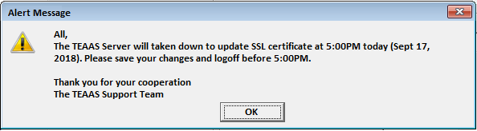

The following table directs the reader to appropriate Users subsections.
Users Subsections |  |  | Roles
Users Subsections | SA | PDM | SDM | TQU | PQU | PRU | DCU | FDEU | OU | DEOU | DOU | ROU | TEOU | SSU | OA | OER | FU | SDEOU
Send An Alert Message | X
Users Screen Overview | X | X | X | X | X | X |  | X | X | X | X | X | X | X |  |  |  | X
Searching for a User | X | X | X | X | X | X |  | X | X | X | X | X | X | X |  |  |  | X
Adding a New User | X
Maintaining User Roles | X
Maintaining User Passwords | X
Modifying an Existing User | X | X | X | X | X | X |  | X | X | X | X | X | X | X |  |  |  | X
Deleting an Existing User | X
Canceling A Users Screen Operation | X | X | X | X | X | X |  | X | X | X | X | X | X | X |  |  |  | X
Closing the Users Screen | X | X | X | X | X | X |  | X | X | X | X | X | X | X |  |  |  | X

Users Screen Overview
The Users screen is used by TEAAS System Administrator(s) to create and maintain application accounts, and by other Users to modify their User information and to search for other Users information.
To access the Users screen, select the User Information button on the Application Browser, select Users from the list box, and click the Open button.
Function Button | Function Name | Sub-Function
 | User Information | Users

The screen that follows is displayed, though its appearance may differ slightly from the figure below depending on the User's assigned Roles.
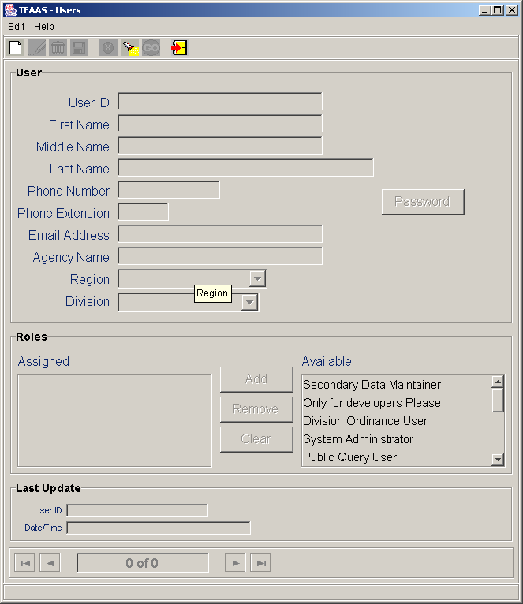
Users Screen

Searching for a User
To search for Users, click the Search icon on the toolbar. A blank screen will be presented for entering search criteria. The following table describes the search criteria allowed.
Field | Search Criteria
User ID | Enter a specific User ID or use wildcard characters to search for one or more User ID. Refer to Appendix C for a description on the use of wildcard characters. Leave User ID empty if this field is not part of the search criteria. Search is not case sensitive.
First Name | Enter a specific First Name or use wildcard characters to search for one or more First Name. Leave First Name empty if this field is not part of the search criteria. Search is not case sensitive.
Middle Name | Enter a specific Middle Name or use wildcard characters to search for one or more Middle Name. Leave Middle Name empty if this field is not part of the search criteria. Search is not case sensitive.
Last Name | Enter a specific Last Name or use wildcard characters to search for one or more Last Name. Leave Last Name empty if this field is not part of the search criteria. Search is not case sensitive.
Phone Number | Enter a specific Phone Number or use wildcard characters to search for one or more Phone Number. Leave Phone Number empty if this field is not part of the search criteria.
Phone Extension | Enter a specific Phone Extension or use wildcard characters to search for one or more Phone Extension. Leave Phone Extension empty if this field is not part of the search criteria.
Email Address | Enter a specific Email Address or use wildcard characters to search for one or more Email Address. Leave Email Address empty if this field is not part of the search criteria. Search is not case sensitive.
Agency Name | Enter a specific Agency Name or use wildcard characters to search for one or more Agency Name. Leave Agency Name empty if this field is not part of the search criteria. Search is not case sensitive.
Division | Select a specific Highway Division for a Division Ordinance User. This field can be selected only for users having a Division User role; for all other users it will be empty. Leave Division empty if this field is not part of the search criteria.
Region | Select a specific Region for a Region Ordinance User. This field can be selected only for users having Region Ordinance User role; for all other users it will be empty. Leave Region empty if this field is not part of the search criteria.

After all desired search criteria have been entered, click the Go icon on the toolbar. A dialog box will appear indicating the number of records returned. Click the OK button on the dialog box to view the records retrieved. Returned records are displayed in view mode. If the logged on users record is shown, the Phone Number, Phone Extension, Email Address, and Agency Name fields can be modified. Click on the Modify icon to modify this information.
If no records are returned, a dialog box will appear indicating such. If records were expected to be retrieved, verify that the search criteria are correct. A new search may be executed by adjusting the search criteria and clicking the Go icon.
It is recommended that the search criteria be as specific as possible to prevent the retrieval of too many records, which could contribute to local memory concerns and slower system performance. Currently, TEAAS will display a maximum of 500 records for any given search, although more than 500 records may actually meet the search criteria.

Adding a New User
To add a new User, click the New icon on the toolbar. A blank screen will be presented for entering a new User. The following table describes the requirements for each field.
Field | Field Requirements
User ID | A unique User ID of 4 - 20 characters must be entered. User ID is case sensitive.
First Name | A First Name with a maximum of 20 characters must be entered.
Middle Name | A Middle Name with a maximum of 20 characters may be entered.
Last Name | A Last Name with a maximum of 25 characters must be entered.
Phone Number | A Phone Number with a maximum of 13 characters may be entered. Parentheses and the hyphen character may be used in the Phone Number.
Phone Extension | A Phone Extension with a maximum of 5 characters may be entered.
Email Address | An Email Address with a maximum of 64 characters may be entered.
Agency Name | An Agency Name with a maximum of 64 characters may be entered.
Division | A Division must be selected for a Division Ordinance User; for all other users leave this field empty.
Region | A Region must be selected for a Region Ordinance User; for all other users leave this field empty.
To complete the new User record, a Password must be assigned, and one or more User Roles may be assigned. Refer to the Maintaining User Passwords and Maintaining User Roles subsections for more information.
After all information has been added, click the Save icon on the toolbar. If business rule conditions are not satisfied, a message will indicate the problem encountered. If all conditions are satisfied, the new User record is saved and displayed on the screen in view mode.

Maintaining User Passwords
To assign a User Password, click the Password button. The following Password Change screen will appear.
Password Change Screen

The Password Change screen will require the completion of two fields: New Password and Confirm New Password. The following table describes the requirements for each field.
Field | Field Requirements
New Password | Must be between 4 and 12 alphanumeric characters and cannot be the same as the existing Password.
Confirm New Password | Must be identical to New Password.

Make note of upper/lower case characters since Password fields are case sensitive.
After the Password fields have been entered, click the OK button to return to the Users screen. An error message will appear if the Password conflicts with any of the above business rules.
The Cancel button closes the Password Change screen without establishing the Password.
Once the User Password has been assigned or changed, the User record must be saved for the Password to be effective. Refer to the Adding a New User subsection for more information on saving a User record.

Maintaining User Roles
To assign a User a particular Role, highlight the desired Role in the Available list and click the Add button. The desired Roles will be moved to the Assigned list.
To remove an assigned Role from a User, highlight the desired Role in the Assigned list and click the Remove button. The desired Role will be removed from the Assigned list and will reappear in the Available list.
To remove all assigned Roles for a User, click the Clear button. All assigned Roles for the User will be removed from the Assigned list.
After the User Roles have been assigned or changed, the User record must be saved for the Roles to be effective. Refer to the Adding a New User subsection for more information on saving a User record.
A user can have only one of these types of Ordinance roles: Ordinance User, Data Entry Ordinance User, Division Ordinance User, Region Ordinance User, and Traffic Engineering Ordinance User. A Division must be selected for a Division Ordinance User; for all other users leave the field empty. A Region must be selected for a Region Ordinance User; for all other users leave the field empty.

Modifying an Existing User
A System Administrator may modify an existing User record when the record is displayed on the screen, either after conducting a search or immediately following a save. To modify a displayed record, click the Modify icon on the toolbar. The First Name, Middle Name, Last Name, Phone Number, Phone Extension, Email Address, and Agency Name fields are enabled for modification. Refer to the Maintaining User Roles and Maintaining User Passwords subsections for information on modifying User Roles and Passwords.
A non-System Administrator user can modify their existing User record when the record is displayed on the screen. To modify a displayed record, click the Modify icon on the toolbar. The Phone Number, Phone Extension, Email Address, and Agency Name fields are enabled for modification.
After changes are made to the User, click the Save icon on the toolbar. All business rule conditions are verified before the modified record is saved. If all conditions are satisfied, the modified User record is saved and displayed on the screen in view mode.
Refer to Adding a New User subsection for information about Region and Division fields. Refer to Maintaining User Roles subsection for requirements for Ordinance user roles.

Deleting an Existing User
An existing User record may be deleted when the record is displayed on the screen, either after conducting a search or immediately following a save. To delete a displayed record, click the Delete icon on the toolbar. A confirmation dialog box will appear. Click the Yes button to proceed with the deletion or the No button to cancel the deletion. If the deleted record was the only record previously displayed on the screen, the screen will be cleared after the delete. If multiple records were displayed, the next record will now be displayed. The record count at the bottom of the Users screen will be adjusted accordingly after the deletion.

Canceling a Users Screen Operation
The New, Modify, and Search operations may be canceled before Save or Go actions are invoked by clicking the Cancel icon on the toolbar. Cancel will return the Users screen to its previous state. For example, if a record is being modified, clicking the Cancel icon will revert the record to its previous values, displaying it in view mode.

Closing the Users Screen
To close the Users screen, click the Close icon on the toolbar. If a New or Modify operation is in progress, the User will be asked to confirm they want to close without saving. Click the Yes button to close without saving or the No button to return to the operation in progress.

street and Feature names
The following table directs the reader to appropriate Street and Feature Names subsections.
Street and Feature Names Subsections |  |  | Roles
Street and Feature Names Subsections | SA | PDM | SDM | TQU | PQU | PRU | DCU | FDEU | OU | DEOU | DOU | ROU | TEOU | SSU | OA | OER | FU | SDEOU
Street and Feature Names Screen Overview |  | X | X | X | X |  |  |  |  |  |  |  |  |  |  |  | X
Searching for a Street and Feature Name Record |  | X | X | X | X |  |  |  |  |  |  |  |  |  |  |  | X
Adding a New Street and Feature Name Record |  | X
Modifying an Existing Street and Feature Name Record |  | X
Deleting an Existing Street and Feature Name Record |  | X
Canceling a Street and Feature Names Screen Operation |  | X | X | X | X |  |  |  |  |  |  |  |  |  |  |  | X
Closing the Street and Feature Names Screen |  | X | X | X | X |  |  |  |  |  |  |  |  |  |  |  | X

Street and Feature Names Screen Overview
The Street and Feature Names screen is used to maintain the 8-digit codes and associated text for primary and secondary routes, local city streets, and political boundaries.
To access the Street and Feature Names screen, select the Feature Names, Secondary Routes and Exceptions button on the Application Browser, select Street and Feature Names from the list box, and click the Open button.
Function Button | Function Name | Sub-Function
 | Feature Names, Secondary Routes and Exceptions | Street and Feature Names

The screen that follows is displayed, though its appearance may differ slightly from the figure below depending on the User's assigned Roles.
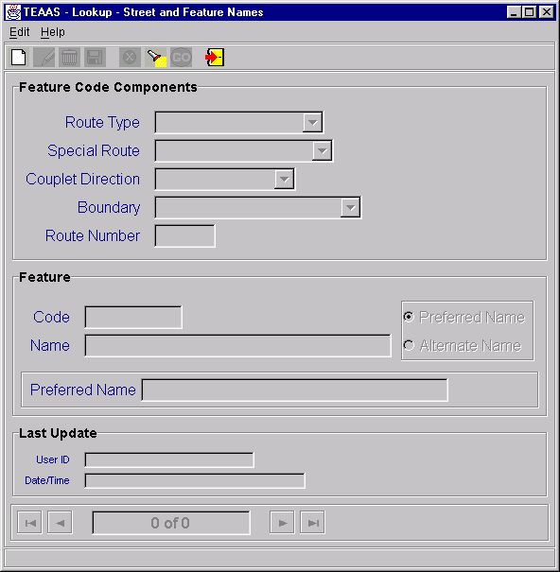
Street and Feature Names Screen

Searching for a Street and Feature Name Record
To search, click the Search icon on the toolbar. A blank screen will be presented for entering search criteria. The following table describes the search criteria allowed.
Field | Search Criteria
Route Type | Select a specific Route Type from the Route Type combo box or leave empty if this field is not part of the search criteria.
Special Route | Select a specific Special Route from the Special Route combo box or leave empty if this field is not part of the search criteria.
Couplet Direction | Select a specific Couplet Direction from the Couplet Direction combo box or leave empty if this field is not part of the search criteria.
Boundary | Select a specific Boundary from the Boundary combo box or leave empty if this field is not part of the search criteria.
Route Number | Enter a specific Route Number by entering the appropriate road code (length depends on the Route Type selected). Wildcard characters may be used to search for one or more routes. Refer to Appendix C for a description on the use of wildcard characters. Leave Route Number empty if this field is not part of the search criteria.
Name | Enter a specific Name or use wildcard characters to search for one or more Name. Leave Name empty if this field is not part of the search criteria. Search is not case sensitive.
Code | Enter a specific Code by entering the 8-digit Code. In the case of boundary features, the code is 8 characters long and consists of one of the prefixes BS (state boundary), BC (county boundary), or BM (municipality boundary) and a 6-digit number. For example, the code for the state of Georgia is BS000901 whereas the code for Wake County is BC000092. Wildcard characters may be used to search for one or more Code. Leave Code empty if this field is not part of the search criteria. Search is not case sensitive.
Preferred/Alternate Name | Enable Preferred Name or Alternate Name radio button. Leave disabled to retrieve both Preferred and Alternate spellings.

After all desired search criteria have been entered, click the Go icon on the toolbar. A dialog box will appear indicating the number of records returned. Click the OK button on the dialog box to view the records retrieved. Returned records are displayed in view mode.
If no records are returned, a dialog box will appear indicating such. If records were expected to be retrieved, verify that the search criteria are correct. A new search may be executed by adjusting the search criteria and clicking the Go icon.
It is recommended that the search criteria be as specific as possible to prevent the retrieval of too many records, which could contribute to local memory concerns and slower system performance. Currently, TEAAS will display a maximum of 500 records for any given search, although more than 500 records may actually meet the search criteria.

Adding a New Street and Feature Name Record
To add a new record, click the New icon on the toolbar. A blank screen will be presented for entering a new record. The following table describes the requirements for each field.
Field | Field Requirements
Route Type | A Route Type must be specified from the Route Type combo box. Depending on the Route Type entered, other fields will be disabled or enabled.
Special Route | A Special Route may be required, depending on the Route Type selected. If not required, Special Route will be disabled.
Couplet Direction | A Couplet Direction may be required, depending on the Route Type selected. If not required, Couplet Direction will be disabled.
Boundary | A Boundary may be required, depending on the Route Type selected. If not required, Boundary will be disabled.
Route Number | A valid Route Number may be required, depending on the Route Type selected. The length of the Route Number is also dependent on the Route Type selected. If not required, Route Number will be disabled.
Name | A Name may be required, depending on the Route Type selected. If not required, Name will be disabled.
Preferred Name/Alternate Name | The Preferred Name/Alternate Name indicator will only be required when Local Street is selected as the Route Type. A Type of Street dialog box will appear. The preferred or alternate spelling must be specified by enabling the appropriate radio button. Click the OK button to select the Type of Street or click the Cancel button to cancel the operation.

After all information has been added, click the Save icon on the toolbar. If business rule conditions are not satisfied, a message will indicate the problem encountered. If all conditions are satisfied, the new Feature Name record is saved and displayed on the screen in view mode.

Modifying an Existing Street and Feature Name Record
An existing record may be modified when the record is displayed on the screen, either after conducting a search or immediately following a save. To modify a displayed record, click the Modify icon on the toolbar. Only the Name field is enabled for a Local Street Route Type. After changes are made to this field, click the Save icon on the toolbar. All business rule conditions are verified before the modified record is saved. If all conditions are satisfied, the modified record is saved and displayed on the screen in view mode.
Modification is not permitted for any Route Type other than Local Street. If modification is required for another Route Type, delete the record (as described in the section below) and re-enter it.

Deleting an Existing Street and Feature Name Record
An existing record may be deleted when the record is displayed on the screen, either after conducting a search or immediately following a save. To delete a displayed record, click the Delete icon on the toolbar. A confirmation dialog box will appear. Click the Yes button to proceed with the deletion or the No button to cancel the deletion. If the deleted record was the only record previously displayed on the screen, the screen will be cleared after the delete. If multiple records were displayed, the next record will now be displayed. The record count at the bottom of the Street and Feature Names screen will be adjusted accordingly after the deletion.

Canceling a Street and Feature Names Screen Operation
The New, Modify, and Search operations may be canceled before Save or Go actions are invoked by clicking the Cancel icon on the toolbar. Cancel will return the Street and Feature Names screen to its previous state. For example, if a record is being modified, clicking the Cancel icon will revert the record to its previous values, displaying it in view mode.

Closing the Street and Feature Names Screen
To close the Street and Feature Names screen, click the Close icon on the toolbar. If a New or Modify operation is in progress, the User will be asked to confirm they want to close without saving. Click the Yes button to close without saving or the No button to return to the operation in progress.

inventoried Routes
The following table directs the reader to appropriate Inventoried Routes subsections.
Inventoried Routes Subsections |  |  | Roles
Inventoried Routes Subsections | SA | PDM | SDM | TQU | PQU | PRU | DCU | FDEU | OU | DEOU | DOU | ROU | TEOU | SSU | OA | OER | FU | SDEOU
Inventoried Routes Screen Overview |  | X | X | X | X |  |  |  |  |  |  |  |  |  |  |  | X
Searching for an Inventoried Route Record |  | X | X | X | X |  |  |  |  |  |  |  |  |  |  |  | X
Adding a New Inventoried Route Record |  | X | X
Modifying an Existing Inventoried Route Record |  | X | X
Deleting an Existing Inventoried Route Record |  | X | X
Canceling an Inventoried Routes Screen Operation |  | X | X | X | X |  |  |  |  |  |  |  |  |  |  |  | X
Launching the Features Report |  | X | X | X | X |  |  |  |  |  |  |  |  |  |  |  | X
Launching the Highest Order Segments Report |  | X | X | X | X |  |  |  |  |  |  |  |  |  |  |  | X
Viewing Boundary Records |  | X | X | X | X |  |  |  |  |  |  |  |  |  |  |  | X
Viewing Highest Order Segments Records |  | X | X | X | X |  |  |  |  |  |  |  |  |  |  |  | X
Viewing Intersection Records |  | X | X | X | X |  |  |  |  |  |  |  |  |  |  |  | X
Viewing Mile Marker Records |  | X | X | X | X |  |  |  |  |  |  |  |  |  |  |  | X
Viewing Railroad Crossing Records |  | X | X | X | X |  |  |  |  |  |  |  |  |  |  |  | X
Viewing Structure Records |  | X | X | X | X |  |  |  |  |  |  |  |  |  |  |  | X
Adding a Boundary Record |  | X | X
Adding a Highest Order Segment Record |  | X | X
Adding an Intersection Record |  | X | X
Adding a Mile Marker Record |  | X | X
Adding a Railroad Crossing Record |  | X | X
Adding a Structure Record |  | X | X
Closing the Inventoried Routes Screen |  | X | X | X | X |  |  |  |  |  |  |  |  |  |  |  | X

Inventoried Routes Screen Overview
The Inventoried Routes screen is used to maintain information on county routes and local streets that have been inventoried either for features or roadway characteristics.
To access the Inventoried Routes screen, select the Inventoried Routes and Highest Order Segments button on the Application Browser, select Inventoried Routes from the list box, and click the Open button.
Function Button | Function Name | Sub-Function
 | Inventoried Routes and Highest Order Segments | Inventoried Routes

The screen that follows is displayed, though its appearance may differ slightly from the figure below depending on the User's assigned Roles.
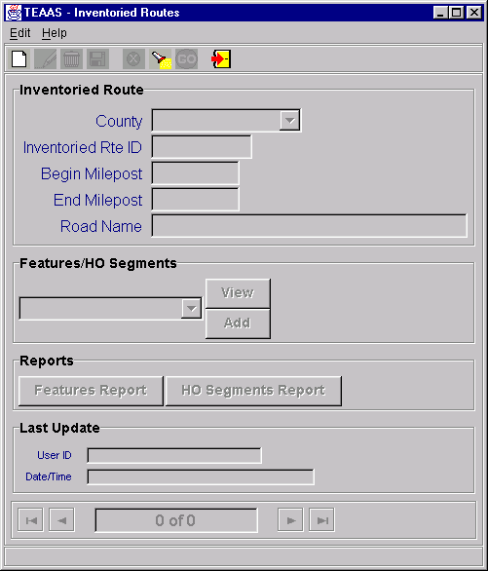
Inventoried Routes Screen

Searching for an Inventoried Route Record
To search for Inventoried Route records, click the Search icon on the toolbar. A blank screen will be presented for entering search criteria. The following table describes the search criteria allowed.
Field | Search Criteria
County | Select a specific County from the County combo box or leave empty if this field is not part of the search criteria.
Inventoried Rte ID | Enter a specific Inventoried Rte ID by entering the 8-digit road code. Wildcard characters may be used to search for one or more Inventoried Rte ID. Refer to Appendix C for a description on the use of wildcard characters. Leave Inventoried Rte ID empty if this field is not part of the search criteria.
Begin Milepost | Enter a specific Begin Milepost value or leave empty if this field is not part of the search criteria.
End Milepost | Enter a specific End Milepost value or leave empty if this field is not part of the search criteria.
Road Name | Road Name is not allowed as a search parameter.

After all desired search criteria have been entered, click the Go icon on the toolbar. A dialog box will appear indicating the number of records returned. Click the OK button on the dialog box to view the records retrieved. Returned records are displayed in view mode.
If no records are returned, a dialog box will appear indicating such. If records were expected to be retrieved, verify that the search criteria are correct. A new search may be executed by adjusting the search criteria and clicking the Go icon.
It is recommended that the search criteria be as specific as possible to prevent the retrieval of too many records, which could contribute to local memory concerns and slower system performance. Currently, TEAAS will display a maximum of 500 records for any given search, although more than 500 records may actually meet the search criteria.

Adding a New Inventoried Route Record
To add a new Inventoried Route record, click the New icon on the toolbar. A blank screen will be presented for entering a new record. The following table describes the requirements for each field.
Field | Field Requirements
County | A County must be selected from the County combo box.
Inventoried Rte ID | A valid 8-digit Inventoried Rte ID for the County must be specified. The Inventoried Rte ID must already exist as a Feature Code.
Begin Milepost | The Begin Milepost value of the Inventoried Route must be entered in the format 999.999. Leading and trailing zeroes may be omitted.
End Milepost | The End Milepost value of the Inventoried Route must be entered in the format 999.999. Leading and trailing zeroes may be omitted.
Road Name | Road Name is not enabled for data entry. Upon saving, Road Name will be populated by the system with the Feature Name that corresponds to the entered Inventoried Rte ID.

After all information has been added, click the Save icon on the toolbar. If business rule conditions are not satisfied, a message will indicate the problem encountered. If all conditions are satisfied, the new Inventoried Route record is saved and displayed on the screen in view mode.

Modifying an Existing Inventoried Route Record
An existing Inventoried Route record may be modified when the record is displayed on the screen, either after conducting a search or immediately following a save. To modify a displayed record, click the Modify icon on the toolbar. Only the Milepost End field is enabled for modification. After changes are made to this field, click the Save icon on the toolbar. All business rule conditions are verified before the modified record is saved. If all conditions are satisfied, the modified Inventoried Route record is saved and displayed on the screen in view mode.

Deleting an Existing Inventoried Route Record
An existing Inventoried Route record may be deleted when the record is displayed on the screen, either after conducting a search or immediately following a save. To delete a displayed record, click the Delete icon on the toolbar. A confirmation dialog box will appear. Click the Yes button to proceed with the deletion or the No button to cancel the deletion. If the deleted record was the only record previously displayed on the screen, the screen will be cleared after the delete. If multiple records were displayed, the next record will now be displayed. The record count at the bottom of the Inventoried Routes screen will be adjusted accordingly after the deletion.

Canceling an Inventoried Routes Screen Operation
The New, Modify, and Search operations may be canceled before Save or Go actions are invoked by clicking the Cancel icon on the toolbar. Cancel will return the Inventoried Routes screen to its previous state. For example, if a record is being modified, clicking the Cancel icon will revert the record to its previous values, displaying it in view mode.

Launching the Features Report
The Features report may be launched from the Inventoried Routes screen by clicking the Features Report button after an existing Inventoried Route record appears in view mode. The report will take the displayed County, Inventoried Route, and Begin Milepost as its selection criteria. Refer to the Features Report section for more information regarding this report.

Launching the Highest Order Segments Report
The Highest Order Segments report may be launched from the Inventoried Routes screen by clicking the HO Segments Report button after an existing Inventoried Route record appears in view mode. The report will take the displayed County, Inventoried Route, and Begin Milepost as its selection criteria. Refer to the Highest Order Segments Report section for more information regarding this report.

Viewing Boundary Records
The Boundaries screen may be launched from the Inventoried Routes screen when an existing Inventoried Route record appears in view mode. Select Boundaries from the Features/HO Segments combo box and click the View button. The Boundaries screen is launched and a search is automatically performed to retrieve all Boundary records for the specified County, Inventoried Route, and Begin Milepost combination. Refer to the Boundaries section for more information regarding the Boundaries screen.

Viewing Highest Order Segment Records
The Highest Order Segments screen may be launched from the Inventoried Routes screen when an existing Inventoried Route record appears in view mode. Select Highest Order Segments from the Features/HO Segments combo box and click the View button. The Highest Order Segments screen is launched and a search is automatically performed to retrieve all Highest Order Segment records for the specified County, Inventoried Route, and Begin Milepost combination. Refer to the Highest Order Segments section for more information regarding the Highest Order Segments screen.

Viewing Intersection Records
The Intersections screen may be launched from the Inventoried Routes screen when an existing Inventoried Route record appears in view mode. Select Intersections from the Features/HO Segments combo box and click the View button. The Intersections screen is launched and a search is automatically performed to retrieve all Intersection records for the specified County, Inventoried Route, and Begin Milepost combination. Refer to the Intersections section for more information regarding the Intersections screen.

Viewing Mile Marker Records
The Mile Markers screen may be launched from the Inventoried Routes screen when an existing Inventoried Route record appears in view mode. Select Mile Markers from the Features/HO Segments combo box and click the View button. The Mile Markers screen is launched and a search is automatically performed to retrieve all Mile Marker records for the specified County, Inventoried Route, and Begin Milepost combination. Refer to the Mile Markers section for more information regarding the Mile Markers screen.

Viewing Railroad Crossing Records
The Railroad Crossings screen may be launched from the Inventoried Routes screen when an existing Inventoried Route record appears in view mode. Select Railroad Crossings from the Features/HO Segments combo box and click the View button. The Railroad Crossings screen is launched and a search is automatically performed to retrieve all Railroad Crossing records for the specified County, Inventoried Route, and Begin Milepost combination. Refer to the Railroad Crossings section for more information regarding the Railroad Crossings screen.

Viewing Structure Records
The Structures screen may be launched from the Inventoried Routes screen when an existing Inventoried Route record appears in view mode. Select Structures from the Features/HO Segments combo box and click the View button. The Structures screen is launched and a search is automatically performed to retrieve all Structure records for the specified County, Inventoried Route, and Begin Milepost combination. Refer to the Structures section for more information regarding the Structures screen.

Adding a Boundary Record
The Boundaries screen may be launched from the Inventoried Routes screen when an existing Inventoried Route record appears in view mode. Select Boundaries from the Features/HO Segments combo box and click the Add button. A blank Boundaries screen is opened to allow the addition of a new Boundary record for the County, Inventoried Route, and Begin Milepost combination. Refer to the Boundaries section for more information regarding the Boundaries screen.

Adding a Highest Order Segment Record
The Highest Order Segments screen may be launched from the Inventoried Routes screen when an existing Inventoried Route record appears in view mode. Select Highest Order Segments from the Features/HO Segments combo box and click the Add button. A blank Highest Order Segments screen is opened to allow the addition of a new Highest Order Segment record for the County, Inventoried Route, and Begin Milepost combination. Refer to the Highest Order Segments section for more information regarding the Highest Order Segments screen.

Adding an Intersection Record
The Intersections screen may be launched from the Inventoried Routes screen when an existing Inventoried Route record appears in view mode. Select Intersections from the Features/HO Segments combo box and click the Add button. A blank Intersections screen is opened to allow the addition of a new Intersection record for the County, Inventoried Route, and Begin Milepost combination. Refer to the Intersections section for more information regarding the Intersections screen.

Adding a Mile Marker Record
The Mile Markers screen may be launched from the Inventoried Routes screen when an existing Inventoried Route record appears in view mode. Select Mile Markers from the Features/HO Segments combo box and click the Add button. A blank Mile Markers screen is opened to allow the addition of a new Mile Marker record for the County, Inventoried Route, and Begin Milepost combination. Refer to the Mile Markers section for more information regarding the Mile Markers screen.

Adding a Railroad Crossing Record
The Railroad Crossings screen may be launched from the Inventoried Routes screen when an existing Inventoried Route record appears in view mode. Select Railroad Crossings from the Features/HO Segments combo box and click the Add button. A blank Railroad Crossings screen is opened to allow the addition of a new Railroad Crossing record for the County, Inventoried Route, and Milepost Begin combination. Refer to the Railroad Crossings section for more information regarding the Railroad Crossings screen.

Adding a Structure Record
The Structures screen may be launched from the Inventoried Routes screen when an existing Inventoried Route record appears in view mode. Select Structures from the Features/HO Segments combo box and click the Add button. A blank Structures screen is opened to allow the addition of new Structure record for the County, Inventoried Route, and Begin Milepost combination. Refer to the Structures section for more information regarding the Structures screen.

Closing the Inventoried Routes Screen
To close the Inventoried Routes screen, click the Close icon on the toolbar. If a New or Modify operation is in progress, the User will be asked to confirm they want to close without saving. Click the Yes button to close without saving or the No button to return to the operation in progress.

Highest order segments
The following table directs the reader to appropriate Highest Order Segments subsections.
Highest Order Segments Subsections |  |  | Roles
Highest Order Segments Subsections | SA | PDM | SDM | TQU | PQU | PRU | DCU | FDEU | OU | DEOU | DOU | ROU | TEOU | SSU | OA | OER | FU | SDEOU
Highest Order Segments Screen Overview |  | X | X | X | X |  |  |  |  |  |  |  |  |  |  |  | X
Searching for a Highest Order Segment Record |  | X | X | X | X |  |  |  |  |  |  |  |  |  |  |  | X
Adding a New Highest Order Segment Record |  | X | X
Modifying an Existing Highest Order Segment Record |  | X | X
Deleting an Existing Highest Order Segment Record |  | X | X
Canceling a Highest Order Segments Screen Operation |  | X | X | X | X |  |  |  |  |  |  |  |  |  |  |  | X
Closing the Highest Order Segments Screen |  | X | X | X | X |  |  |  |  |  |  |  |  |  |  |  | X

Highest Order Segments Screen Overview
The Highest Order Segments screen is used to identify the Highest Order Route coinciding with the Inventoried Route for any given segment of the roadway.
To access the Highest Order Segments screen, select the Inventoried Routes and Highest Order Segments button on the Application Browser, select Highest Order Segments from the list box, and click the Open button.
Function Button | Function Name | Sub-Function
 | Inventoried Routes and Highest Order Segments | Highest Order Segments

Highest Order Segments can also be accessed from the Inventoried Routes screen. Refer to the Inventoried Routes section for a description on accessing the Highest Order Segments screen in that manner.
The screen that follows is displayed, though its appearance may differ slightly from the figure below depending on the User's assigned Roles.
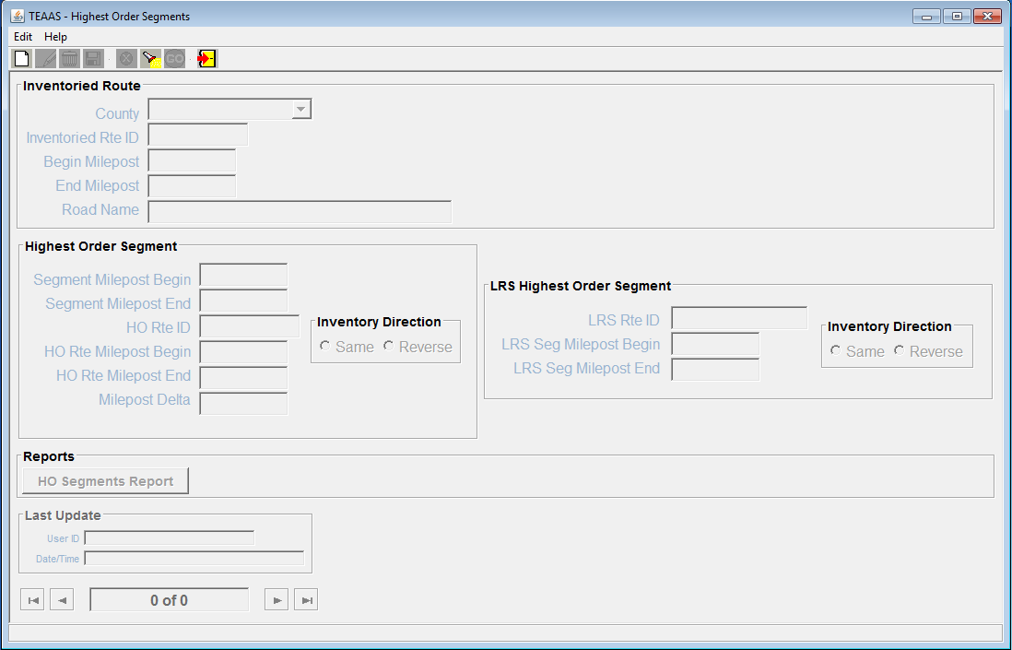
Highest Order Segments Screen

Searching for a Highest Order Segment Record
To search for Highest Order Segment records, click the Search icon on the toolbar. A blank screen will be presented for entering search criteria. The following table describes the search criteria allowed.
Field | Search Criteria
County | Select a specific County from the County combo box or leave empty if this field is not part of the search criteria.
Inventoried Rte ID | Enter a specific Inventoried Rte ID by entering the 8-digit road code. Wildcard characters may be used to search for one or more Inventoried Rte ID. Refer to Appendix C for a description on the use of wildcard characters. Leave Inventoried Rte ID empty if this field is not part of the search criteria.
Begin Milepost | Enter a specific Begin Milepost value or leave empty if this field is not part of the search criteria.
End Milepost | End Milepost is not allowed as a search parameter.
Road Name | Road Name is not allowed as a search parameter.
Segment Milepost Begin | Enter a specific Segment Milepost Begin value or leave empty if this field is not part of the search criteria.
Segment Milepost End | Enter a specific Segment Milepost End value or leave empty if this field is not part of the search criteria.
HO Rte ID | Enter a specific HO Rte ID by entering an 8-digit road code. Wildcard characters may be used to search for one or more HO Rte ID. Leave HO Rte ID empty if this field is not part of the search criteria.
HO Rte Milepost Begin | Enter a specific HO Rte Milepost Begin value or leave empty if this field is not part of the search criteria.
HO Rte Milepost End | HO Rte Milepost End is not allowed as a search parameter.
Milepost Delta | Milepost Delta is not allowed as a search parameter.
Inventoried Direction | Inventoried Direction is not allowed as a search parameter.
LRS Rte ID | Enter a specific LRS Rte ID linked to the HO Segment
LRS Seg Milepost Begin | Enter a specific LRS Segment begin milepost number
LRS Seg Milepost End | Enter a specific LRS Segment end milepost number
LRS Inventory Direction | LRS Inventory Direction is not allowed as a search parameter.

After all desired search criteria have been entered, click the Go icon on the toolbar. A dialog box will appear indicating the number of records returned. Click the OK button on the dialog box to view the records retrieved. Returned records are displayed in view mode.
If no records are returned, a dialog box will appear indicating such. If records were expected to be retrieved, verify that the search criteria are correct. A new search may be executed by adjusting the search criteria and clicking the Go icon.
It is recommended that the search criteria be as specific as possible to prevent the retrieval of too many records, which could contribute to local memory concerns and slower system performance. Currently, TEAAS will display a maximum of 500 records for any given search, although more than 500 records may actually meet the search criteria.

Adding a New Highest Order Segment Record
To add a new Highest Order Segment record, click the New icon on the toolbar. A blank screen will be presented for entering a new record. The following table describes the requirements for each field.
Field | Field Requirements
County | A County must be selected from the County combo box.
Inventoried Rte ID | A valid 8-digit Inventoried Rte ID for the County must be specified. The Inventoried Rte ID must already exist as an Inventoried Route in the selected County.
Begin Milepost | The Begin Milepost value of the Inventoried Route must be entered in the format 999.999. Leading and trailing zeroes may be omitted.
End Milepost | The End Milepost value of the Inventoried Route will automatically be populated from the Inventoried Route table.
Segment Milepost Begin | The beginning milepost location of the Inventoried Route segment must be entered in the format 999.999. Leading and trailing zeroes may be omitted.
Segment Milepost End | The ending milepost location of the Inventoried Route segment must be entered in the format 999.999. Leading and trailing zeroes may be omitted.
Road Name | Road Name is not enabled for data entry. Upon saving, Road Name will be populated by the system with the Feature Name that corresponds to the entered Inventoried Rte ID.
HO Rte ID | A valid 8-digit code must be specified. The HO Rte ID must already exist as an Inventoried Route.
HO Rte Milepost Begin | The beginning milepost location on the Highest Order Route for the Inventoried Route segment must be entered in the format 999.999. Leading and trailing zeroes may be omitted.
HO Rte Milepost End | The ending milepost location on the Highest Order Route for the Inventoried Route is maintained by the system and is determined using the Segment Milepost End and the Inventoried Direction.
Milepost Delta | The Milepost Delta is maintained by the system and is determined using the Segment Milepost End and the Inventoried Direction.
Inventoried Direction | The Inventoried Direction must be specified as:  Same – Both the Inventoried Route and Highest Order Route were inventoried in the same direction.  Reverse – The Inventoried Route and the Highest Order Route were inventoried in opposite directions.
LRS Rte ID | The LRS non-system Route ID. It must be 11 digits where the last three digits must match the county number.
LRS Seg Milepost Begin | The LRS Segment Milepost Begin number. It must be entered in the format 999.999. Leading and trailing zeroes may be omitted.
LRS Seg Milepost End | The LRS Segment Milepost End number. It must be entered in the format 999.999. Leading and trailing zeroes may be omitted.
LRS Inventory Direction | The LRS route’s Inventory Direction:  Same – Both the LRS non-system Route and Highest Order Route were inventoried in the same direction.  Reverse – The LRS non-system Route and the Highest Order Route were inventoried in opposite direction.
After all information has been added, click the Save icon on the toolbar. If business rule conditions are not satisfied, a message will indicate the problem encountered. If all conditions are satisfied, the new Highest Order Segment record is saved and displayed on the screen in view mode.

Modifying an Existing Highest Order Segment Record
An existing Highest Order Segment record may be modified when the record is displayed on the screen, either after conducting a search or immediately following a save. To modify a displayed record, click the Modify icon on the toolbar. Only the Segment Milepost Begin, Segment Milepost End, HO Rte ID, HO Rte Milepost Begin, and Inventoried Direction fields are enabled for modification. After changes are made to these fields, click the Save icon on the toolbar. All business rule conditions are verified before the modified record is saved. If all conditions are satisfied, the modified Highest Order Segment record is saved and displayed on the screen in view mode.

Deleting an Existing Highest Order Segment Record
An existing Highest Order Segment record may be deleted when the record is displayed on the screen, either after conducting a search or immediately following a save. To delete a displayed record, click the Delete icon on the toolbar. A confirmation dialog box will appear. Click the Yes button to proceed with the deletion or the No button to cancel the deletion. If the deleted record was the only record previously displayed on the screen, the screen will be cleared after the delete. If multiple records were displayed, the next record will now be displayed. The record count at the bottom of the Highest Order Segments screen will be adjusted accordingly after the deletion.

Canceling a Highest Order Segments Screen Operation
The New, Modify, and Search operations may be canceled before Save or Go actions are invoked by clicking the Cancel icon on the toolbar. Cancel will return the Highest Order Segments screen to its previous state. For example, if a record is being modified, clicking the Cancel icon will revert the record to its previous values, displaying it in view mode.

Launching the Highest Order Segments Report
The Highest Order Segments report may be launched from the Highest Order Segments screen by clicking the HO Segments Report button after an existing Highest Order Route record appears in view mode. The report will take the displayed County, Inventoried Route, and Begin Milepost as its selection criteria. Refer to the Highest Order Segments Report section for more information regarding this report.

Closing the Highest Order Segments Screen
To close the Highest Order Segments screen, click the Close icon on the toolbar. If a New or Modify operation is in progress, the User will be asked to confirm they want to close without saving. Click the Yes button to close without saving or the No button to return to the operation in progress.

Intersections
The following table directs the reader to appropriate Intersections subsections.
INTERSECTIONS Subsections |  |  | Roles
INTERSECTIONS Subsections | SA | PDM | SDM | TQU | PQU | PRU | DCU | FDEU | OU | DEOU | DOU | ROU | TEOU | SSU | OA | O  ER | FU | SDEOU
Intersections Screen Overview |  | X | X | X | X |  |  | X |  |  |  |  |  |  |  |  | X
Searching for an Intersection Record |  | X | X | X | X |  |  | X |  |  |  |  |  |  |  |  | X
Adding a New Intersection Record |  | X | X |  |  |  |  | X
Modifying an Existing Intersection Record |  | X | X |  |  |  |  | X
Deleting an Existing Intersection Record |  | X | X |  |  |  |  | X
Canceling a Intersections Screen Operation |  | X | X | X | X |  |  | X |  |  |  |  |  |  |  |  | X
Launching a Features Report |  | X | X | X | X |  |  | X |  |  |  |  |  |  |  |  | X
Closing the Intersections Screen |  | X | X | X | X |  |  | X |  |  |  |  |  |  |  |  | X

Intersections Screen Overview
The Intersections screen is used to maintain location information for Intersections on the Inventoried Route.
To access the Intersections screen, select the Roadway Features button on the Application Browser, select Intersections from the list box, and click the Open button.
Function Button | Function Name | Sub-Function
 | Roadway Features | Intersections

Intersections can also be accessed from the Inventoried Routes screen. Refer to the Inventoried Routes section for a description on accessing Features screens in that manner.
The screen that follows is displayed, though its appearance may differ slightly from the figure below depending on the User's assigned Roles.
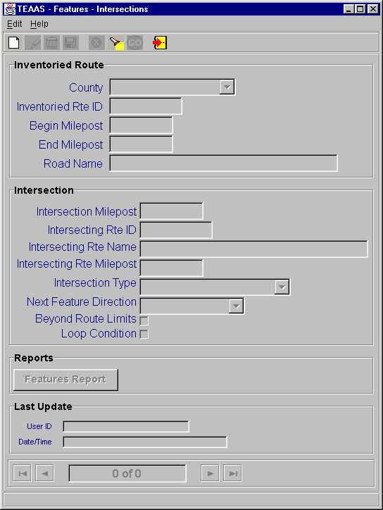
Intersections Screen

Searching for an Intersection Record
To search for Intersection records, click the Search icon on the toolbar. A blank screen will be presented for entering search criteria. The following table describes the search criteria allowed.
Field | Search Criteria
County | Select a specific County from the County combo box or leave empty if this field is not part of the search criteria.
Inventoried Rte ID | Enter a specific Inventoried Rte ID by entering the 8-digit road code. Wildcard characters may be used to search for one or more Inventoried Rte ID. Refer to Appendix C for a description on the use of wildcard characters. Leave Inventoried Rte ID empty if this field is not part of the search criteria.
Begin Milepost | Enter a specific Begin Milepost value or leave empty if this field is not part of the search criteria.
End Milepost | End Milepost is not allowed as a search parameter.
Road Name | Road Name is not allowed as a search parameter.
Intersection Milepost | Enter a specific Intersection Milepost value or leave empty if this field is not part of the search criteria.
Intersecting Rte ID | Enter a specific Intersecting Rte ID by entering an 8-digit road code. Wildcard characters may be used to search for one or more Intersecting Rte ID. Leave Intersecting Rte ID empty if this field is not part of the search criteria.
Intersecting Rte Name | Intersecting Rte Name is not allowed as a search parameter.
Intersecting Rte Milepost | Intersecting Rte Milepost is not allowed as a search parameter.
Intersection Type | Select a specific Intersection Type from the Intersection Type combo box or leave empty if this field is not part of the search criteria.
Next Feature Direction | Select a specific Next Feature Direction from the Next Feature Direction combo box or leave empty if this field is not part of the search criteria.
Beyond Route Limits | Beyond Route Limits indicator is not allowed as a search parameter.
Loop Condition | Loop Condition indicator is not allowed as a search parameter.

After all desired search criteria have been entered, click the Go icon on the toolbar. A dialog box will appear indicating the number of records returned. Click the OK button on the dialog box to view the records retrieved. Returned records are displayed in view mode.
If no records are returned, a dialog box will appear indicating such. If records were expected to be retrieved, verify that the search criteria are correct. A new search may be executed by adjusting the search criteria and clicking the Go icon.
It is recommended that the search criteria be as specific as possible to prevent the retrieval of too many records, which could contribute to local memory concerns and slower system performance. Currently, TEAAS will display a maximum of 500 records for any given search, although more than 500 records may actually meet the search criteria.

Adding a New Intersection Record
To add a new Intersection record, click the New icon on the toolbar. A blank screen will be presented for entering a new record. The following table describes the requirements for each field.
Field | Field Requirements
County | A County must be selected from the County combo box.
Inventoried Rte ID | A valid 8-digit Inventoried Rte ID for the County must be specified. The Inventoried Rte ID must already exist as an Inventoried Route in the selected County.
Begin Milepost | The Begin Milepost value of the Inventoried Route must be entered in the format 999.999. Leading and trailing zeroes may be omitted.
End Milepost | The End Milepost value of the Inventoried Route will automatically be populated from the Inventoried Route table.
Road Name | Road Name is not enabled for data entry. Upon saving, Road Name will be populated by the system with the Feature Name that corresponds to the entered Inventoried Rte ID.
Intersection Milepost | The location of the Intersection must be entered in the format 999.999. Leading and trailing zeroes may be omitted.
Intersecting Rte ID | A valid 8-digit Intersecting Rte ID must be specified. The Intersecting Rte ID must already exist as a Feature Code.
Intersecting Rte Name | The name associated with the Intersecting Rte ID. This field is read only and will not accept data entry.
Intersecting Rte Milepost | Intersecting Rte Milepost is disabled for data entry. Intersecting Rte Milepost is maintained by the system and is populated if the Intersecting Rte ID has only one corresponding Intersection record for the Inventoried Rte in the selected County.
Intersection Type | An Intersection Type must be selected from the Intersection Type combo box.
Next Feature Direction | A Next Feature Direction must be selected from the Next Feature Direction combo box.
Beyond Route Limits | Select the Beyond Route Limits indicator only if the Intersection Milepost value is outside the range of the begin and end milepost of the Inventoried Rte ID.
Loop Condition | Loop Condition is disabled for data entry. Loop Condition is maintained by the system and the checkbox is marked if the County, Inventoried Route ID, Begin Milepost, and Intersecting Rte ID combination exists more than once.

After all information has been added, click the Save icon on the toolbar. If business rule conditions are not satisfied, a message will indicate the problem encountered. If all conditions are satisfied, the new Intersection record is saved and displayed on the screen in view mode.

Modifying an Existing Intersection Record
An existing Intersection record may be modified when the record is displayed on the screen, either after conducting a search or immediately following a save. To modify a displayed record, click the Modify icon on the toolbar. The Intersection Milepost, Intersection Type, Next Feature Direction, and Beyond Route Limits fields are enabled for modification. After changes are made to these fields, click the Save icon on the toolbar. All business rule conditions are verified before the modified record is saved. If all conditions are satisfied, the modified Intersection record is saved and displayed on the screen in view mode.

Deleting an Existing Intersection Record
An existing Intersection record may be deleted when the record is displayed on the screen, either after conducting a search or immediately following a save. To delete a displayed record, click the Delete icon on the toolbar. A confirmation dialog box will appear. Click the Yes button to proceed with the deletion or the No button to cancel the deletion. If the deleted record was the only record previously displayed on the screen, the screen will be cleared after the delete. If multiple records were displayed, the next record will now be displayed. The record count at the bottom of the Intersections screen will be adjusted accordingly after the deletion.

Canceling an Intersections Screen Operation
The New, Modify, and Search operations may be canceled before Save or Go actions are invoked by clicking the Cancel icon on the toolbar. Cancel will return the Intersections screen to its previous state. For example, if a record is being modified, clicking the Cancel icon will revert the record to its previous values, displaying it in view mode.

Launching the Features Report
The Features report may be launched from the Intersections screen by clicking the Features Report button after an existing Intersection record appears in view mode. The report will take the displayed County, Inventoried Route, and Begin Milepost as its selection criteria. Refer to the Features Report section for more information regarding this report.

Closing the Intersections Screen
To close the Intersections screen, click the Close icon on the toolbar. If a New or Modify operation is in progress, the User will be asked to confirm they want to close without saving. Click the Yes button to close without saving or the No button to return to the operation in progress.

Boundaries
The following table directs the reader to appropriate Boundaries subsections.
BOUNDARIES Subsections | Roles
BOUNDARIES Subsections | SA | PDM | SDM | TQU | PQU | PRU | DCU | FDEU | OU | DEOU | DOU | ROU | TEOU | SSU | OA | SDEOU
Boundaries Screen Overview |  | X | X | X | X |  |  | X
Searching for a Boundary Record |  | X | X | X | X |  |  | X
Adding a New Boundary Record |  | X | X |  |  |  |  | X
Modifying an Existing Boundary Record |  | X | X |  |  |  |  | X
Deleting an Existing Boundary Record |  | X | X |  |  |  |  | X
Canceling a Boundaries Screen Operation |  | X | X | X | X |  |  | X
Launching the Features Report |  | X | X | X | X |  |  | X
Closing the Boundaries Screen |  | X | X | X | X |  |  | X

Boundaries Screen Overview
The Boundaries screen is used to maintain location information for political boundaries that cross the Inventoried Route.
To access the Boundaries screen, select the Roadway Features button on the Application Browser, select Boundaries from the list box, and click the Open button.
Function Button | Function Name | Sub-Function
 | Roadway Features | Boundaries

Boundaries can also be accessed from the Inventoried Routes screen. Refer to the Inventoried Routes section for a description on accessing Features screens in that manner.
The screen that follows is displayed, though its appearance may differ slightly from the figure below depending on the User's assigned Roles.
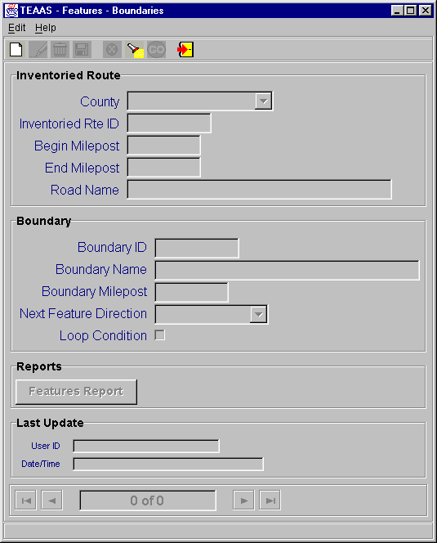
Boundaries Screen

Searching for a Boundary Record
To search for Boundary records, click the Search icon on the toolbar. A blank screen will be presented for entering search criteria. The following table describes the search criteria allowed.
Field | Search Criteria
County | Select a specific County from the County combo box or leave empty if this field is not part of the search criteria.
Inventoried Rte ID | Enter a specific Inventoried Rte ID by entering the 8-digit road code. Wildcard characters may be used to search for one or more Inventoried Rte ID. Refer to Appendix C for a description on the use of wildcard characters. Leave Inventoried Rte ID empty if this field is not part of the search criteria.
Begin Milepost | Enter a specific Begin Milepost value or leave empty if this field is not part of the search criteria.
End Milepost | End Milepost is not allowed as a search parameter.
Road Name | Road Name is not allowed as a search parameter.
Boundary ID | Enter a specific Boundary ID by entering an 8-character long Boundary code, which consists of one of the prefixes BS (state boundary), BC (county boundary), BM (municipality boundary). For example, the code for the state of Georgia is BS000901 and for Wake County is BC000092. Wildcard characters may be used to search for one or more Boundary IDs. Leave Boundary ID empty if this field is not part of the search criteria. Search is not case sensitive.
Boundary Name | Boundary Name is not allowed as a search parameter.
Boundary Milepost | Enter a specific Boundary Milepost value or leave empty if this field is not part of the search criteria.
Next Feature Direction | Select a specific Next Feature Direction from the Next Feature Direction combo box or leave empty if this field is not part of the search criteria.
Loop Condition | Loop Condition indicator is not allowed as a search parameter.

After all desired search criteria have been entered, click the Go icon on the toolbar. A dialog box will appear indicating the number of records returned. Click the OK button on the dialog box to view the records retrieved. Returned records are displayed in view mode.
If no records are returned, a dialog box will appear indicating such. If records were expected to be retrieved, verify that the search criteria are correct. A new search may be executed by adjusting the search criteria and clicking the Go icon.
It is recommended that the search criteria be as specific as possible to prevent the retrieval of too many records, which could contribute to local memory concerns and slower system performance. Currently, TEAAS will display a maximum of 500 records for any given search, although more than 500 records may actually meet the search criteria.

Adding a New Boundary Record
To add a new Boundary record, click the New icon on the toolbar. A blank screen will be presented for entering a new record. The following table describes the requirements for each field.
Field | Field Requirements
County | A County must be selected from the County combo box.
Inventoried Rte ID | A valid 8-digit Inventoried Rte ID for the County must be specified. The Inventoried Rte ID must already exist as an Inventoried Route in the selected County.
Begin Milepost | The Begin Milepost value of the Inventoried Route must be entered in the format 999.999. Leading and trailing zeroes may be omitted.
End Milepost | The End Milepost value of the Inventoried Route will automatically be populated from the Inventoried Route table.
Road Name | Road Name is not enabled for data entry. Upon saving, Road Name will be populated by the system with the Feature Name that corresponds to the entered Inventoried Rte ID.
Boundary ID | A valid 8-character alphanumeric Boundary ID must be specified. It must consist of one of the prefixes BS (state boundary), BC (county boundary), BM (municipality boundary) and a 6-digit number. For example, the code for the state of Georgia is BS000901 and for Wake County is BC000092. The Boundary ID must already exist as a Feature Code.
Boundary Name | The name associated with the Boundary ID. Boundary Name is read only and will not accept data entry.
Boundary Milepost | The location of the Boundary must be entered in the format 999.999. Leading and trailing zeroes may be omitted.
Next Feature Direction | A Next Feature Direction must be selected from the Next Feature Direction combo box.
Loop Condition | Loop Condition indicator is disabled for data entry. Loop Condition is maintained by the system and the checkbox is marked if the County, Inventoried Route ID, Begin Milepost, and Boundary ID combination exists more than once.

After all information has been added, click the Save icon on the toolbar. If business rule conditions are not satisfied, a message will indicate the problem encountered. If conditions are satisfied, the new record is saved and displayed on the screen in view mode.

Modifying an Existing Boundary Record
An existing Boundary record may be modified when the record is displayed on the screen, either after conducting a search or immediately following a save. To modify a displayed record, click the Modify icon on the toolbar. The Boundary Milepost and Next Feature Direction fields are enabled for modification. After changes are made to these fields, click the Save icon. All business rule conditions are verified before the modified record is saved. If all conditions are satisfied, the modified Boundary record is saved and displayed on the screen in view mode.

Deleting an Existing Boundary Record
An existing Boundary record may be deleted when the record is displayed on the screen, either after conducting a search or immediately following a save. To delete a displayed record, click the Delete icon on the toolbar. A confirmation dialog box will appear. Click the Yes button to proceed with the deletion or the No button to cancel the deletion. If the deleted record was the only record previously displayed on the screen, the screen will be cleared after the delete. If multiple records were displayed, the next record will now be displayed. The record count at the bottom of the Boundaries screen will be adjusted accordingly after the deletion.

Canceling a Boundaries Screen Operation
The New, Modify, and Search operations may be canceled before Save or Go actions are invoked by clicking the Cancel icon on the toolbar. Cancel will return the Boundaries screen to its previous state. For example, if a record is being modified, clicking the Cancel icon will revert the record to its previous values, displaying it in view mode.

Launching the Features Report
The Features report may be launched from the Boundaries screen by clicking the Features Report button after an existing Boundary record appears in view mode. The report will take the displayed County, Inventoried Route, and Begin Milepost as its selection criteria. Refer to the Features Report section for more information regarding this report.

Closing the Boundaries Screen
To close the Boundaries screen, click the Close icon on the toolbar. If a New or Modify operation is in progress, the User will be asked to confirm they want to close without saving. Click the Yes button to close without saving or the No button to return to the operation in progress.

Structures
The following table directs the reader to appropriate Structures subsections.
STRUCTURES Subsections |  |  | Roles
STRUCTURES Subsections | SA | PDM | SDM | TQU | PQU | PRU | DCU | FDEU | OU | DEOU | DOU | ROU | TEOU | SSU | OA | OER | FU | SDEOU
Structures Screen Overview |  | X | X | X | X |  |  | X |  |  |  |  |  |  |  |  | X
Searching for a Structure Record |  | X | X | X | X |  |  | X |  |  |  |  |  |  |  |  | X
Adding a New Structure Record |  | X | X |  |  |  |  | X
Modifying an Existing Structure Record |  | X | X |  |  |  |  | X
Deleting an Existing Structure Record |  | X | X |  |  |  |  | X
Canceling a Structures Screen Operation |  | X | X | X | X |  |  | X |  |  |  |  |  |  |  |  | X
Launching the Features Report |  | X | X | X | X |  |  | X |  |  |  |  |  |  |  |  | X
Closing the Structures Screen |  | X | X | X | X |  |  | X |  |  |  |  |  |  |  |  | X

Structures Screen Overview
The Structures screen is used to maintain location information on Structures (bridges, culverts, tunnels, overhead signs, pedestrian overpasses, and ferry landings) on the Inventoried Route.
To access the Structures screen, select the Roadway Features button on the Application Browser, select Structures from the list box, and click the Open button.
Function Button | Function Name | Sub-Function
 | Roadway Features | Structures

Structures can also be accessed from the Inventoried Routes screen. Refer to the Inventoried Routes section for a description on accessing Features screens in that manner.
The screen that follows is displayed, though its appearance may differ slightly from the figure below depending on the User's assigned Roles.
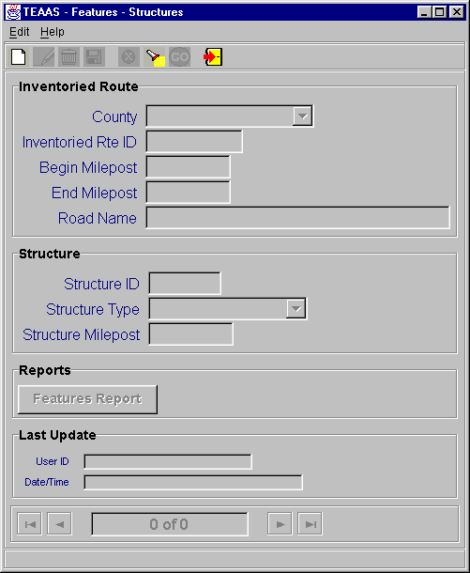
Structures Screen

Searching for a Structure Record
To search for Structure records, click the Search icon on the toolbar. A blank screen will be presented for entering search criteria. The following table describes the search criteria allowed.
Field | Search Criteria
County | Select a specific County from the County combo box or leave empty if this field is not part of the search criteria.
Inventoried Rte ID | Enter a specific Inventoried Rte ID by entering the 8-digit road code. Wildcard characters may be used to search for one or more Inventoried Rte ID. Refer to Appendix C for a description on the use of wildcard characters. Leave Inventoried Rte ID empty if this field is not part of the search criteria.
Begin Milepost | Enter a specific Begin Milepost value or leave empty if this field is not part of the search criteria.
End Milepost | End Milepost is not allowed as a search parameter.
Road Name | Road Name is not allowed as a search parameter.
Structure ID | Enter a specific Structure ID. Wildcard characters may be used to search for one or more Structure IDs. Leave Structure ID empty if this field is not part of the search criteria. Search is not case sensitive.
Structure Type | Select a specific Structure Type from the Structure Type combo box or leave empty if this field is not part of the search criteria.
Structure Milepost | Enter a specific Structure Milepost value or leave empty if this field is not part of the search criteria.

After all desired search criteria have been entered, click the Go icon on the toolbar. A dialog box will appear indicating the number of records returned. Click the OK button on the dialog box to view the records retrieved. Returned records are displayed in view mode.
If no records are returned, a dialog box will appear indicating such. If records were expected to be retrieved, verify that the search criteria are correct. A new search may be executed by adjusting the search criteria and clicking the Go icon.
It is recommended that the search criteria be as specific as possible to prevent the retrieval of too many records, which could contribute to local memory concerns and slower system performance. Currently, TEAAS will display a maximum of 500 records for any given search, although more than 500 records may actually meet the search criteria.

Adding a New Structure Record
To add a new Structure record, click the New icon on the toolbar. A blank screen will be presented for entering a new record. The following table describes the requirements for each field.
Field | Field Requirements
County | A County must be selected from the County combo box.
Inventoried Rte ID | A valid 8-digit Inventoried Rte ID for the County must be specified. The Inventoried Rte ID must already exist as an Inventoried Route in the selected County.
Begin Milepost | The Begin Milepost value of the Inventoried Route must be entered in the format 999.999. Leading and trailing zeroes may be omitted.
End Milepost | The End Milepost value of the Inventoried Route will automatically be populated from the Inventoried Route table.
Road Name | Road Name is not enabled for data entry. Upon saving, Road Name will be populated by the system with the Feature Name that corresponds to the entered Inventoried Rte ID.
Structure ID | A 6-character Structure ID must be entered in the format 999999 (i.e., 6 digits) or Xbbbbb (i.e., X followed by 5 spaces to have the system automatically generate a dummy Structure ID).
Structure Type | A Structure Type must be selected from the Structure Type combo box.
Structure Milepost | The location of the Structure must be entered in the format 999.999. Leading and trailing zeroes may be omitted.

After all information has been added, click the Save icon on the toolbar. If business rule conditions are not satisfied, a message will indicate the problem encountered. If all conditions are satisfied, the new Structure record is saved and displayed on the screen in view mode.

Modifying an Existing Structure Record
An existing Structure record may be modified when the record is displayed on the screen, either after conducting a search or immediately following a save. To modify a displayed record, click the Modify icon on the toolbar. Only the Structure ID, Structure Type, and Structure Milepost fields are enabled for modification. After changes are made to these fields, click the Save icon on the toolbar. All business rule conditions are verified before the modified record is saved. If all conditions are satisfied, the modified Structure record is saved and displayed on the screen in view mode.

Deleting an Existing Structure Record
An existing Structure record may be deleted when the record is displayed on the screen, either after conducting a search or immediately following a save. To delete a displayed record, click the Delete icon on the toolbar. A confirmation dialog box will appear. Click the Yes button to proceed with the deletion or the No button to cancel the deletion. If the deleted record was the only record previously displayed on the screen, the screen will be cleared after the delete. If multiple records were displayed, the next record will now be displayed. The record count at the bottom of the Structures screen will be adjusted accordingly after the deletion.

Canceling a Structures Screen Operation
The New, Modify, and Search operations may be canceled before Save or Go actions are invoked by clicking the Cancel icon on the toolbar. Cancel will return the Structures screen to its previous state. For example, if a record is being modified, clicking the Cancel icon will revert the record to its previous values, displaying it in view mode.

Launching the Features Report
The Features report may be launched from the Structures screen by clicking the Features Report button after an existing Structure record appears in view mode. The report will take the displayed County, Inventoried Route, and Begin Milepost as its selection criteria. Refer to the Features Report section for more information regarding this report.

Closing the Structures Screen
To close the Structures screen, click the Close icon on the toolbar. If a New or Modify operation is in progress, the User will be asked to confirm they want to close without saving. Click the Yes button to close without saving or the No button to return to the operation in progress.

Mile markers
The following table directs the reader to appropriate Mile Markers subsections.
MILE MARKERS Subsections |  |  | Roles
MILE MARKERS Subsections | SA | PDM | SDM | TQU | PQU | PRU | DCU | FDEU | OU | DEOU | DOU | ROU | TEOU | SSU | OA | OER | FU | SDEOU
Mile Markers Screen Overview |  | X | X | X | X |  |  | X |  |  |  |  |  |  |  |  | X
Searching for a Mile Marker Record |  | X | X | X | X |  |  | X |  |  |  |  |  |  |  |  | X
Adding a New Mile Marker Record |  | X | X |  |  |  |  | X
Modifying an Existing Mile Marker Record |  | X | X |  |  |  |  | X
Deleting an Existing Mile Marker Record |  | X | X |  |  |  |  | X
Canceling a Mile Markers Screen Operation |  | X | X | X | X |  |  | X |  |  |  |  |  |  |  |  | X
Launching the Features Report |  | X | X | X | X |  |  | X |  |  |  |  |  |  |  |  | X
Closing the Mile Markers Screen |  | X | X | X | X |  |  | X |  |  |  |  |  |  |  |  | X

Mile Markers Screen Overview
The Mile Markers screen is used to maintain location information on Mile Markers posted on the Inventoried Route.
To access the Mile Markers screen, select the Roadway Features button on the Application Browser, select Mile Markers from the list box, and click the Open button.
Function Button | Function Name | Sub-Function
 | Roadway Features | Mile Markers

Mile Markers can also be accessed from the Inventoried Routes screen. Refer to the Inventoried Routes section for a description on accessing Features screens in that manner.
The screen that follows is displayed, though its appearance may differ slightly from the figure below depending on the User's assigned Roles.
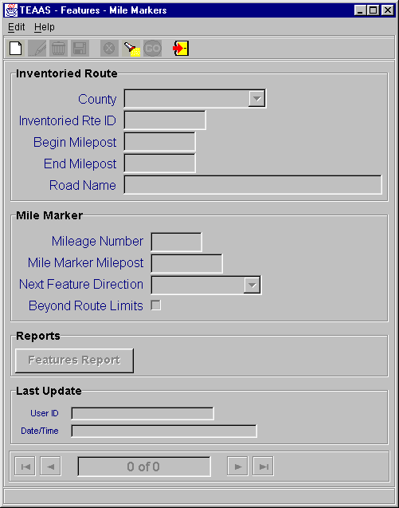
Mile Markers Screen

Searching for a Mile Marker Record
To search for Mile Marker records, click the Search icon on the toolbar. A blank screen will be presented for entering search criteria. The following table describes the search criteria allowed.
Field | Search Criteria
County | Select a specific County from the County combo box or leave empty if this field is not part of the search criteria.
Inventoried Rte ID | Enter a specific Inventoried Rte ID by entering the 8-digit road code. Wildcard characters may be used to search for one or more Inventoried Rte ID. Refer to Appendix C for a description on the use of wildcard characters. Leave Inventoried Rte ID empty if this field is not part of the search criteria.
Begin Milepost | Enter a specific Begin Milepost value or leave empty if this field is not part of the search criteria.
End Milepost | End Milepost is not allowed as a search parameter.
Road Name | Road Name is not allowed as a search parameter.
Mileage Number | Enter a specific Mileage Number value or leave empty if this field is not part of the search criteria.
Mile Marker Milepost | Enter a specific Mile Marker Milepost value or leave empty if this field is not part of the search criteria.
Next Feature Direction | Select a specific Next Feature Direction from the Next Feature Direction combo box or leave empty if this field is not part of the search criteria.
Beyond Route Limits | Beyond Route Limits indicator is not allowed as a search parameter.

After all desired search criteria have been entered, click the Go icon on the toolbar. A dialog box will appear indicating the number of records returned. Click the OK button on the dialog box to view the records retrieved. Returned records are displayed in view mode.
If no records are returned, a dialog box will appear indicating such. If records were expected to be retrieved, verify that the search criteria are correct. A new search may be executed by adjusting the search criteria and clicking the Go icon.
It is recommended that the search criteria be as specific as possible to prevent the retrieval of too many records, which could contribute to local memory concerns and slower system performance. Currently, TEAAS will display a maximum of 500 records for any given search, although more than 500 records may actually meet the search criteria.

Adding a New Mile Marker Record
To add a new Mile Marker record, click the New icon on the toolbar. A blank screen will be presented for entering a new record. The following table describes the requirements for each field.
Field | Field Requirements
County | A County must be selected from the County combo box.
Inventoried Rte ID | A valid 8-digit Inventoried Rte ID for the County must be specified. The Inventoried Rte ID must already exist as an Inventoried Route in the selected County.
Begin Milepost | The Begin Milepost value of the Inventoried Route must be entered in the format 999.999. Leading and trailing zeroes may be omitted.
End Milepost | The End Milepost value of the Inventoried Route will automatically be populated from the Inventoried Route table.
Road Name | Road Name is not enabled for data entry. Upon saving, Road Name will be populated by the system with the Feature Name that corresponds to the entered Inventoried Rte ID.
Mileage Number | The Mileage Number of the Mile Marker must be entered in the format 999.9. Leading and trailing zeroes may be omitted.
Mile Marker Milepost | The location of the Mile Marker must be entered in the format 999.999. Leading and trailing zeroes may be omitted.
Next Feature Direction | A Next Feature Direction must be selected from the Next Feature Direction combo box.
Beyond Route Limits | Enable the Beyond Route Limits indicator only if the Mile Marker Milepost value is outside the range of the begin and end milepost of the Inventoried Rte ID.

After all information has been added, click the Save icon on the toolbar. If business rule conditions are not satisfied, a message will indicate the problem encountered. If all conditions are satisfied, the new Mile Marker record is saved and displayed on the screen in view mode.

Modifying an Existing Mile Marker Record
An existing Mile Marker record may be modified when the record is displayed on the screen, either after conducting a search or immediately following a save. To modify a displayed record, click the Modify icon on the toolbar. Only the Mile Marker Milepost, Next Feature Direction, and Beyond Route Limits fields are enabled for modification. After changes are made to these fields, click the Save icon on the toolbar. All business rule conditions are verified before the modified record is saved. If all conditions are satisfied, the modified Mile Marker record is saved and displayed on the screen in view mode.

Deleting an Existing Mile Marker Record
An existing Mile Marker record may be deleted when the record is displayed on the screen, either after conducting a search or immediately following a save. To delete a displayed record, click the Delete icon on the toolbar. A confirmation dialog box will appear. Click the Yes button to proceed with the deletion or the No button to cancel the deletion. If the deleted record was the only record previously displayed on the screen, the screen will be cleared after the delete. If multiple records were displayed, the next record will now be displayed. The record count at the bottom of the Mile Markers screen will be adjusted accordingly after the deletion.

Canceling a Mile Markers Screen Operation
The New, Modify, and Search operations may be canceled before Save or Go actions are invoked by clicking the Cancel icon on the toolbar. Cancel will return the Mile Markers screen to its previous state. For example, if a record is being modified, clicking the Cancel icon will revert the record to its previous values, displaying it in view mode.

Launching the Features Report
The Features report may be launched from the Mile Markers screen by clicking the Features Report button after an existing Mile Marker record appears in view mode. The report will take the displayed County, Inventoried Route, and Begin Milepost as its selection criteria. Refer to the Features Report section for more information regarding this report.

Closing the Mile Markers Screen
To close the Mile Markers screen, click the Close icon on the toolbar. If a New or Modify operation is in progress, the User will be asked to confirm they want to close without saving. Click the Yes button to close without saving or the No button to return to the operation in progress.

Railroad crossings
The following table directs the reader to appropriate Railroad Crossings subsections.
RAILROAD CROSSINGS Subsections |  |  | Roles
RAILROAD CROSSINGS Subsections | SA | PDM | SDM | TQU | PQU | PRU | DCU | FDEU | OU | DEOU | DOU | ROU | TEOU | SSU | OA | OER | FU | SDEOU
Railroad Crossings Screen Overview |  | X | X | X | X |  |  | X |  |  |  |  |  |  |  |  | X
Searching for a Railroad Crossing Record |  | X | X | X | X |  |  | X |  |  |  |  |  |  |  |  | X
Adding a New Railroad Crossing Record |  | X | X |  |  |  |  | X
Modifying an Existing Railroad Crossing Record |  | X | X |  |  |  |  | X
Deleting an Existing Railroad Crossing Record |  | X | X |  |  |  |  | X
Canceling a Railroad Crossings Screen Operation |  | X | X | X | X |  |  | X |  |  |  |  |  |  |  |  | X
Launching the Features Report |  | X | X | X | X |  |  | X |  |  |  |  |  |  |  |  | X
Launching the County Report |  | X | X | X | X |  |  | X |  |  |  |  |  |  |  |  | X
Launching the Strip Report |  | X | X | X | X |  |  | X |  |  |  |  |  |  |  |  | X
Closing the Railroad Crossings Screen |  | X | X | X | X |  |  | X |  |  |  |  |  |  |  |  | X

Railroad Crossings Screen Overview
The Railroad Crossings screen is used to maintain location information on Railroad Crossings that occur on the Inventoried Route.
To access the Railroad Crossings screen, select the Roadway Features button on the Application Browser, select Railroad Crossings from the list box, and click the Open button.
Function Button | Function Name | Sub-Function
 | Roadway Features | Railroad Crossings

Railroad Crossings can also be accessed from the Inventoried Routes screen. Refer to the Inventoried Routes section for a description on accessing Features screens in that manner.
The screen that follows is displayed, though its appearance may differ slightly from the figure below depending on the User's assigned Roles.
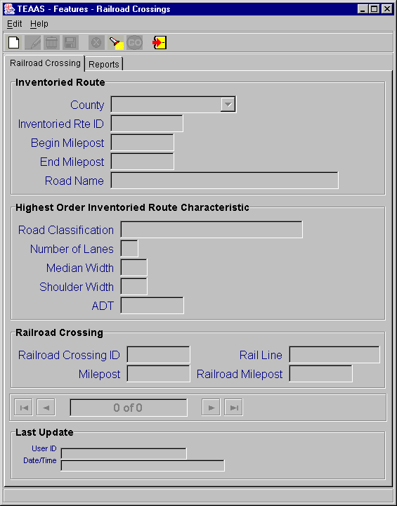
Railroad Crossings Screen

Searching for a Railroad Crossing Record
To search for Railroad Crossing records, click the Search icon on the toolbar. A blank screen will be presented for entering search criteria. The following table describes the search criteria allowed.
Field | Search Criteria
County | Select a specific County from the County combo box or leave empty if this field is not part of the search criteria.
Inventoried Rte ID | Enter a specific Inventoried Rte ID by entering the 8-digit road code. Wildcard characters may be used to search for one or more Inventoried Rte ID. Refer to Appendix C for a description on the use of wildcard characters. Leave Inventoried Rte ID empty if this field is not part of the search criteria.
Begin Milepost | Enter a specific Begin Milepost value or leave empty if this field is not part of the search criteria.
Railroad Crossing ID | Enter a specific Railroad Crossing ID. Wildcard characters may be used to search for one or more Railroad Crossing ID. Leave Railroad Crossing ID empty if this field is not part of the search criteria. Search is not case sensitive.
Milepost | Enter a specific Milepost value or leave empty if this field is not part of the search criteria.
Rail Line | Enter a specific Rail Line value or leave empty if this field is not part of the search criteria. Search is not case sensitive.
Railroad Milepost | Enter a specific Railroad Milepost value or leave empty if this field is not part of the search criteria.

After all desired search criteria have been entered, click the Go icon on the toolbar. A dialog box will appear indicating the number of records returned. Click the OK button on the dialog box to view the records retrieved. Returned records are displayed in view mode.
If no records are returned, a dialog box will appear indicating such. If records were expected to be retrieved, verify that the search criteria are correct. A new search may be executed by adjusting the search criteria and clicking the Go icon.
It is recommended that the search criteria be as specific as possible to prevent the retrieval of too many records, which could contribute to local memory concerns and slower system performance. Currently, TEAAS will display a maximum of 500 records for any given search, although more than 500 records may actually meet the search criteria.

Adding a New Railroad Crossing Record
To add a new Railroad Crossing record, click the New icon on the toolbar. A blank screen will be presented for entering a new record. The following table describes the requirements for each field.
Field | Field Requirements
County | A County must be selected from the County combo box.
Inventoried Rte ID | A valid 8-digit Inventoried Rte ID for the County must be specified. The Inventoried Rte ID must already exist as an Inventoried Route in the selected County.
Begin Milepost | The Begin Milepost value of the Inventoried Route must be entered in the format 999.999. Leading and trailing zeroes may be omitted.
End Milepost | The End Milepost value of the Inventoried Route will automatically be populated from the Inventoried Route table.
Road Name | Road Name is not enabled for data entry. Upon saving, Road Name will be populated by the system with the Feature Name that corresponds to the entered Inventoried Rte ID.
Railroad Crossing ID | A 7-character Railroad Crossing ID must be entered in the format 999999A (i.e., 6 digits followed by an alpha character).
Milepost | The location of the Railroad Crossing must be entered in the format 999.999. Leading and trailing zeroes may be omitted.
Rail Line | A 10-digit Rail Line ID can be specified here.
Railroad Milepost | The Railroad Milepost value can be entered in the format 999.999. Leading and trailing zeroes may be omitted.

After all information has been added, click the Save icon on the toolbar. If business rule conditions are not satisfied, a message will indicate the problem encountered. If all conditions are satisfied, the new Railroad Crossing record is saved and displayed on the screen in view mode.

Modifying an Existing Railroad Crossing Record
An existing Railroad Crossing record may be modified when the record is displayed on the screen, either after conducting a search or immediately following a save. To modify a displayed record, click the Modify icon on the toolbar. Only the Railroad Crossing ID, Milepost, Rail Line, and Railroad Milepost fields are enabled for modification. After changes are made to these fields, click the Save icon on the toolbar. All business rule conditions are verified before the modified record is saved. If all conditions are satisfied, the modified Railroad Crossing record is saved and displayed on the screen in view mode.

Deleting an Existing Railroad Crossing Record
An existing Railroad Crossing record may be deleted when the record is displayed on the screen, either after conducting a search or immediately following a save. To delete a displayed record, click the Delete icon on the toolbar. A confirmation dialog box will appear. Click the Yes button to proceed with the deletion or the No button to cancel the deletion. If the deleted record was the only record previously displayed on the screen, the screen will be cleared after the delete. If multiple records were displayed, the next record will now be displayed. The record count at the bottom of the Railroad Crossings screen will be adjusted accordingly after the deletion.

Canceling a Railroad Crossings Screen Operation
The New, Modify, and Search operations may be canceled before Save or Go actions are invoked by clicking the Cancel icon on the toolbar. Cancel will return the Railroad Crossings screen to its previous state. For example, if a record is being modified, clicking the Cancel icon will revert the record to its previous values, displaying it in view mode.
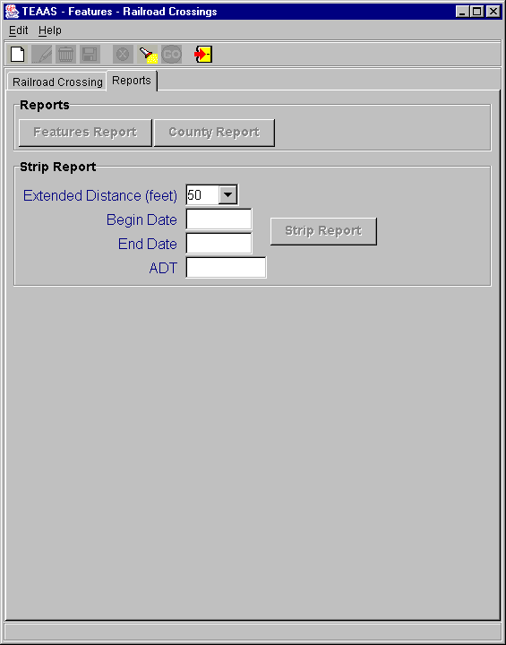
Railroad Crossings Reports Screen

Launching the Features Report
The Features report may be launched from the Railroad Crossing Report screen by clicking the Features Report button in the Reports Tab after an existing Railroad Crossing record appears in view mode. The report will take the displayed County, Inventoried Route, and Begin Milepost as its selection criteria. Refer to the Features Report section for more information regarding this report.

Launching the County Report
The County report may be launched from the Railroad Crossing Report screen by clicking the County Report button in the Reports Tab after county has been selected in view mode. The report will be displayed using County as its selection criteria.

Launching the Strip Report
The Strip report may be launched from the Railroad Crossing Report screen by clicking the Strip Report button in the Reports Tab after county and railroad crossing id has been selected in view mode. The County, railroad crossing id, Extended Distance Feet, Begin Date, End Date, and report ADT (use Highest Order Inventoried Route Characteristic ADT) will be used as the report generation criteria.
A Strip report will be generated for every route that is coinciding at the Railroad Crossing ID. The routes will be determined by performing a search on the Railroad Crossing table using the County and the Railroad Crossing ID. If there is more than one route is retrieved an information box similar to this will be displayed, indicating multiple Strip Reports will be generated.
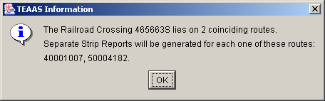
TEAAS – Railroad Crossing coinciding routes TEAAS information dialog box
Refer to the Strip Analysis Report section for more information regarding this report.

Closing the Railroad Crossings Screen
To close the Railroad Crossings screen, click the Close icon on the toolbar. If a New or Modify operation is in progress, the User will be asked to confirm they want to close without saving. Click the Yes button to close without saving or the No button to return to the operation in progress.

Secondary routes
The following table directs the reader to appropriate Secondary Routes subsections.
SECONDARY ROUTES Subsections |  |  | Roles
SECONDARY ROUTES Subsections | SA | PDM | SDM | TQU | PQU | PRU | DCU | FDEU | OU | DEOU | DOU | ROU | TEOU | SSU | OA | OER | FU | SDEOU
Secondary Routes Screen Overview |  | X | X | X | X |  |  |  |  |  |  |  |  |  |  |  | X
Searching for a Secondary Route Record |  | X | X | X | X |  |  |  |  |  |  |  |  |  |  |  | X
Adding a New Secondary Route Record |  | X | X
Modifying an Existing Secondary Route Record |  | X | X
Deleting an Existing Secondary Route Record |  | X | X
Canceling a Secondary Routes Screen Operation |  | X | X | X | X |  |  |  |  |  |  |  |  |  |  |  | X
Closing the Secondary Routes Screen |  | X | X | X | X |  |  |  |  |  |  |  |  |  |  |  | X

Secondary Routes Screen Overview
The Secondary Routes screen is used to associate local street names to Secondary Routes within each county.
To access the Secondary Routes screen, select the Feature Names, Secondary Routes and Exceptions button on the Application Browser, select Secondary Routes from the list box, and click the Open button.
Function Button | Function Name | Sub-Function
 | Feature Names, Secondary Routes and Exceptions | Secondary Routes

The screen that follows is displayed, though its appearance may differ slightly from the figure below depending on the User's assigned Roles.
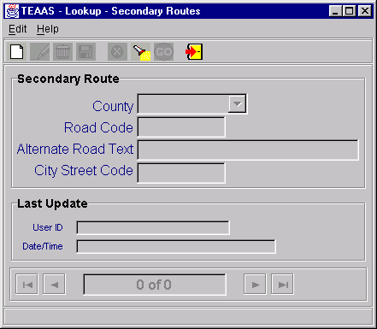
Secondary Routes Screen

Searching for a Secondary Route Record
To search for Secondary Route records, click the Search icon on the toolbar. A blank screen will be presented for entering search criteria. The following table describes the search criteria allowed.
Field | Search Criteria
County | Select a specific County from the County combo box or leave empty if this field is not part of the search criteria.
Road Code | Enter a specific Road Code by entering the 8-digit road code of the Secondary Route. Wildcard characters may be used to search for one or more Road Code. Refer to Appendix C for a description on the use of wildcard characters. Leave Road Code empty if this field is not part of the search criteria.
Alternate Road Text | Enter a specific Alternate Road Text spelling. Wildcard characters may be used to search for one or more Alternate Road Text spellings. Leave Alternate Road Text empty if this field is not part of the search criteria. Search is not case sensitive.
City Street Code | Enter a specific City Street Code by entering the 8-digit road code of the city street. Wildcard characters may be used to search for one or more City Street Code. Refer to Appendix C for a description on the use of wildcard characters. Leave City Street Code empty if this field is not part of the search criteria.

After all desired search criteria have been entered, click the Go icon on the toolbar. A dialog box will appear indicating the number of records returned. Click the OK button on the dialog box to view the records retrieved. Returned records are displayed in view mode.
If no records are returned, a dialog box will appear indicating such. If records were expected to be retrieved, verify that the search criteria are correct. A new search may be executed by adjusting the search criteria and clicking the Go icon.
It is recommended that the search criteria be as specific as possible to prevent the retrieval of too many records, which could contribute to local memory concerns and slower system performance. Currently, TEAAS will display a maximum of 500 records for any given search, although more than 500 records may actually meet the search criteria.

Adding a Secondary Route Record
To add a new Secondary Route record, click the New icon on the toolbar. A blank screen will be presented for entering a new record. The following table describes the requirements for each field.
Field | Field Requirements
County | A County must be selected from the County combo box.
Road Code | A valid 8-digit Road Code for the County must be specified. The 8-digit code must already exist as a Feature Code.
Alternate Road Text | A 25-character (maximum) Alternate Road Text must be entered. The Alternate Road Text entered here must not already exist as an alternate name for the specified Secondary Route in the selected County.
City Street Code | The City Street Code is maintained by the system and is populated from the Feature Code table.
After all information has been added, click the Save icon on the toolbar. If business rule conditions are not satisfied, a message will indicate the problem encountered. If all conditions are satisfied, the new Secondary Route record is saved and displayed on the screen in view mode.

Modifying an Existing Secondary Route Record
An existing Secondary Route record may be modified when the record is displayed on the screen, either after conducting a search or immediately following a save. To modify a displayed record, click the Modify icon on the toolbar. Only the Alternate Road Text is enabled for modification. After changes are made to this field, click the Save icon on the toolbar. All business rule conditions are verified before the modified record is saved. If all conditions are satisfied, the modified Secondary Route record is saved and displayed on the screen in view mode.

Deleting an Existing Secondary Route Record
An existing Secondary Route record may be deleted when the record is displayed on the screen, either after conducting a search or immediately following a save. To delete a displayed record, click the Delete icon on the toolbar. A confirmation dialog box will appear. Click the Yes button to proceed with the deletion or the No button to cancel the deletion. If the deleted record was the only record previously displayed on the screen, the screen will be cleared after the delete. If multiple records were displayed, the next record will now be displayed. The record count at the bottom of the Secondary Routes screen will be adjusted accordingly after the deletion.

Canceling a Secondary Routes Screen Operation
The New, Modify, and Search operations may be canceled before Save or Go actions are invoked by clicking the Cancel icon on the toolbar. Cancel will return the Secondary Routes screen to its previous state. For example, if a record is being modified, clicking the Cancel icon will revert the record to its previous values, displaying it in view mode.

Closing the Secondary Routes Screen
To close the Secondary Routes screen, click the Close icon on the toolbar. If a New or Modify operation is in progress, the User will be asked to confirm they want to close without saving. Click the Yes button to close without saving or the No button to return to the operation in progress.

Ordinances
The following table directs the reader to appropriate Ordinances subsections.
ORDINANCES Subsections |  |  | Roles
ORDINANCES Subsections | SA | PDM | SDM | TQU | PQU | PRU | DCU | FDEU | OU | DEOU | DOU | ROU | TEOU | SSU | OA | OER | FU | SDEOU
Ordinances Screen Overview |  |  |  |  |  |  |  |  | X | X | X | X | X |  | X |  |  | X
Searching for Ordinances |  |  |  |  |  |  |  |  | X | X | X | X | X |  | X |  |  | X
Viewing Ordinance Details |  |  |  |  |  |  |  |  | X | X | X | X | X |  | X |  |  | X
Adding a New Ordinance |  |  |  |  |  |  |  |  |  | X | X | X | X |  |  |  |  | X
Modifying an Existing Ordinance |  |  |  |  |  |  |  |  |  | X | X | X | X |  |  |  |  | X
Deleting an Existing Ordinance |  |  |  |  |  |  |  |  |  | X | X | X | X |  |  |  |  | X
Canceling a Ordinances Screen Operation |  |  |  |  |  |  |  |  |  | X | X | X | X |  |  |  |  | X
Performing Milepost |  |  |  |  |  |  |  |  |  | X | X | X | X |  |  |  |  | X
Division Approval of an Ordinance |  |  |  |  |  |  |  |  |  |  | X | X | X
Region Approval of an Ordinance |  |  |  |  |  |  |  |  |  |  |  | X | X
State Approval of an Ordinance |  |  |  |  |  |  |  |  |  |  |  |  | X
State Remove Approval of an Ordinance |  |  |  |  |  |  |  |  |  |  |  |  |  |  | X
Division Recommend for Repeal / Revoke Recommendation of an Ordinance |  |  |  |  |  |  |  |  |  |  | X | X | X
Region Recommend for Repeal / Revoke Recommendation of an Ordinance |  |  |  |  |  |  |  |  |  |  |  | X | X
State Recommend for Repeal of an Ordinance |  |  |  |  |  |  |  |  |  |  |  |  | X
State Revoke Repeal Recommendation of an Ordinance |  |  |  |  |  |  |  |  |  |  |  |  |  |  | X
Generating the Municipality Certificates |  |  |  |  |  |  |  |  | X | X | X | X | X |  |  |  |  | X
Exporting Ordinances from Search Screen |  |  |  |  |  |  |  |  | X | X | X | X | X |  | X |  |  | X
Generating the Certification of Rulemaking |  |  |  |  |  |  |  |  |  |  |  |  | X
Generating the Ordinance Report |  |  |  |  |  |  |  |  | X | X | X | X | X |  |  |  |  | X
Closing the Ordinances Screen |  |  |  |  |  |  |  |  | X | X | X | X | X |  | X |  |  | X

Ordinances Screen Overview
The Ordinances screen is used to maintain ordinances, generate ordinance reports, generate Certification of Rulemaking report, and export Ordinances.
To access the Ordinances screen, select the Ordinances button on the Application Browser, select Ordinances from the list box, and click the Open button.
Function Button | Function Name | Sub-Function
 | Ordinances | Ordinances

The screens that follow are displayed, though their appearance may differ slightly from the figures below depending on the User's assigned Roles. The column widths in the Results table can be resized by clicking and dragging the column header separators. Double-clicking a column header sorts the table based on the column. Double-clicking the column again sorts based on the reverse order.
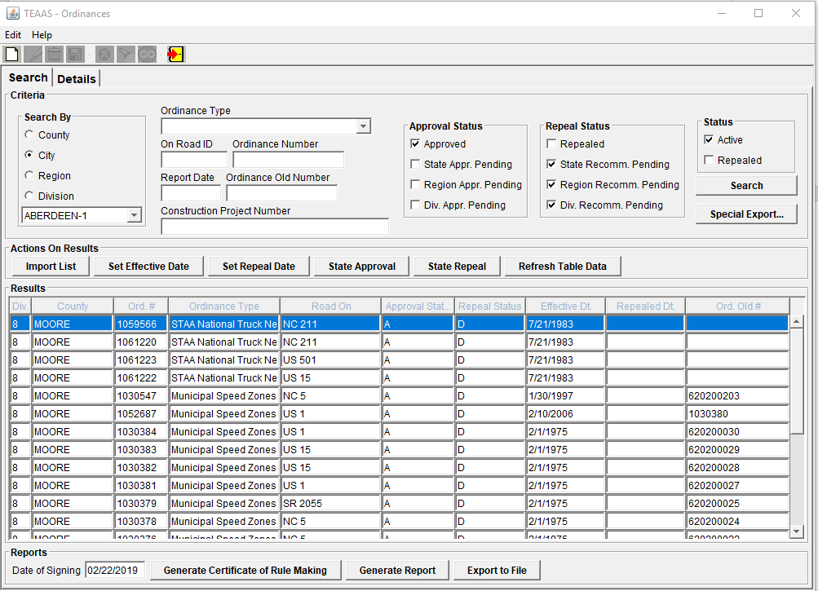
Ordinances – Search Panel
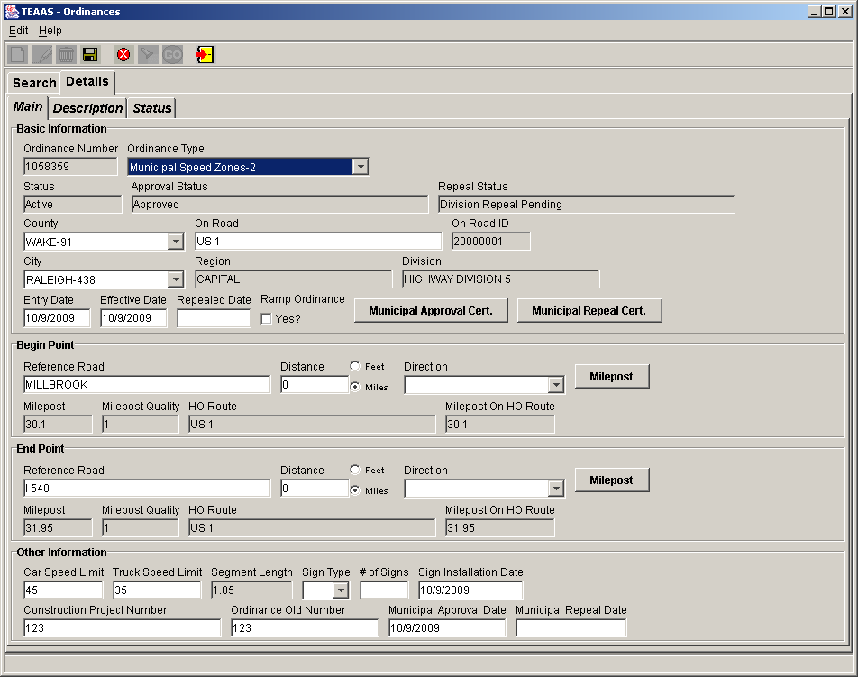
Ordinances – Details Panel – Main Sub Panel
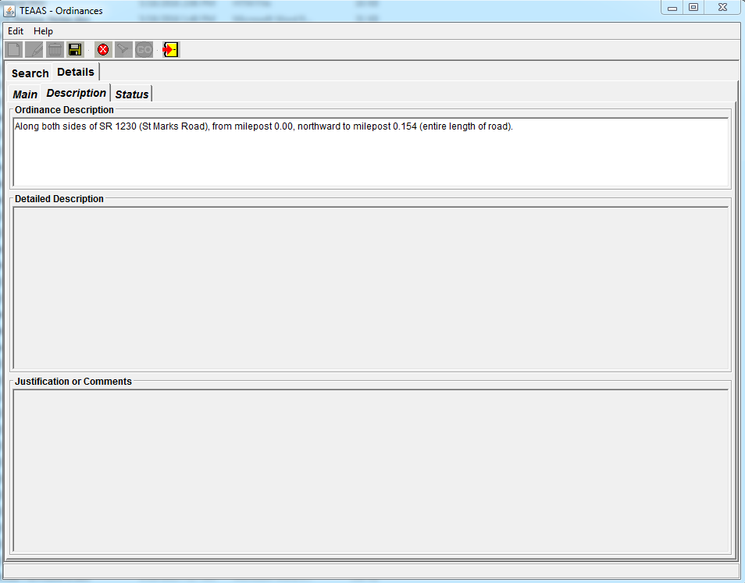
Ordinances – Details Panel – Description Sub Panel

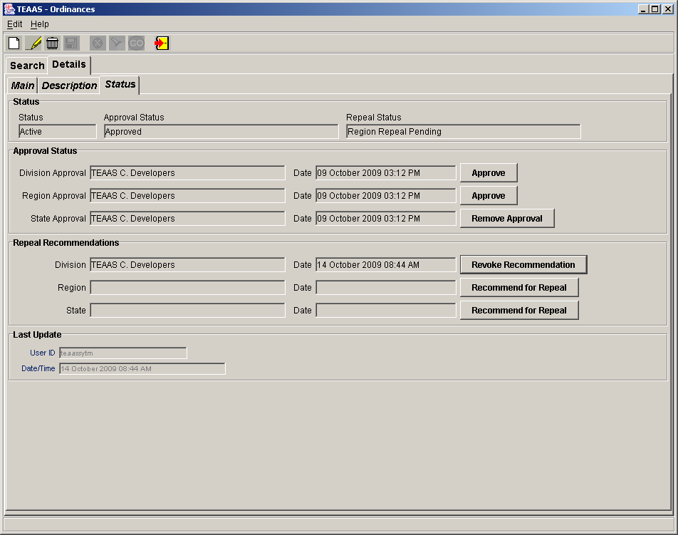
Ordinances – Details Panel – Status Sub Panel

Searching for Ordinances
To search for Ordinances, click the Search panel. The following table describes the search criteria allowed.
Field | Search Criteria
Search By | One of the four options as shown should be selected. Will be defaulted to County
Search By List | This list will change based on what is selected in the "Search By" option. It could either be a list of counties or a list of cities or list of regions or list of divisions.
Ordinance Type | List of ordinance types will be shown. If nothing is selected then the search will return all ordinance types.
On Road ID | An 8-digit on Road Code can be entered. Smaller ids with wild cards of '*' and '?' can be input.
Report Date | An optional date in mm/dd/yyyy format can be entered. Entering a date here will select only the ordinances with either the effective date or the repeal date as the one entered.
Ordinance Number | A 7-digit ordinance number can be entered. Wildcard characters may be used to search for one or more ordinance numbers. Refer to Appendix C for a description on the use of wildcard characters.
Ordinance Old Number | A 15-digit old ordinance number can be entered. Wildcard characters may be used to search for one or more Ordinance Old Number. Refer to Appendix C for a description on the use of wildcard characters.
Construction Project Number | A 25-digit Construction Project Number can be entered. Wildcard characters may be used to search for one or more Construction Project Numbers. Refer to Appendix C for a description on the use of wildcard characters.
Approval Status | One of the four options as shown can be selected. Will be defaulted to Approved. If nothing is selected then the search will return all Approval Statuses.
Repeal Status | One of four options as shown can be selected. Will default to State Recomm. Pending , Region Recomm. Pending and Div. Recomm. Pending. If nothing is selected then the search will return all Repeal Statuses.
Status | One of the two options as shown can be selected. Will be defaulted to Active. If nothing is selected then the search will return all Statuses.

After all desired search criteria have been entered, click the Search button. A dialog box will appear indicating the number of records returned. Click the OK button on the dialog box to view the records retrieved. Summary information about the Ordinances is displayed in Results table.
If no records are returned, a dialog box will appear indicating such. If records were expected to be retrieved, verify that the search criteria are correct. A new search may be executed by adjusting the search criteria and clicking the Search button.

Search Limitations
It is recommended that the search criteria be as specific as possible to prevent the retrieval of too many records, which could contribute to local memory concerns and slower system performance. Currently, TEAAS Ordinances will display a maximum of 2000 records for any given search, although more than 2000 records may actually meet the search criteria.

Status, Approval Status, and Repeal Status
Ordinances can have Statuses of Active or Repealed. Any Ordinances that are created with or without an effective date are Active. Any Ordinance with a repealed date is still active, since the status is not set to Repealed.
Within the Active status, an Ordinance can have various Approval Statuses: Division Approval Pending, Region Approval Pending, State Approval Pending and Approved. An Approved Ordinance means Division, Region, and Traffic Engineering Ordinance Users have provided their approval. Traffic Engineering Ordinance Users have to provide an effective date to move the Ordinance to an Approved approval status.
Within the Repealed status, an Ordinance can have various Repeal Statuses: Division Repeal Pending, Region Repeal Pending, State Repeal Pending, and Repealed. A Repealed Ordinance means Division, Region, and Traffic Engineering Ordinance Users have provided their approval for Repeal. Traffic Engineering Ordinance Users have to provide a repealed date to move the Ordinance to a repeal status of Repealed.

Search and Changes to Ordinances
Changes performed on an Ordinance (additions, updates, deletions, and approvals) in the Details panel will be reflected in the Search panel.

Importing a List of Ordinances
The Action on Results panel, Import List button can be used to import a list of Ordinances directly into the Results table. The following dialog box appears where the user can input multiple Ordinance numbers. There should be only one ordinance number per line. A list of ordinance numbers already available in a text file can be input by copying and pasting. There is no limit to the number or ordinance numbers that can be keyed into the box, but only the first 2000 will be considered, the rest will be ignored. This list of Ordinance numbers can either be used to replace the current results or append to it. Duplicates will be ignored.
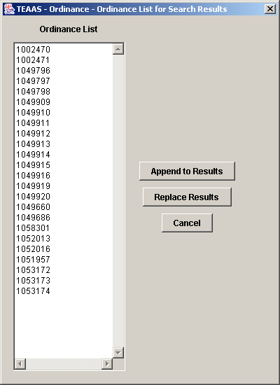
Ordinances – Import List pop up
The following table describes the button functions.
Button | Function
Append to Results | The list of ordinances in the pop up will append to the current ordinances in the results table.
Replace Results | The list of ordinances in the pop up will replace the current ordinances in the results table.
Cancel | Closes the pop up and no action is taken.

Append to Results and Replace Results perform a search for each ordinance provided in the list and then populates the Results table. Errors encountered with invalid Ordinance numbers entered will be displayed in an error screen after the import process is completed.
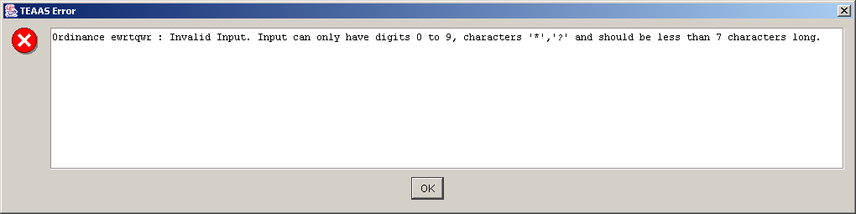
Ordinances – Import List Error message pop up

Batch Updates
The following buttons will allow the user to perform Batch Updates on the ordinances currently shown in the results table, and will only be enabled if the results table is not empty.
Button | Function
Set Effective Date | Clicking on the Set Effective Date button will bring up the screen as shown below. Clicking on Set Effective Date button will result in effective date being set to all the Ordinances in the Results table. Errors encountered during the process will be captured and shown to the user.  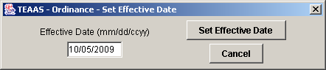
Set Repeal Date | Clicking on the Set Repeal Date button will bring up the screen as shown below. Clicking on Set Repeal Date button will result in repeal date being set to all the Ordinances in the Results table. Errors encountered during the process will be captured and shown to the user.  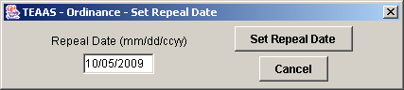
State Approval | Clicking on the State Approval button will bring up the confirmation screen as shown below. Clicking on Yes will result in State Approvals being done to all the Ordinances in the Results table. Errors encountered during the process will be captured and shown to the user.  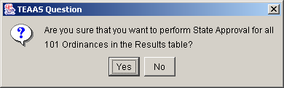
State Repeal | Clicking on the State Repeal button will bring up the confirmation screen as shown below. Clicking on Yes will result in State Repeals being done to all the Ordinances in the Results table. Errors encountered during the process will be captured and shown to the user.  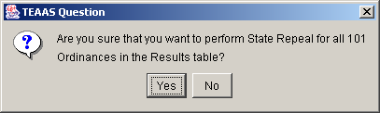
Refresh Table Data | This will refresh the results table with the current data from the database.

The following error message can pop while performing batch updates.
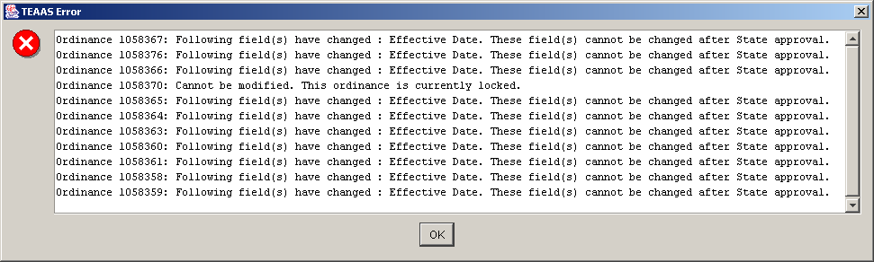
Ordinances – Batch Updates Error message pop up

Viewing Ordinance Details
To view the details of an Ordinance, the Summary information about the Ordinances should be available in the Results table in the Search panel. Select an Ordinance in the Results table and click on the Details Panel. The Details panel consists of three sub panels called Main , Description and Status which contain all the details about an Ordinance. Depending on the Ordinance type certain fields may or may not have values. For example, the Car Speed Limit and Truck Speed Limit information will be available only for Speed Limit types of Ordinances.

Adding an Ordinance
To add a new Ordinance, click the New icon on the toolbar. A blank screen will be presented for entering a new record. The following table describes the requirements for each field.
Field | Field Requirements
Ordinances – Details – Main sub panel – Basic Information
Ordinance Number | A 7-digit display only field. The Ordinance Number is a sequential number that will be automatically generated by the system whenever new ordinances are created. An ordinance number once assigned to an ordinance cannot be re-used. Suppose an ordinance number 1111111 is assigned to an ordinance and the user decides to delete (prior to any approval) the ordinance number 1111111 will be lost and cannot be reused.
Ordinance Type | List of ordinance types will be shown. Input Mandatory.
Status | A 15 character display only field. Ordinances can have Statuses of Active or Repealed
Approval Status | A 35 character display only field. Ordinances can have Approval Statuses of Division Approval Pending, Region Approval Pending, State Approval Pending and Approved
Repeal Status | A 35 character display only field. Ordinances can have Repeal Statuses of Division Repeal Pending, Region Repeal Pending, State Repeal Pending, and Repealed.
County | A County must be selected from the County combo box.
On Road | An On Road name must be entered. Road Name entered here should be a valid feature name.
On Road ID | An 8-digit display only field. This will be the 8-digit feature code for "On Road"
City | A City must be selected from the City combo box. Default value will be "Rural". User could select from one of the incorporated cities for the County previously selected.
Region | A 35 character display only field. This will be derived from the MVC_COUNTY_REFERENCE table for the County entered.
Division | A 35 character display only field. This will be derived from the MVC_COUNTY_REFERENCE table for the County entered.
Entry Date | A valid date in mm/dd/yyyy format must be entered. Will be defaulted to today's date.
Effective Date | A date in mm/dd/yyyy format can be entered. Only the users with State Traffic Engineer privilege can input a date in this field.
Ramp Ordinance | A check box to capture if the Ordinance is on a ramp. Ordinance Overlap checks will not be performed for an Ordinance that has the “Ramp Ordinance” flag checked. Also, these Ordinances will not be considered as an overlapping Ordinance for any other Ordinance.  This value in this field cannot be changed after the Ordinance has been passed through State Approval. Changing this value after Division or Regional approval will result in the approvals being cleared and it will have to be performed again
Municipal Approval Cert. | Generates a Municipal Approval Certificate. This button will only be enabled for Ordinance Types that have been identified as “Municipal Approval Allowed” ordinances.
Municipal Repeal Cert. | Generates a Municipal Repeal Certificate. This button will only be enabled for Ordinance Types that have been identified as “Municipal Approval Allowed” ordinances.
Repealed Date | A date in mm/dd/yyyy format can be entered. Only the users with State Traffic Engineer privilege can input a date in this field.
Ordinances – Details – Main sub panel – Begin Point
Reference Road | A Reference Road name must be entered. Road Name entered here should be a valid feature name.
Distance | Distance must be entered. If entered in feet then it should be a whole number greater than 0 and less than 9999. If entered in miles then it should be decimal number greater than 0 and less than 99.99. By default the mile radio button is selected when a value is entered in the distance field. Appropriate distance type radio button (feet or mile) should be chosen.
Direction | A Direction must be selected from the Direction combo box.
Milepost button | Will perform mileposting.
Milepost field | A 7-digit display only field. Will be calculated/assigned by the milepost process.
Milepost Quality | A 1 digit display only field. Will be calculated/assigned by the milepost process.
HO Route | A 25 character display only field. Will be calculated/assigned by the milepost process.
Milepost on HO Route | A 7 character decimal number display only field. Will be calculated / assigned by the milepost process.
Ordinances – Details – Main sub panel – End Point (Same as Begin Point)
Ordinances – Details – Main sub panel – Other Information
Car Speed Limit | Car Speed Limit must be entered for all 'Speed Limit' ordinance types. Not allowed for other ordinance types. Should be a whole number between 0 and 99
Truck Speed Limit | Truck Speed Limit must be entered for all 'Speed Limit' ordinance types. Not allowed for other ordinance types. Should be a whole number between 0 and 99
Segment Length | A 7 digit read only field. Calculated by the system as a difference between End Milepost and Begin milepost
Sign Type | Sign Type must be selected for all 'Sign' ordinance types. Not allowed for other ordinance types.
# of Signs | # of Signs must be entered for all 'Sign' ordinance types. Not allowed for other ordinance types.
Sign Installation Date | A valid date in mm/dd/yyyy format may be entered.
Construction Project Number | A 25 character Construction Project Number may be entered.
Ordinance Old Number | A 15 character Ordinance Old Number may be entered.
Municipal Approval Date | For setting the Municipal Approval Date. Ordinance Types with “Municipal Approval Required” parameter set, the Ordinance Approval(s) can be done only if the Municipal Approval Date is set..
Municipal Repeal Date | For setting the Municipal Repeal Date. Ordinance Types with “Municipal Approval Required” parameter set, the Ordinance Repeals(s) can be done only if the Municipal Repeal Date is set.
Ordinances – Details – Description sub panel
Ordinance Description | An 80 character Ordinance Description must be entered. Apostrophes are not allowed, a tool tip appears over this field stating this.
Detailed Description | A 4000 character Detailed Description must be entered for all 'Route Changes' and 'Truck Route' ordinance types. Input not allowed for other ordinance types. Apostrophes are not allowed, a tool tip appears over this field stating this.
Justification or Comments | A 4000 character Justification or Comments must be entered.
Ordinances – Details – Status sub panel –Status
Status | A 15 character display only field. Ordinances can have Statuses of Active or Repealed
Approval Status | A 35 character display only field. Ordinances can have Approval Statuses of Division Approval Pending, Region Approval Pending, State Approval Pending and Approved
Repeal Status | A 35 character display only field. Ordinances can have Repeal Statuses of Division Repeal Pending, Region Repeal Pending, State Repeal Pending, and Repealed.
Ordinances – Details – Status sub panel – Approval Status
Division Approval | A 30 character display only field. First Name, Middle Initial and Last Name of the user who performed the division approval.
Division Approval – Date | A 30 character display only field. Date and Time when division approval was done.
Division Approval – Approve button | Will perform Division Approval.
Region Approval | A 30 character display only field. First Name, Middle Initial and Last Name of the user who performed the region approval.
Region Approval – Date | A 30 character display only field. Date and Time when region approval was done.
Region Approval – Approve button | Will perform Region Approval. Can be done only if the Division Approval has been done.
State Approval | A 30 character display only field. First Name, Middle Initial and Last Name of the user who performed the State approval.
State Approval – Date | A 30 character display only field. Date and Time when state approval was done.
State Approval – Approve / Remove Approval button | Will perform State Approval and Removal of Approval. Can be done only if Division and Region Approvals have been done. Button will change to Remove Approval after approval is complete. Button will toggle back to Approve after approval is removed.
Ordinances – Details – Status sub panel – Repeal Recommendations
Division Repeal | A 30 character display only field. First Name, Middle Initial and Last Name of the user who performed the Division Repeal.
Division Repeal – Date | A 30 character display only field. Date and Time when Division Repeal was done.
Division Repeal – Recommend for Repeal / Revoke Recommendation button | Will perform Division Repeal. Button will change to Revoke Recommendation after recommend for repeal is complete. Revoke Recommendation will remove the Division Repeal and empty the fields. Button will toggle back to Recommend for Repeal after repeal is removed.
Region Repeal | A 30 character display only field. First Name, Middle Initial and Last Name of the user who performed the Region Repeal.
Region Repeal – Date | A 30 character display only field. Date and Time when region approval was done.
Region Repeal – Recommend for Repeal / Revoke Recommendation button | Will perform Region Repeal. Button will change to Revoke Recommendation after recommend for repeal is complete. Can be done only if Division repeal has been done. Revoke Recommendation will remove the Region Repeal and empty the fields. Button will toggle back to Recommend for Repeal after repeal is removed.
State Repeal | A 30 character display only field. First Name, Middle Initial and Last Name of the user who performed the State Repeal.
State Repeal – Date | A 30 character display only field. Date and Time when State Repeal was done.
State Repeal – Recommend for Repeal / Revoke Recommendation button | Will perform State Repeal. Button will change to Revoke Recommendation after recommend for repeal is complete. Can be done only if Division and Region repeals have been done. Revoke Recommendation will remove the State Repeal and empty the fields. Button will toggle back to Recommend for Repeal after repeal is removed.

While entering the values some of the fields may be preemptively disabled or enabled. The field values will be validated against the business rules as soon as the cursor is moved out of the field. After all information has been added, click the Save icon on the toolbar. If any additional business rule conditions are not satisfied, a message will indicate the problem encountered. If all conditions are satisfied, the new Ordinance is saved and displayed on the screen in view mode.
The Data Entry, State Data Entry, Division, Region, and Traffic Engineering Ordinance Users can add new Ordinances. But the approvals have to be performed sequentially: Division, Region and State.

Modifying an Existing Ordinance
An existing Ordinance may be modified when the record is displayed in the Details panel, either after conducting a search and viewing details or immediately following a save. To modify a displayed record, click the Modify icon on the toolbar. After changes are made to the fields, click the Save icon on the toolbar. All business rule conditions are verified before the modified record is saved. If all conditions are satisfied, the modified Ordinance is saved and displayed on the screen in view mode.
The Data Entry, State Data Entry, Division, Region, and Traffic Engineering Ordinance Users can modify Ordinances that are not approved. Upon modification, any approvals that were performed on the ordinance will be cleared.
Begin Point, End Point, Sign Installation Date, and Ordinance Old Number can be modified even after State Approval.

Deleting an Existing Ordinance
An existing not approved Ordinance may be deleted when the record is displayed on the screen, either after conducting a search and viewing details or immediately following a save. To delete a displayed record, click the Delete icon on the toolbar. A confirmation dialog box will appear. Click the Yes button to proceed with the deletion or the No button to cancel the deletion. An error message will be displayed, if trying to delete an approved Ordinance or trying to delete an Ordinance belonging to another user. The screen will be cleared after the delete.

Canceling an Ordinances Screen Operation
New and Modify operations may be canceled before the Save action is invoked, by clicking the Cancel icon on the toolbar. Cancel will return the Ordinances Details panel to its previous state. For example, if a record is being modified, clicking the Cancel icon, will revert the record to its previous values, displaying it in view mode.

Performing Milepost
When an Ordinance is in the New or Modify mode, Milepost can be performed on the Begin Point or the End Point by clicking on the respective Milepost button. Upon completion of Milepost, the Highest Order fields are populated in the respective Point panels.
The Milepost process is also executed upon clicking the Save icon while in the New or Modify mode.

Division Approval of an Ordinance
Division Approvals are the first level of approvals that has to be performed on an Ordinance. Approvals can be performed only in the view mode. The Division Approval button is on the Details panel’s Status sub-panel. The Division Approval button will be enabled only for users having Division Ordinance User, Region Ordinance User, Traffic Engineering Ordinance User roles. A Division Ordinance user can only approve ordinances belonging to their division. Upon successful approval, the Division Approval field will be populated with User’s First Name, Middle Initial and Last Name and the timestamp information when the Ordinance was approved. Long User’s name may be truncated for display purposes. After the approval if the Ordinance was modified, division approval performed on the ordinance will be cleared.
A Region Ordinance User can perform Division Approval for all the divisions belonging to their region. A Traffic Engineering Ordinance User can perform Division Approval for any division.

Region Approval of an Ordinance
Region Approvals are the second level of approvals that has to be performed on an Ordinance. Approvals can be performed only in the view mode. The Region Approval button is on the Details panel’s Status sub-panel. The Region Approval button will be enabled only for users having Region Ordinance User, and Traffic Engineering Ordinance User roles. A Region Ordinance user can only approve ordinances belonging to their region and which the Divisions have already approved. Upon successful approval, the Region Approval field will be populated with User’s First Name, Middle Initial and Last Name and the timestamp information when the Ordinance was approved. Long User’s name may be truncated for display purposes. After the approval if the Ordinance was modified, division and region approvals performed on the ordinance will be cleared.
A Traffic Engineering Ordinance User can perform Region Approval for any region.

State Approval of an Ordinance
State Approvals are the third and final level of approvals that has to be performed on an Ordinance to make it Approved. The State Approval button is on the Details panel’s Status sub-panel. The State Approval button will be enabled only for users having Ordinance Administrator role. A Ordinance Administrator User can only approve ordinances that have already been approved by the Divisions and Regions and an Effective Date has been set. Upon successful approval, the State Approval field will be populated with User’s First Name, Middle Initial and Last Name and the timestamp information when the Ordinance was approved. Long User’s name may be truncated for display purposes. The Approve button will be replaced by the Remove Approval button.
A State Approved Ordinance cannot be modified, except for the following fields: Begin Point, End Point, Sign Installation Date, and Ordinance Old Number.

State Remove Approval of an Ordinance
The Ordinance Administrator has the ability to Remove Approval of a State Approved Ordinance. Some of the State Approved Ordinances may have to be “un-approved” in certain rare instances. Clicking the State Remove Approval button will accomplish this. An Ordinance may have to be “un-approved”
The State Approval cannot be removed once the Repeal process has been started.

Division Recommend for Repeal / Revoke Recommendation of an Ordinance
Division Recommend for Repeal is the first level of repeals that has to be performed on an Ordinance. Repeals can be performed only in the view mode. The Division Recommend for Repeal button is on the Details panel’s Status sub-panel. The Division Recommend for Repeal button will be enabled only for users having Division Ordinance User, Region Ordinance User, and Traffic Engineering Ordinance User roles. Division Repeal Recommendation can be performed only on Ordinances that are Active and have been approved at the State Level. A Division Ordinance user can only perform Recommend for Repeal on ordinances belonging to their division. Upon successful repeal recommendation, the Division Repeal field will be populated with User’s First Name, Middle Initial and Last Name and the timestamp information when the Ordinance was recommended for repeal. Long User’s name may be truncated for display purposes. The Repeal button will be replaced by the Revoke Recommendation button.
The Region Revoke Recommendation button can be used to “un-repeal” an Ordinance. The Repeal Revoke Recommendation might result in an overlap. When this happens, an informational message will be displayed indicating the overlap and will still go ahead and remove the repeal recommendation for the Ordinance. The user has to ensure that the overlap issue is addressed.
A Region Ordinance User can perform Division Recommend for Repeal / Revoke Recommendation for all the divisions belonging to their region. A Traffic Engineering Ordinance User can perform Division Recommend for Repeal / Revoke Recommendation for any division.

Region Recommend for Repeal / Revoke Recommendation of an Ordinance
Region Recommend for Repeal is the second level of repeals that has to be performed on an Ordinance. Repeals can be performed only in the view mode. The Region Recommend for Repeal button is on the Details panel’s Status sub-panel. The Region Recommend for Repeal button will be enabled only for users having Region Ordinance User, and Traffic Engineering Ordinance User roles. Region Repeal Recommendation can be performed only on Ordinances that have already received the Recommend for Repeal at the Division Level. A Region Ordinance user can only perform Recommend for Repeal on ordinances belonging to their Region. Upon successful repeal recommendation, the Region Repeal field will be populated with User’s First Name, Middle Initial and Last Name and the timestamp information when the Ordinance was recommended for repeal. Long User’s name may be truncated for display purposes. The Repeal button will be replaced by the Revoke Recommendation button.
The Region Revoke Recommendation button can be used to “un-repeal” an Ordinance. The Repeal Revoke Recommendation might result in an overlap. When this happens, an informational message will be displayed indicating the overlap and will still go ahead and remove the repeal recommendation for the Ordinance. The user has to ensure that the overlap issue is addressed.
A Traffic Engineering Ordinance User can perform Region Recommend for Repeal / Revoke Recommendation for any region.

State Recommend for Repeal of an Ordinance
State Recommend for Repeal is the third and final level of repeals that has to be performed on an Ordinance to make it Repealed. The State Recommend for Repeal button is on the Details panel’s Status sub-panel. The State Recommend for Repeal button will be enabled only for users having Ordinance Administrator role. A Ordinance Administrator can only repeal ordinances that have already been recommended for repeal by the Divisions and Regions and a Repeal Date has been set. Upon successful Repeal, the State Repeal field will be populated with User’s First Name, Middle Initial and Last Name and the timestamp information when the Ordinance was approved. Long User’s name may be truncated for display purposes. The Repeal button will be replaced by the Revoke Recommendation button.
The Ordinance will change to Repealed Status after the State Repeal Recommendation.

State Revoke Repeal Recommendation of an Ordinance
The Ordinance Administrator has the ability to Revoke Recommendation of a State Repealed Ordinance. Some of the State Repealed Ordinances may have to be “un-repealed” in certain rare instances. Clicking the State Repeal Revoke Recommendation button will accomplish this. The Repeal Revoke Recommendation might result in an overlap. When this happens, an informational message will be displayed indicating the overlap and will still go ahead and remove the repeal recommendation for the Ordinance. The user has to ensure that the overlap issue is addressed.

Approvals, Repeals, Revoke Repeals, and Overlaps of Ordinances
The Ordinance approvals and repeals have to occur in the following order:
- Division Approve
- Region Approve
- State Approve
- Division Recommend for Repeal
- Region Recommend for Repeal
- State Recommend for Repeal.
The Region Approval cannot occur prior to Division Approval, State Approval cannot occur prior to Region Approval, so on so forth. Ordinance Administrator can remove approval only from State Approved Ordinances. Recommend for Repeal can be performed only on Ordinances that are Active and have been approved at the State Level. The status of the Ordinance will change to Repealed only after the State Repeal Recommendation.
Repeal Revoke Recommendation can occur in the reverse order:
- State Repeal Revoke Recommendation
- Region Repeal Revoke Recommendation
- Division Repeal Revoke Recommendation.
Ordinance Overlap checks will be performed during Division and Regional approvals. Ordinance Overlap checks will not be performed for an Ordinance that has the “Ramp Ordinance” flag checked. Also, the Ramp Flag Ordinances will not be considered as an overlapping Ordinance for any other Ordinance.
An ordinance Recommended for Repeal will not be allowed to overlap with any other Ordinance at the same approval level. For example if a Division user is trying to enter a new Ordinance say A and it overlaps with an existing Ordinance B, then if the Division user Recommends Ordinance B for repeal, then it will no longer overlap with A during the overlap check done during Divisional Approval of A. But B will overlap with A during Regional Approval done for A. After Recommend for Repeal is done at the Regional Level for B it will no longer overlap with A during Regional Approval.
The Repeal Revoke Recommendation might result in an overlap. When this happens, an informational message will be displayed. This would mean that there is at the least one more Ordinance in the System that is currently in valid state in spite of its causing overlap. The application will not prevent the user from creating an Overlap. The user has to ensure that the overlap issue is addressed.

Generating the Municipality Certificates

Generating the Municipal Approval Certificate
The Municipal Approval Certificate can be generated for ordinances that are identified as “Municipal Approval Allowed” ordinances and are present in the Results table. Select an ordinance in the Results table. Select Details panel. Clicking on the Municipal Approval Cert. button will generate the Municipal Approval Certificate for the Ordinance currently being displayed The certificate will appear in view mode in e.Report Engine. The report may be viewed on the screen, printed, or saved to a file. Refer to Appendix D for an overview of the use of e.Report Engine.
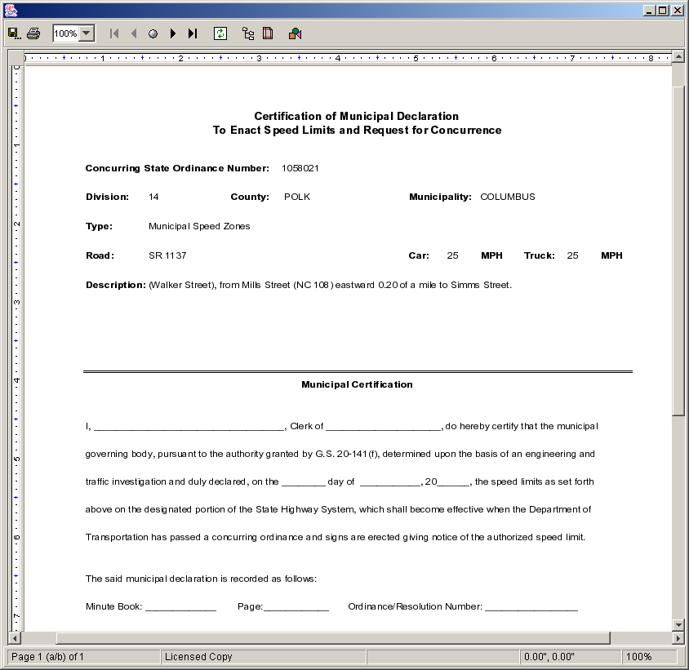
Ordinances – Municipal Approval Certificate

Generating the Municipal Repeal Certificate
The Municipal Repeal Certificate can be generated for a ordinances that are identified as “Municipal Approval Allowed” ordinances and are present in the Results table. Select an ordinance in the Results table. Select Details panel. Clicking on the Municipal Repeal Cert. button will generate the Municipal Repeal Certificate for the Ordinance currently being displayed The certificate will appear in view mode in e.Report Engine. The report may be viewed on the screen, printed, or saved to a file. Refer to Appendix D for an overview of the use of e.Report Engine.
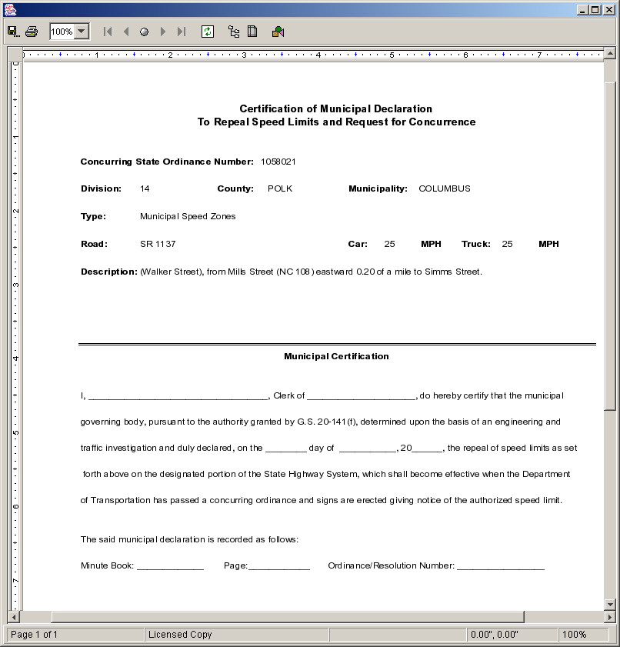
Ordinances – Municipal Repeal Certificate

Exporting Ordinances from Search Screen
The Ordinances Search panel has an Export to File button and a Special Export… button. The former allows users to export all the ordinance information for the Ordinances in the Results table. Users can pick and choose fields, including those shown in the Results table. The Search function has a limit of 2000 records in its Results table and therefore Export To File has the same limit.
The Special Export button allows users to ordinances by ordinance group names. Here users cannot pick and choose fields; the number of data element exported is fix and. Data elements exported includes ordinance data elements and higher order route information such as HO route IDs and their milepost numbers relative to the ordinance’s mileposts. The export is a limited a maximum of 20,000 records to export.
The following table describes the requirements for each field.
Field | Field Requirements
Export to File button | Will display the Export to File Options dialog box.
Special Export… button | Will display the Special Export dialog box.

Pressing the “Export to File” button from the Search panel will bring up a screen as shown below:
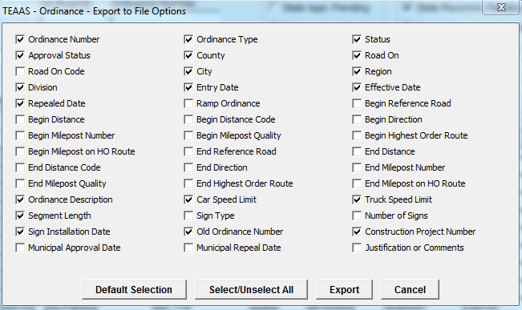
Ordinances – Export to File Options Dialog Box
All the fields that need to be exported can be selected by clicking on the respective check boxes. As shown above some of the fields will be selected by default.
The following table describes the requirements for each field in the Export to File Options dialog box.
Field | Field Requirements
Default Selection button | Will select the default check boxes for export.
Select/Unselect All button | If at least one of the check boxes is checked, clicking this button will deselect all the check boxes. If all the check boxes are unchecked, clicking this button will select all the check boxes.
Export button | The Export button will export the data into an ASCII text file in a ".csv" (comma separated values) format. This file could be opened using MS-Excel.
Cancel button | Cancels the operation.

The Export button will bring up a File Save dialog box shown below and will prompt for a file name. Error message is displayed if the file already exists or if the file cannot be written to.
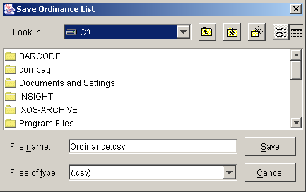
The saved file will contain the information for the selected fields for all the records in the Search Results table.
Pressing the “Special Export…” button from the Search panel will bring up a screen as shown below:
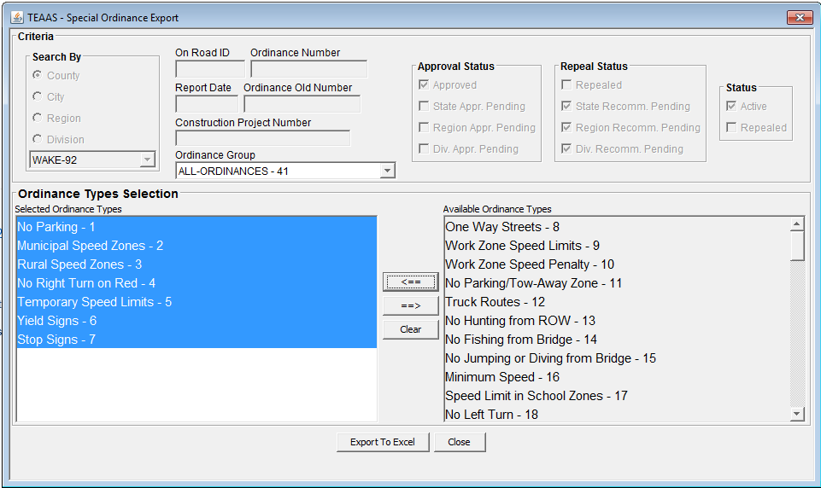
Ordinances – Special Ordinance Export Dialog Box
The Search criteria shown are carried over from the Ordinance Search screen except for Ordinance Type field which has been replaced in the Special Export screen with an Ordinance Group dropdown. Users can related ordinance by a group name in the Ordinance Type Maintenance screen and use that name here to export them all at once. (Refer to Ordinance Maintenance for more information on ordinance groups.)
A dialog similar to the one below will popup when pressing the Export to Excel button.
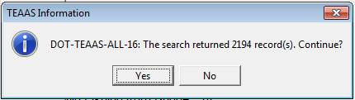
A file selection dialog will popup next
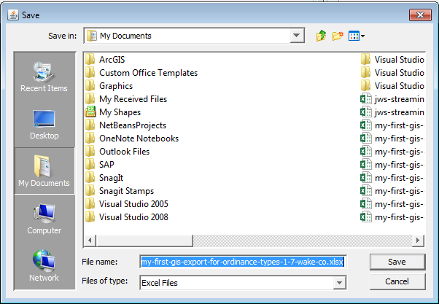
If the user chooses a filename that already exists, a confirmation dialog box will display
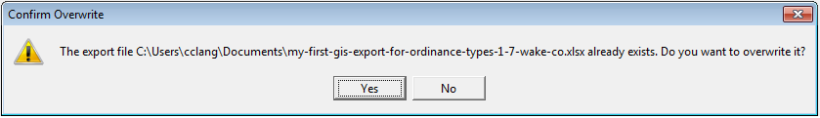

Generating the Certification of Rulemaking
The Certification of Rulemaking report can be generated for a set of ordinances that are present in the Results table. The system will validate that the effective date or repeal date of all the ordinances in the Results to generate the report is the same.
The following table describes the requirements for each field.

Field | Field Requirements
Date of Signing | A valid date in mm/dd/yyyy format must be entered for generating the certificate of rulemaking. This will be defaulted to the current date.
Generate Certificate of Rulemaking button | Will validate the effective and repeal dates and generate the Certificate of Rulemaking report.

Clicking the Generate Certificate of Rulemaking button will cause the Generate Certificate of Rulemaking Report to appear in view mode in e.Report Engine. The report may be viewed on the screen, printed, or saved to a file. Refer to Appendix D for an overview of the use of e.Report Engine.

Certification of Rulemaking Report Details
The report generated has a front page, body and a last page. The front page is the report header. The prominent elements contained within the front page are:
- Action of Adoption or Repeal of Ordinances
- Statutory Authority
- Rule Summary
- Effective Date
- Date, Signature, Name, and Title of the person signing the ordinances
The report body may contain as many as five different sections. The sections are grouped based on the data to be reported for a type of ordinance. Each of these five sections will be broken down based on ordinance type and the ordinances that become effective and the ones that are repealed will be separated out for each ordinance type. The statute number will be printed based on the ordinance types contained in the section. If there is nothing to report for an ordinance type then the headings will not appear. If within an ordinance type there are some ordinances to be declared but nothing to repeal, then the repeal subsection will not appear.
Section 1 will contain Ordinances of the following types:
- No Parking
- One Way Streets
- No Hunting from Right Of Way
- No Fishing from Bridge
- No Jumping or Diving from Bridge
- No Stopping, Standing or Parking on Right Of Way
- No Fishing from Highway Right Of Way
- No Loitering on Highway Right Of Way
- No Motorized Vehicle Zone
- Trucks Prohibited Route
- No Parking/Tow-Away Zone
Section 2 will contain Ordinances of the following types:
- Municipal Speed Zones
- Rural Speed Zones
- Temporary Speed Limits
- Minimum Speed
- Work Zone Speed Limits
- Work Zone Speed Penalty
Section 3 will contain Ordinances of the following types:
- No Right Turn on Red
- No Left Turn
- No Right Turn
- No U-turn
Section 4 will contain Ordinances of the following types:
- Stop Signs
- Yield Signs
Section 5 will contain Ordinances of the following types:
- Route Changes (Interstate, U.S., and N.C.)
- Truck Routes
- Truck Information Station
The last page is the report footer. The prominent elements contained within the front page are:
- Statutes
- Count of Adopted and Repealed Ordinances by Type
- Effective Date
- Date, Signature, Name, and Title of the person signing the ordinances

Generating the Ordinance Report
The Ordinance report can be generated for a set of ordinances that are present in the Results table. This can be generated by users who do not have access/authority to generate the previous report due to the legalities attached to it. This report can be used for filing/verification purposes.
The following table describes the requirements for each field.
Field | Field Requirements
Generate Report button | Will validate the effective and repeal dates and generate the Certificate of Rulemaking report.

Clicking the Generate Report button will cause the Ordinance Report to appear in view mode in e.Report Engine. The report may be viewed on the screen, printed, or saved to a file. Refer to Appendix D for an overview of the use of e.Report Engine.
The Ordinance Report has only one common template for all ordinance types. The rendered report will display the status code abbreviations at the top of the report as follows:
Approval Status: D – division approval pending, R – region approval pending, S – state approval pending, A – approved
Repeal Status: D – division repeal pending, R – region repeal pending, S – state repeal pending, C – repealed
The abbreviations and their definitions will be displayed at the top of every page. The dynamic contents of the report will consist of name value pairs. See screenshot below for more details.
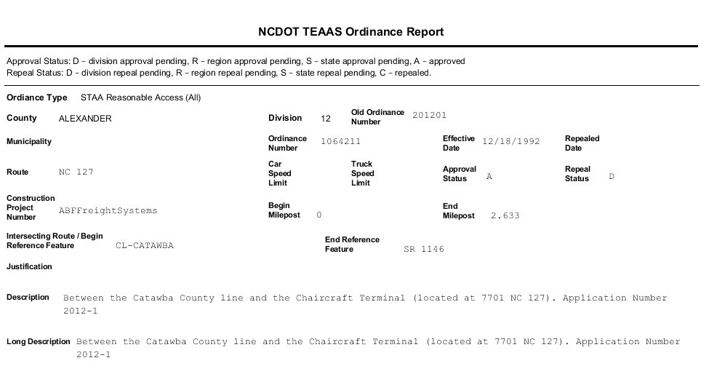

Closing the Ordinances Screen
To close the Ordinances screen, click the Close icon on the toolbar. If a New or Modify operation is in progress, the User will be asked to confirm they want to close without saving. Click the Yes button to close without saving or the No button to return to the operation in progress.

Ordinances TYPes

Ordinances Type Screen Overview
The Ordinances Type screen is used to maintain ordinances types, create new ordinance types, modify ordinance types, delete ordinance types, and export Ordinances types.
To access the Ordinances screen, select the Ordinances button on the Application Browser, select Ordinances from the list box, and click the Open button.
Function Button | Function Name | Sub-Function
 | Ordinances | Ordinances Type Maintenance

The screens that follow are displayed, though their appearance may differ slightly from the figures below depending on the User's assigned Roles.
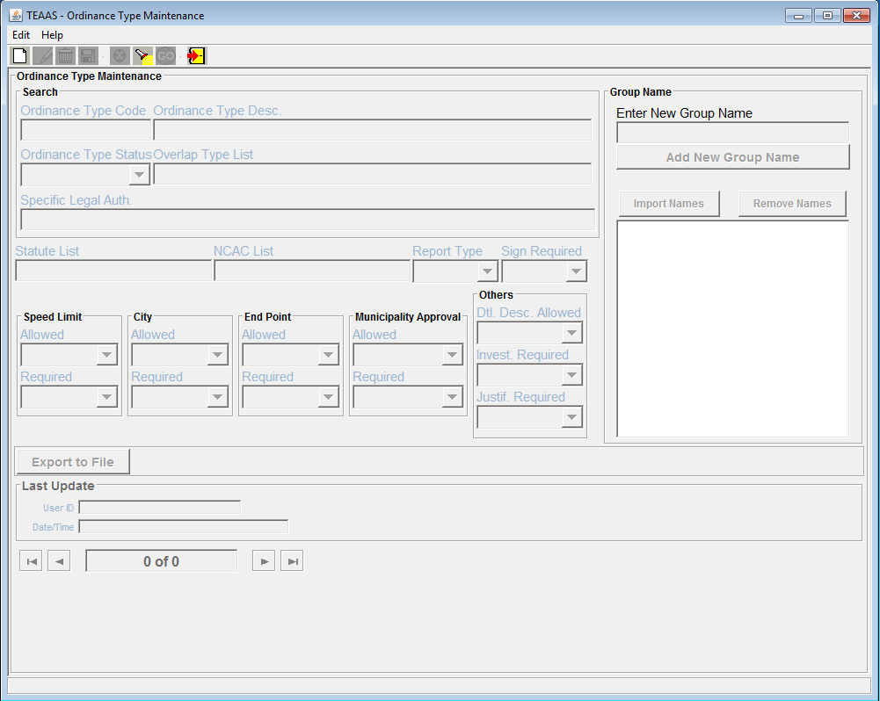

Searching for Ordinances Types
To search for Ordinances, click the Search panel. The following table describes the search criteria allowed.
Field | Search Criteria
Search By Ordinance Type Code | Wild cards * and ? allowed
Ordinance Type Desc | Wild cards * and ? allowed
Ordinance Type Status | Wild cards * and ? allowed
Ordinance Type List | Wild cards * and ? allowed
Specific Legal Authorization | Wild cards * and ? allowed

After all desired search criteria have been entered, click the Search button. A dialog box will appear indicating the number of records returned. Click the OK button on the dialog box to view the records retrieved. Summary information about the Ordinances Type is displayed in Results table.
If no records are returned, a dialog box will appear indicating such. If records were expected to be retrieved, verify that the search criteria are correct. A new search may be executed by adjusting the search criteria and clicking the Search button.

Adding an Ordinance Type
To add a new Ordinance Type, click the New icon on the toolbar. A blank screen will be presented for entering a new record. The following table describes the requirements for each field.
Field | Field Requirements
Ordinances – Details – Main sub panel – Basic Information
Ordinance Type Code | Will be defaulted to the next ordinance type code. Can be overridden.
Ordinance Type Desc. | A 64 character description
Ordinance Type Status | A list box with Ordinance Type Status of “A” or “I”
Overlap Type List | A128 character description
Specific Legal Authorization | A 128 character description
Statue List | A 128 character description
NCAC List | A 128 character description
Report Type | A list box with 1 to 5 choices
Sign Required | A list box with 1 to 5 choices
Speed Limit Allowed | A list box with “Y” or “N”
Speed Limit Required | A list box with “Y” or “N”
City Allowed | A list box with “Y” or “N”
City Required | A list box with “Y” or “N”
End Point Allowed | A list box with “Y” or “N”
End Point Required | A list box with “Y” or “N”
Municipality Approval Allowed | A list box with “Y” or “N”
Municipality Approval Required | A list box with “Y” or “N”
Detail Description Allowed | A list box with “Y” or “N”
Investigation Required | A list box with “Y” or “N”
Justification Required | A list box with “Y” or “N”
Export to File | A button which is enabled when ordinance type is displayed as a result of search
Enter New Group Name | A text field for entering an ordinance group name to associate with the ordinance type. It has a limit of 50 characters.
Add New Group Name | A button to add the new group name into the list box below it
Import Names | Import existing group names in to the list box below it
Remove Names | Remove highlighted group names from the list box below it.

While entering the values all of the fields are enabled.
.

Modifying an Existing Ordinance Type
An existing Ordinance Type may be modified when the record is displayed. To modify a displayed record, click the Modify icon on the toolbar. After changes are made to the fields, click the Save icon on the toolbar. All business rule conditions are verified before the modified record is saved. If all conditions are satisfied, the modified Ordinance is saved and displayed on the screen in view mode.

If no record is modified an error message is displayed indicating that no records are modified.

Deleting an Existing Ordinance Type
An existing Ordinance Type not associated with an Ordinance may be deleted when the record is displayed on the screen, either after conducting a search and viewing details or immediately following a save. To delete a displayed record, click the Delete icon on the toolbar. A confirmation dialog box will appear. Click the Yes button to proceed with the deletion or the No button to cancel the deletion. Ordinance group names associated the Ordinance Type will not be deleted. An error message will be displayed, if trying to delete has an associated Ordinance. The screen will be cleared after the delete.

Canceling an Ordinances Type Screen Operation
New and Modify operations may be canceled before the Save action is invoked, by clicking the Cancel icon on the toolbar. Cancel will return the Ordinances Type to its previous state. For example, if a record is being modified, clicking the Cancel icon, will revert the record to its previous values, displaying it in view mode.

Exporting Ordinance Types
The Export to File button will be enabled when ordinance type is displayed after a search and the displayed records could be exported to an excel spread sheet by clicking the Export to File button.

municipality Names
The following table directs the reader to appropriate Municipality Administration subsections.
MUNICIPALITY NAMES Subsections |  |  | Roles
MUNICIPALITY NAMES Subsections | SA | PDM | SDM | TQU | PQU | PRU | DCU | FDEU | OU | DEOU | DOU | ROU | TEOU | SSU | OA | OER | FU | SDEOU
Municipality Names Screen Overview |  | X | X | X | X
Searching for a Municipality Names Record |  | X | X | X | X
Adding a New Municipality Names Record |  | X
Modifying an Existing Municipality Names Record |  | X
Canceling a Municipality Names Screen Operation |  | X | X | X | X
Deleting a Municipality Names Record |  | X
Closing the Municipality Names Screen |  | X | X | X | X

Municipality Administration Screen Overview
The Municipality Names screen is used to maintain the 6-digit city codes and associated text for municipalities, and political boundaries.
To access the Municipality Names screen, select the Feature Names, Secondary Routes and Exceptions button on the Application Browser, select Municipality Names from the list box, and click the Open button.
Function Button | Function Name | Sub-Function
 | Feature Names, Secondary Routes and Exceptions | Municipality Names

The screen that follows is displayed.
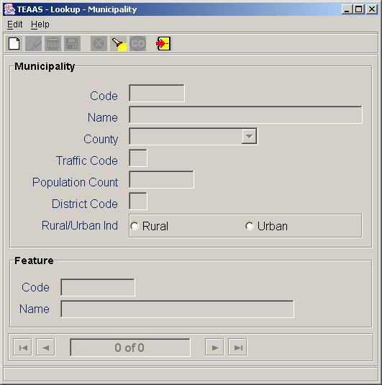
Municipality Names Screen

Searching for a Municipality Names Record
To search, click the Search icon on the toolbar. A blank screen will be presented for entering search criteria. The following table describes the search criteria allowed.
Field | Search Criteria
Code | Enter a specific Code by entering the 6-digit City Code. Wildcard characters may be used to search for one or more City Codes. Leave Code empty if this field is not part of the search criteria.
Name | Enter a specific Municipality Name or use wildcard characters to search for one or more Municipality Name. Leave Name empty if this field is not part of the search criteria. Search is not case sensitive.
County | Select a specific County from the County combo box or leave empty if this field is not part of the search criteria.
Traffic Code | Enter a specific Traffic Code or use wildcard characters to search for one or more Traffic Code. Leave Traffic Code empty if this field is not part of the search criteria.
Population Count | Enter a specific Population Count or use wildcard characters to search for one or more Population Count. Leave Population Count empty if this field is not part of the search criteria.
District Code | Enter a District Code or use wildcard characters to search for one or more District Code. Leave District Code empty if this field is not part of the search criteria. Search is not case sensitive.
Rural/Urban Ind | Select either the Rural or Urban Indicator to search for all Rural or Urban city codes. Do not select Rural/Urban Ind if this field is not part of the search criteria.

After all desired search criteria have been entered, click the Go icon on the toolbar. A dialog box will appear indicating the number of records returned. Click the OK button on the dialog box to view the records retrieved. Returned records are displayed in view mode.
If no records are returned, a dialog box will appear indicating such. If records were expected to be retrieved, verify that the search criteria are correct. A new search may be executed by adjusting the search criteria and clicking the Go icon.
It is recommended that the search criteria be as specific as possible to prevent the retrieval of too many records, which could contribute to local memory concerns and slower system performance. Currently, TEAAS will display a maximum of 500 records for any given search, although more than 500 records may actually meet the search criteria.

Adding a New Municipality Names Record
To add a new record, click the New icon on the toolbar. A blank screen will be presented for entering a new record. The following table describes the requirements for each field.
Field | Field Requirements
Name | A Municipality Name must be specified. This field will only accept alpha text and is 22 characters in width. The Name field in the Feature section will be filled in automatically.
County | A County must be selected from the County combo box.
Traffic Code | A Traffic Code may be typed in. This is a numeric only field and is two digits.
Population Count | A Population Count value must be specified. This is a numeric only field and is 7 digits. The Population Count must be greater than one.
District Code | A District Code must be specified. This field will only accept alpha text and is one character wide.

After all information has been added, click the Save icon on the toolbar. If business rule conditions are not satisfied, a message will indicate the problem encountered. If all conditions are satisfied, the new Municipality Name record is saved and displayed on the screen in view mode. The Municipality Name record consists of the data necessary to insert a record into the city population table and feature name table.

Modifying an Existing Municipality Names Record
An existing record may be modified when the record is displayed on the screen, either after conducting a search or immediately following a save. To modify a displayed record, click the Modify icon on the toolbar. If there are no crashes associated with the city code being modified, the Name, County, Traffic Code, and Population Count fields can be modified. If there are crashes associated with the city code being modified, the Traffic Code and Population Count fields can be modified. After changes are made to the fields, click the Save icon on the toolbar. All business rule conditions are verified before the modified record is saved. If all conditions are satisfied, the modified record is saved and displayed on the screen in view mode.

Canceling a Municipality Names Screen Operation
The New, Modify, and Search operations may be canceled before Save or Go actions are invoked by clicking the Cancel icon on the toolbar. Cancel will return the Municipality Name screen to its previous state. For example, if a record is being modified, clicking the Cancel icon will revert the record to its previous values, displaying it in view mode.

Deleting an Existing Municipality Names Record
An existing record may be deleted when the record is displayed on the screen, either after conducting a search or immediately following a save. To delete a displayed record, click the Delete icon on the toolbar. The record will be deleted if there are no crashes associated with the city code to be deleted.

Closing the Municipality Names Screen
To close the Municipality Names screen, click the Close icon on the toolbar. If a New or Modify operation is in progress, the User will be asked to confirm they want to close without saving. Click the Yes button to close without saving or the No button to return to the operation in progress.

STreet name exceptions
The following table directs the reader to appropriate Street Name Exceptions subsections.
STREET NAME EXCEPTIONS Subsections |  |  | Roles
STREET NAME EXCEPTIONS Subsections | SA | PDM | SDM | TQU | PQU | PRU | DCU | FDEU | OU | DEOU | DOU | ROU | TEOU | SSU | OA | OER | FU | SDEOU
Street Name Exceptions Screen Overview |  | X
Retrieving Street Name Exceptions |  | X
Adding Feature Names |  | X
Closing the Street Name Exceptions Screen |  | X

Street Name Exceptions Screen Overview
The Street Name Exceptions screen identifies and retrieves all Local Street names found in the Crash system that did not encode to a valid 8-digit code during mileposting. It also identifies Secondary Routes that do not have a valid Alternate Road Text name. Street names and secondary route alternate names may be added to TEAAS via this screen.
To access the Street Name Exceptions screen, select the Feature Names, Secondary Routes and Exceptions button on the Application Browser, select Street Name Exceptions from the list box, and click the Open button.
Function Button | Function Name | Sub-Function
 | Feature Names, Secondary Routes and Exceptions | Street Name Exceptions

The screen that follows is displayed.
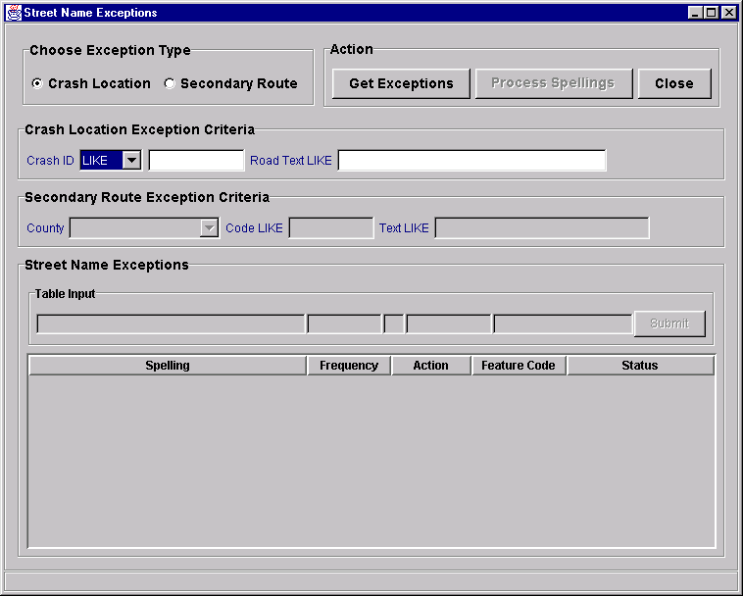
Street Name Exceptions Screen

Retrieving Street Name Exceptions
Retrieval of Street Name exceptions is based on search criteria entered by the User at the top of the screen. The following table describes the search criteria allowed.
Field | Search Criteria
Exception Type | Select Crash Location or Secondary Route.
Crash ID Comparison Combo Box | If Crash Location is selected for Exception type:  Select 'LIKE' to use the '*' wildcard character in the Crash ID field.  Select '=' to search for a specific Crash ID.  Select '<' to search Crash IDs less than a specified value.  Select '>' to search Crash IDs greater than a specified value.
Crash ID | If Crash Location is selected for Exception type:  If '=', '<', or '>' has been specified as the comparison operator, enter a specific Crash ID.  If 'LIKE' has been specified as the comparison operator, enter a partial Crash ID in combination with wildcard characters to search for more than one Crash ID.  Use the '*' by itself or leave blank to select all spellings meeting the Crash ID selection criteria.
Road Text LIKE | If Crash Location is selected for Exception type:  Enter a specific spelling to retrieve only spellings identical to that Street Name entry.  Enter a partial spelling in combination with wildcard characters to search for more than one spelling.  Use the '*' by itself or leave blank to select all spellings meeting the Crash ID selection criteria. Search is not case sensitive.
County | If Secondary Route is selected for Exception type:  Select a County from the County combo box or leave it blank.
Code LIKE | If Secondary Route is selected for Exception type:  Enter a specific code to retrieve only spellings related to that Road Code.  Enter a partial code in combination with wildcard characters to search spellings for more than one Road Code.  Use the '*' by itself or leave blank to select all spellings meeting the other selection criteria.
Text LIKE | If Secondary Route is selected for Exception type:  Enter a specific spelling to retrieve only spellings identical to that Street Name entry.  Enter a partial spelling in combination with wildcard characters to search for more than one spelling.  Use the '*' by itself or leave blank to select all spellings meeting the other selection criteria. Search is not case sensitive.

After all desired search criteria have been entered, click the Get Exceptions button. A dialog box will appear indicating the number of records returned. Street Name Exception now only looks up exceptions in un-mileposted crashes. A maximum of 200 retrieved records will be displayed. Click the OK button on the dialog box to display the retrieved records. The table displays the retrieved Street Names sorted by frequency (the number of spellings meeting the search criteria). The table also contains Action, Feature Code, and Status columns, which are discussed in more detail in the section below.
If the result set is different than expected, verify the search criteria are correct. A new search may be executed by adjusting the criteria and clicking the Get Exceptions button.

Adding Street Names
The Street Name exceptions retrieved may be added as either preferred or alternate Local Street spellings. (The User should use the search function on the Street and Feature Names screen to determine if the spelling is an alternate name for an existing street.) The following table describes the requirements for each field.
Field | Field Requirements
Action | I – Ignore. Retrieved records default to this value. Records with this Action code will be ignored when the spellings are processed.  A – Alternate Spelling. This code is used when a preferred spelling already exists for this street. This Street Name will be added as an alternate spelling associated with the Feature Code specified by the User.  P – Preferred Spelling. This code is used when no preferred spelling is found via the Street and Feature Names screen for the selected street. A new 8-digit code will be created by the system and the Street Name will be identified as the preferred spelling.
Feature Code | When Action code 'A' – If the spelling is an alternate name for an existing street, enter that street code here.  When Action code 'P' – The 8-digit street code will be created by the system.

Click on the row you want to modify and press the Enter key on your keyboard. The row will be moved to the table input box. After making all necessary modifications, click the Submit button to place the row back into the table. Repeat for each row that you want to modify.
After making all necessary modifications, click the Process Spellings button. The Status column will be updated to reflect the processing. The following table describes the feedback documented in the Status column.
Status | Meaning
Completed | The spelling has been added successfully.
Not Processed | The record was ignored (Action code 'I').
Error | An error occurred in processing the spelling.

Records containing errors must be researched to determine the specific cause. Errors may include specifying an invalid street code, or adding a Street Name that already exists. The User should use the search function on the Street and Feature Names screen to assist in resolving errors.
Updates to accident records based on the processed exceptions do not take place until the next remileposting of accidents. Therefore, subsequent retrievals with same selection criteria will produce the same Crash IDs until the next remileposting process has been completed.

Closing the Street Name Exceptions Screen
To close the Street Name Exceptions screen, click the Close button. If the Get Exceptions or Process Spellings operation is in progress, the Street Name Exceptions screen may not be closed until the operation is complete.

MUNICIPALITY name exceptions
The following table directs the reader to appropriate Municipality Name Exceptions subsections.
MUNICIPALITY NAME EXCEPTIONS Subsections |  |  | Roles
MUNICIPALITY NAME EXCEPTIONS Subsections | SA | PDM | SDM | TQU | PQU | PRU | DCU | FDEU | OU | DEOU | DOU | ROU | TEOU | SSU | OA | OER | FU | SDEOU
Municipality Name Exceptions Screen Overview |  | X
Retrieving Municipality Name Exceptions |  | X
Modifying Municipality Name Exceptions |  | X
Closing the Municipality Name Exceptions Screen |  | X

Municipality Name Exceptions Screen Overview
The Municipality Name Exceptions screen identifies and retrieves all Municipality Names in the database that are not valid names.
To access the Municipality Name Exceptions screen, select the Feature Names, Secondary Routes and Exceptions button on the Application Browser, select Municipality Name Exceptions from the list box, and click the Open button.
Function Button | Function Name | Sub-Function
 | Feature Names, Secondary Routes and Exceptions | Municipality Name Exceptions

The screen that follows is displayed.
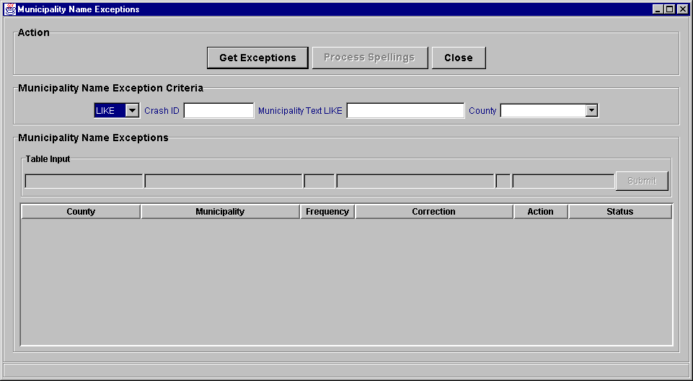
Municipality Name Exceptions Screen

Retrieving Municipality Name Exceptions
Retrieval of Municipality Name exceptions is based on search criteria entered by the User in the Municipality Name Exception Criteria section near the top of the screen. The following table describes the search criteria allowed.
Field | Search Criteria
Crash ID | If '=', '<', or '>' has been specified as the comparison operator, enter a specific Crash ID.  If 'LIKE' has been specified as the comparison operator, enter a partial Crash ID in combination with wildcard characters to search for more than one Crash ID.  Use the '*' by itself or leave blank to select all spellings meeting the Crash ID selection criteria.
Municipality Text LIKE | Enter a specific spelling to retrieve only spellings identical to that Municipality Name entry.  Enter a partial spelling in combination with wildcard characters to search for more than one spelling.  Use the '*' by itself or leave blank to select all spellings meeting the Municipality Name selection criteria. Search is not case sensitive.
County | Select a county from the combo box to retrieve only spellings identical to that County Name entry.  Leave blank to search all counties.

After all desired search criteria have been entered, click the Get Exceptions button. A dialog box will appear indicating the number of records returned. A maximum of 200 retrieved records will be displayed. Click the OK button on the dialog box to display the retrieved records. The table displays the retrieved Municipality Names sorted by County Name. The Frequency shows the number of spellings meeting the search criteria. The table also contains Correction, Action, and Status columns, which are discussed in more detail in the section below.
If the result set is different than expected, verify the search criteria are correct. A new search may be executed by adjusting the criteria and clicking the Get Exceptions button.

Modifying Municipality Names
Clicking on the row you want to modify and then pressing the Enter key on your keyboard, the Municipality Name exceptions retrieved can be modified. The row will be moved to the table input box. After making all necessary modifications, click the Submit button to place the row back into the table. Repeat for each row that you want to modify
The following table describes the requirements for each field.
Field | Field Requirements
Correction | The new spelling of the Municipality.
Action | I – Ignore. Retrieved records default to this value. Records with this Action code will be ignored when the Process Spellings button is selected.  C – Correct Spelling. This is the correct spelling for this Municipality. Records with this Action code will be processed when the Process Spellings button is selected.

After making all necessary modifications, click the Process Spellings button. The Status column will be updated to reflect the processing. The following table describes the feedback documented in the Status column.
Status | Meaning
Completed | The spelling has been processed successfully.
Not Processed | The record was ignored (Action code 'I').
Error | An error occurred in processing the spelling.

Records containing errors must be researched to determine the specific cause. There are two reasons why errors may occur. Selecting a Municipality that is not in the database or selecting a Municipality that is not in a particular County.
Updates to accident records based on the processed exceptions do not take place until the next remileposting of accidents. Therefore, any reports that access this information are not available until the next remileposting process has been completed.

Closing the Municipality Name Exceptions Screen
To close the Municipality Name Exceptions screen, click the Close button. If the Get Exceptions or Process Spellings operation is in progress, the Municipality Name Exceptions screen may not be closed until the operation is complete.

Fiche report
The following table directs the reader to appropriate Fiche Report subsections.
FICHE REPORT Subsections |  |  | Roles
FICHE REPORT Subsections | SA | PDM | SDM | TQU | PQU | PRU | DCU | FDEU | OU | DEOU | DOU | ROU | TEOU | SSU | OA | OER | FU | SDEOU
Fiche Report Overview |  |  |  | X | X
Beginning a Fiche Report |  |  |  | X | X
Road Identification Process |  |  |  | X | X
Generating the Fiche Report |  |  |  | X | X
Closing the Fiche Report Screen |  |  |  | X | X

Fiche Report Overview
The Fiche Report displays information regarding crashes occurring in a specific county, within a specific municipality, during a selected period of time, and on a specific physical roadway.
To access the Fiche Report screen, select the Generate Reports button on the Application Browser, select Fiche Report from the list box, and click the Open button.
Function Button | Function Name | Sub-Function
 | Generate Reports | Fiche Report

The Fiche Report screen below will be displayed. The User input selection criteria and Fiche Report generation processes are described in the sections below.
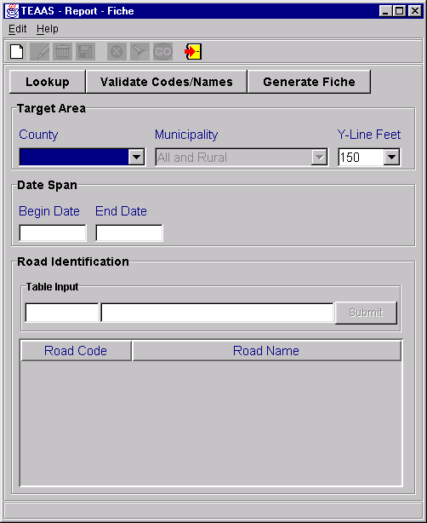
Fiche Report Screen

Beginning a Fiche Report
A blank Fiche Report screen appears when it is initially launched from the Application Browser. Click the New icon on the toolbar at any time to clear the current information or begin a new Fiche Report. The following table describes the requirements for each field.
Field | Field Requirements
County | A County must be selected from the County combo box.
Municipality | To retrieve accidents for a specific municipality within the County, select the municipality name.  To retrieve all accidents occurring outside incorporated municipalities, within the specified County, select 'Rural'.  To retrieve all accidents occurring in the specified County, select 'All and Rural' (the default value).
Y-Line Feet | Select a value from the combo box or enter a whole number between 0 and 9999, inclusive. The default value is 150.
Begin Date | Enter the beginning date for the range of accident dates to be retrieved. The format is MM/DD/CCYY. Leading zeroes for the month and day may be omitted.
End Date | Enter the ending date for the range of accident dates to be retrieved. The format is MM/DD/CCYY. Leading zeroes for the month and day may be omitted. End Date cannot be less than Begin Date.
Road Code/Road Name | At least one Road Code/Road Name is required to generate the Fiche Report. It is recommended the User enter only a Road Code or Road Name to eliminate possible inconsistencies. Refer to the Road Identification Process described below.  Road Code – In the first Table Input box, enter a valid 8-digit code identifying the physical roadway, OR  Road Name – In the second Table Input box, enter a road name of up to 25 alphanumeric characters.

Road Identification Process
After either a Road Code or Road Name has been entered, click the Submit button to add the selection to the Road Code/Road Name table. If there are coinciding routes for the physical roadway, input additional Road Codes or Road Names using the same procedure. All Road Codes/Road Names entered should relate to only one physical roadway.
To delete a row in the Road Code/Road Name table, highlight the row and strike the Delete key on the keyboard.
To modify a row in the Road Code/Road Name table, highlight the row and strike the Enter key on the keyboard. The record will appear in the table input section where modifications can be made. After modifications are made, click the Submit button to add the record back to the Road Code/Road Name table.
To retrieve Alternate Street Names for Secondary Route codes in the Road Code/Road Name table, click the Lookup button. The Secondary Route Names Lookup screen will list the Alternate Street Names for the Secondary Routes in the table. To add a Street Name to the Road Code/Road Name table, highlight the name and click the Include button. Multiple entries may be highlighted using the Ctrl or Shift key.
After all desired Road Codes, Road Names, and Secondary Route Alternate Street Names have been added to the Road Code/Road Name table, validate entries before generating the Fiche Report by clicking the Validate Codes/Names button. If validation is not explicitly selected by the User, it will occur when the Generate Fiche button is clicked. Road Codes may be overwritten by the system for those rows containing both a Road Code and Road Name. After the validation process has been completed, the Fiche Report may be generated as described in the section below.

Generating the Fiche Report
To generate the Fiche Report, click the Generate Fiche button. The Fiche Report will appear in view mode in e.Report Engine. The report may be viewed on the screen, printed, or saved to a file. Refer to Appendix D for an overview of the use of e.Report Engine.

Closing the Fiche Report Screen
The Fiche Report screen may be closed at any time except while report creation is in progress. To close the Fiche Report screen, click the Close icon on the toolbar.

Intersection ANALYSIS report
The following table directs the reader to appropriate Intersection Analysis Report subsections.
INTERSECTION ANALYSIS REPORT Subsections |  |  | Roles
INTERSECTION ANALYSIS REPORT Subsections | SA | PDM | SDM | TQU | PQU | PRU | DCU | FDEU | OU | DEOU | DOU | ROU | TEOU | SSU | OA | OER | FU | SDEOU
Intersection Analysis Report Overview |  |  |  | X | X
Study Information Tab |  |  |  | X | X
Road Identification Tab |  |  |  | X | X
Accident Adjustments Tab |  |  |  | X | X
Creating a New Intersection Analysis Study |  |  |  | X | X
Saving a New Intersection Analysis Study |  |  |  | X | X
Searching for an Intersection Analysis Study |  |  |  | X | X
Modifying an Intersection Analysis Study |  |  |  | X | X
Deleting an Intersection Analysis Study |  |  |  | X | X
Canceling an Intersection Analysis Study |  |  |  | X | X
Closing the Intersection Analysis Report Screen |  |  |  | X | X

Intersection Analysis Report Overview
The Intersection Analysis Report displays information regarding crashes occurring within a selected period of time at a specified intersection.
To access the Intersection Analysis Report screen, select the Generate Reports button on the Application Browser, select Intersection Analysis Report from the list box, and click the Open button.
Function Button | Function Name | Sub-Function
 | Generate Reports | Intersection Analysis Report

The screen that appears is comprised of three tabs:
- The Study Information tab collects information about the Study Area and the person or organization who requested the Study.
- The Road Identification tab allows the User to identify the primary road used to generate a Fiche Report, and to specify the Intersection road combinations to be used in the Study.
- The Accident Adjustments tab allows the User to include or exclude accidents from the next Study generated.
The use of each tab is discussed in more detail in the following sections.

Study Information Tab
The Study Information tab below is initially displayed after the Open button is clicked on the Application Browser.
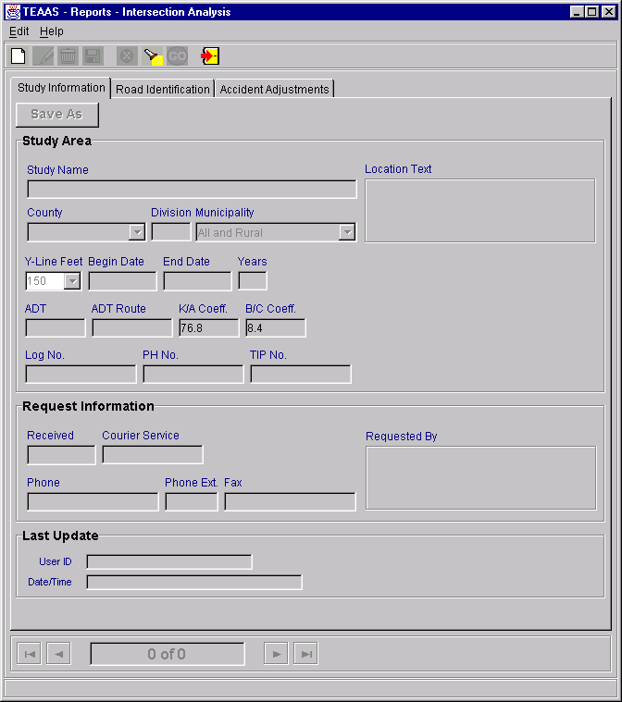
Intersection Analysis Report: Study Information Tab

The Study Information tab collects information about the Study Area and the person or organization who requested the Study. The following table describes the requirements for each field.
Field | Req'd  to  Save | Req'd  for  Fiche | Req'd  for  Study | Field Requirements
Study Name | X |  |  | A unique name of up to 30-alphanumeric characters given to the Study criteria. Search is non case sensitive.
Location Text |  |  |  | A text description of up to 160 alphanumeric characters. Search is non case sensitive.
County |  | X | X | A County must be selected from the County combo box.
Municipality |  | X | X | To retrieve accidents for a specific municipality within the County, select the municipality name.  To retrieve all accidents occurring outside incorporated municipalities, within the specified County, select 'Rural.'  To retrieve all accidents occurring in the specified County, select 'All and Rural' (the default value).
Y-Line Feet |  | X | X | Select a value from the combo box or enter a whole number between 0 and 9999, inclusive. The default value is 150 feet.
Begin Date |  | X | X | Enter the beginning date for the range of accident dates to be retrieved. The format is MM/DD/CCYY. Leading zeroes for the month and day may be omitted.
End Date |  | X | X | Enter the ending date for the range of accident dates to be retrieved. The format is MM/DD/CCYY. Leading zeroes for the month and day may be omitted. End Date cannot be less than Begin Date.
ADT |  |  | X | The Average Daily Traffic (ADT) count must be entered in the range 1-999999.
ADT Route |  |  |  | The 8-digit code identifying the route on which the ADT was taken.
K/A Coeff |  |  | X | The K/A Coefficient in the format 99.9 must be entered. K/A Coefficient has a default value that will be retrieved from the FTV_MASTER_LOOKUP table. The default value should not be altered if no other value is known.
B/C Coeff |  |  | X | The B/C Coefficient in the format 99.9 must be entered. B/C Coefficient has a default value that will be retrieved from the FTV_MASTER_LOOKUP table. The default value should not be altered if no other value is known.
Log No. |  |  |  | The number assigned by the User to identify the Study. May be up to 11 alphanumeric characters. Search is non case sensitive.
PH No. |  |  |  | The number used by the Highway Safety Improvement Program to track potentially hazardous (PH) areas. May be up to 10 alphanumeric characters. This field is now a searchable filed and the search is non case sensitive.
TIP No. |  |  |  | The number assigned by the Division of Highways to track Transportation Improvement Program (TIP) projects. May be up to 10 alphanumeric characters. Search is non case sensitive.
Received |  |  |  | The date that the request for the Study was received may be entered in the format MM/DD/CCYY. Leading zeroes for the month and day may be omitted.
Courier Service |  |  |  | The courier address for the requestor may be entered, up to 10 alphanumeric characters.
Requested By |  |  |  | The person or organization requesting the Study may be entered, up to 60 alphanumeric characters.
Phone |  |  |  | The requestor's phone number may be entered, up to 13 characters. Parentheses and the hyphen character may be used in the phone number.
Phone Ext. |  |  |  | A Phone Extension with a maximum of 5 characters may be entered.
Fax |  |  |  | The requestor's fax number may be entered, up to 13 characters. Parentheses and the hyphen character may be used in the phone number.
User ID |  |  |  | User ID of the person who last updated the report. Search is non case sensitive.
Date/Time |  |  |  | Date and time the report was last updated.

Road Identification Tab
The Road Identification tab appears as displayed below.
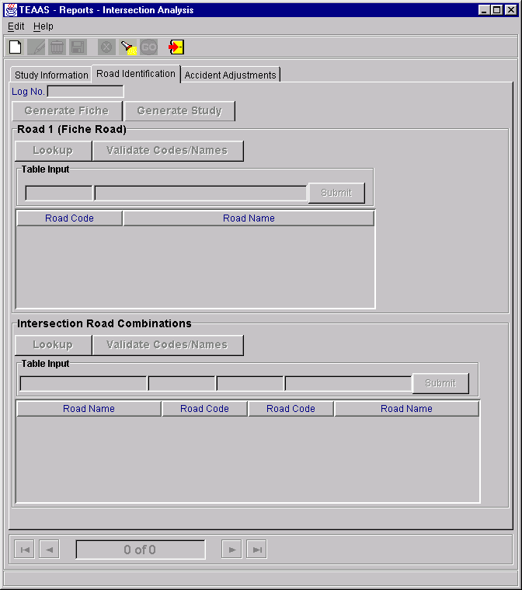
Intersection Analysis Report: Road Identification Tab

The Road Identification tab contains two subsections: Road 1 (Fiche Road) and Intersection Road Combinations. The use of each subsection is described below.

Road 1 (Fiche Road)
At least one Road Code/Road Name is required to generate the Fiche report. It is recommended the User enter only a Road Code or Road Name to eliminate possible inconsistencies. In the first Table Input box, enter a valid 8-digit code identifying the physical roadway; or in the second Table Input box, enter a road name of up to 25 alphanumeric characters.
After either a Road Code or Road Name has been entered, click the Submit button to add the selection to the Road Code/Road Name table. If there are coinciding routes for the physical roadway, input additional Road Codes or Road Names using the same procedure. All Road Codes/Road Names entered should relate to only one physical roadway.
To delete a row in the Road Code/Road Name table, highlight the row and strike the Delete key on the keyboard.
To modify a row in the Road Code/Road Name table, highlight the row and strike the Enter key on the keyboard. The record will appear in the table input section where modifications can be made. After modifications are made, click the Submit button to add the record back to the Road Code/Road Name table.
To retrieve Alternate Street Names for Secondary Route codes in the Road Code/Road Name table, click the Lookup button. The Secondary Route Names Lookup screen will list the Alternate Street Names for the Secondary Routes in the table. To add a Street Name to the Road Code/Road Name table, highlight the name and click the Include button. Multiple entries may be highlighted using the Ctrl or Shift key.
After all desired Road Code, Road Name, and Secondary Route Alternate Street Name entries have been added to the Road Code/Road Name table, validate entries before generating the Fiche Report by clicking the Validate Codes/Names button. If validation is not explicitly selected by the User, it will occur when the Generate Fiche button is clicked. Road Codes may be overwritten by the system for those rows containing both a Road Code and Road Name. After the validation process has been completed, the Fiche Report may be generated by clicking the Generate Fiche button. The Fiche report will be created and will appear in view mode in e.Report Engine. The report may be viewed on the screen, printed, or saved to a file. Refer to Appendix D for an overview of the use of e.Report Engine.

Intersection Road Combinations
The User must specify at least one Intersection Road Combination to generate a Study. It is recommended the User enter only a Road Code or Road Name to eliminate possible inconsistencies.
If the intersecting roads are thought of as the combination of A and B:
- For Road A, in the first Table Input box, enter a road name of up to 25 alphanumeric characters; or in the second Table Input box, enter a valid 8-digit code identifying the road.
- For Road B, in the third Table Input box, enter a valid 8-digit code identifying the road; or in the fourth Table Input box, enter a road name of up to 25 alphanumeric characters.
After an Intersection Road Combination has been entered, click the Submit button to add the selection to the Combination table. If there are coinciding routes for either road, input additional combinations using the same procedure, though an intersection combination need only be entered once. For example, if Main and First streets have been entered as an intersection combination, the combination of First and Main is not required.
To delete a row in the Combination table, highlight the row and strike the Delete key on the keyboard.
To modify a row in the Combination table, highlight the row and strike the Enter key on the keyboard. The record will appear in the table input section where modifications can be made. After modifications are made, click the Submit button to add the record back to the Combination table.
To retrieve Alternate Street Names for Secondary Route codes in the Combination table, click the Lookup button. The Secondary Route Names Lookup screen will list the Alternate Street Names for the Secondary Routes in the table. To add a Street Name to the Combination table, highlight the name and click the Include button. Multiple entries may be highlighted using the Ctrl or Shift keys. Intersecting roads must be specified for any Secondary Route Alternate Street Names included in this manner by modifying the appropriate row(s).
After all desired intersection combinations have been added to the table, validate entries before generating the Study by clicking the Validate Codes/Names button. If the User does not explicitly select validation, it will occur when the Generate Study button is clicked. Road Codes may be overwritten by the system for those rows containing both a Road Code and Road Name. After the validation process has been completed, the Study may be generated by clicking the Generate Study button.
The following “TEAAS – Crash Lists” dialog box will appear and ask the User if they want to save the Crash ID list, or the Detailed Crash ID list.

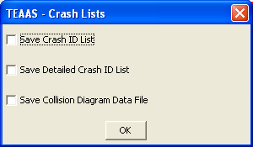
TEAAS – Crash Lists dialog box
If no selection is desired, just click the OK button. If one or more of the files is desired, check the appropriate check box and click on the OK button.
If the “Save Crash ID List” dialog box were selected, the following “Save Crash ID List” dialog box will appear.

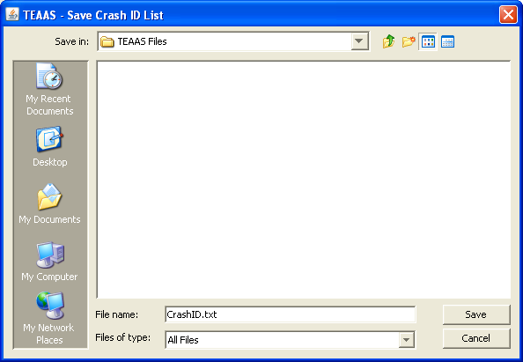
Save Crash ID List dialog box
Identify the directory in which to store the file, and click the Save button or Cancel button to skip. The data will be saved.
If the “Save Detailed Crash ID List” dialog box were selected, the following “Save Detailed Crash ID List” dialog box will appear.

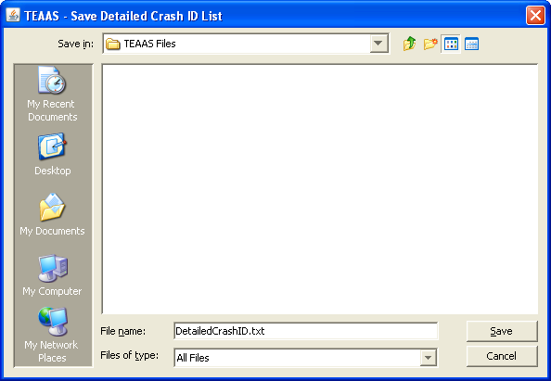
Save Detailed Crash ID List dialog box
Identify the directory in which to store the file, and click the Save button or Cancel button to skip. The data will be saved.
If the “Save Collision Diagram data File” dialog box were selected, the following “Save Collision Diagram Data” dialog box will appear.
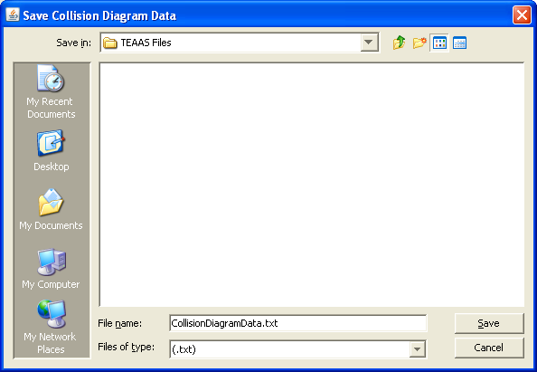
Save Collision Diagram Data dialog box
The Study will be created and will appear in view mode in e.Report Engine. The report may be viewed on the screen, printed, or saved to a file. Refer to Appendix D for an overview of the use of e.Report Engine.

Accident Adjustments Tab
The Accident Adjustments tab appears as displayed below.
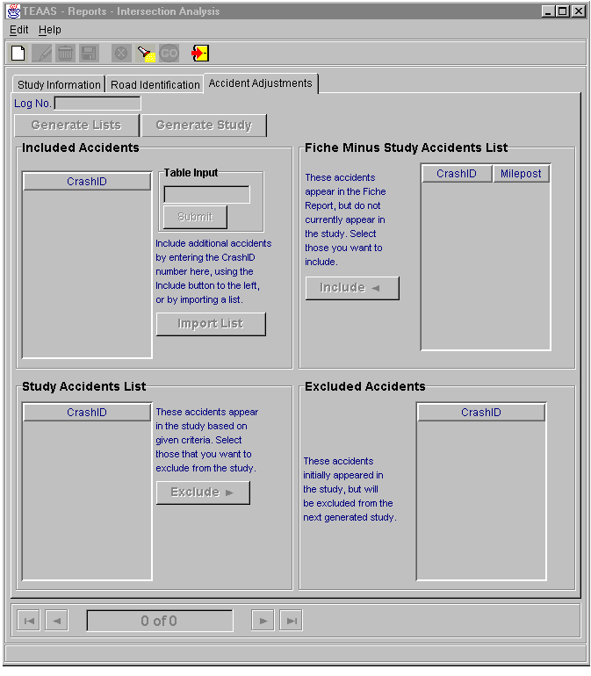Intersection Analysis Report: Accident Adjustments Tab
The Accidents Adjustments Tab contains four subsections: Fiche Minus Study Accidents List, Included Accidents, Study Accidents List, and Excluded Accidents. The use of each subsection is described below.
Inclusions and/or exclusions are not required to generate a Study; however, they allow the User to refine the next Study generated.

Fiche Minus Study Accidents List
The Fiche Minus Study Accidents List is populated only after the Generate Lists button has been clicked. The accidents appearing in this table are contained within the Fiche Report but do not currently appear in the Study. To include accidents in the next Study generated, highlight the Crash ID in the Fiche Minus Study Accidents List and click the Include button. The highlighted Crash ID will be copied to the Included Accidents table to the right. The Ctrl and Shift keys may be used to highlight multiple records. Continue this process until all desired accidents have been selected and copied to the Included Accidents table. After all inclusion activity has been completed, a new Study may be generated by clicking the Generate Study button.

Included Accidents
This table may be populated in any combination of three ways:
- Crash IDs may be included from the Fiche Minus Study Accidents List, as described above.
- A specific Crash ID may be added to the Included Accidents table by entering a Crash ID in the Table Input field and clicking the Submit button.
- Multiple Crash IDs may be added from a text file by clicking the Import List button. A Get Import List dialog box will appear to allow the User to specify the text file to be imported. After the file name has been specified, click the OK button to import the file. The Crash IDs contained in the text file will appear in the Included Accidents table. Click the Cancel button on the Get Import List dialog box to cancel the import process. The text file must contain only Crash IDs, one per line.
Crash IDs contained in the Included Accidents table may be deleted by highlighting the Crash ID in the Included Accidents table and striking the Delete key. The Ctrl and Shift keys may be used to highlight multiple records.
Crash IDs contained in the Included Accidents table may be sorted (ascending) by clicking the Sort button.
The Crash IDs contained in the Included Accidents table will be validated to make sure that the Accident Date of the Crash ID is within the Study date range. An error will be shown with the Crash ID. Remove this Crash ID from the Included Accidents table and click the Generate Study button again,
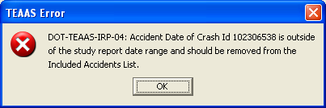
Error Message when the Crash ID Accident Date is not within the Study Date Range

After all inclusion activity has been completed, a new Study may be generated by clicking the Generate Study button.

Study Accidents List
The Study Accidents List is populated only after the Generate Lists button has been clicked. The accidents appearing in this table are contained in the Study. To exclude Crash IDs for the next Study generated, highlight the Crash ID in the Study Accidents List and click the Exclude button. The highlighted Crash ID will be copied to the Excluded Accidents table to the right. The Ctrl and Shift keys may be used to highlight multiple records. Continue this process until all desired Crash IDs have been selected and copied to the Excluded Accidents table. After all exclusion activity has been completed, a new Study may be generated by clicking the Generate Study button.

Excluded Accidents
The Excluded Accidents table can be populated only by excluding accidents in the manner described in the Study Accidents List section above. Crash IDs contained in the Excluded Accidents table may be deleted by highlighting the Crash ID in the Excluded Accidents table and striking the Delete key. The Ctrl and Shift keys may be used to highlight multiple records. After all exclusion activity has been completed, a new Study may be generated by clicking the Generate Study button.

Creating a New Intersection Analysis Study
The Intersection Analysis Report screen appears in view mode when it is initially launched from the Application Browser. Click the New icon on the toolbar to begin a new Intersection Analysis Study. When modifying an existing Study, either save the Study, or cancel changes, then click the New icon. Refer to the Study Information Tab, Road Identification Tab, and Accident Adjustments Tab subsections for descriptions of input requirements.

Saving a New Intersection Analysis Study
After all desired information and criteria have been added, click the Save icon on the toolbar. If business rule conditions are not satisfied, a message will indicate the problem encountered. If all conditions are satisfied, the new Study is saved and displayed on the screen in view mode.

Searching for an Intersection Analysis Study
Existing studies may be used as a starting point for creating a new Study. Click the Search icon on the toolbar. The Study Name, Location Text, Log No., PH No., TIP No., County, and User ID fields will be enabled for search criteria to be entered. Enter the information you want to search by, or use wildcard characters to search for one or more Study. After search criteria are entered, click the Go icon on the toolbar to retrieve all studies satisfying the search criteria. The navigation bar may be used to view the studies returned by the search. Search is not case sensitive. Note that the report cannot be generated without clicking the Modify icon on the toolbar. Please refer to Modifying an Intersection Analysis Study, below.

Modifying an Intersection Analysis Study
When an existing Study is displayed on the screen in view mode, the User must click the Modify icon on the toolbar to have the ability to generate the report, regardless of whether the Study criteria will be altered. The User may modify the criteria, generate the report, and close the Study without saving changes
When saving modifications, the following rules apply:
- The User who originally created the Study may save changes to that Study Name by clicking the Save icon on the toolbar.
- The User who originally created the Study may save the modified criteria as another Study Name by clicking the Save As button on the Study Information Tab.
- A User who did not create the Study can save the modified criteria as another Study Name by clicking either the Save icon on the toolbar, or by clicking the Save As button on the Study Information Tab.

Deleting an Intersection Analysis Study
An existing Study may only be deleted by the original creator of the Study, either after conducting a search to retrieve the Study or immediately after saving the Study. To delete a displayed Study, click the Delete icon on the toolbar. A confirmation dialog box will appear. Click the Yes button to proceed with the deletion or the No button to cancel the deletion. If the deleted Study was the only Study previously displayed on the screen, the screen will be cleared after the delete. If multiple Studies were displayed, the next Study will now be displayed. The record count at the bottom of the Intersection Analysis Report screen will be adjusted accordingly after the deletion.

Canceling an Intersection Analysis Study Operation
The New, Modify, and Search operations may be canceled before Save or Go actions are invoked by clicking the Cancel icon on the toolbar. Cancel will return the Intersection Analysis Report screen to its previous state. For example, if a Study is being modified, clicking Cancel will revert the record to its previous values, displaying it in view mode.

Closing the Intersection Analysis Report Screen
The Intersection Analysis Report screen may be closed at any point except while the creation of the report or generation of the lists is in progress. To close the Intersection Analysis Report screen, click the Close icon on the toolbar.

Strip ANALYSIS report
The following table directs the reader to appropriate Strip Analysis Report subsections.
STRIP ANALYSIS REPORT Subsections |  |  | Roles
STRIP ANALYSIS REPORT Subsections | SA | PDM | SDM | TQU | PQU | PRU | DCU | FDEU | OU | DEOU | DOU | ROU | TEOU | SSU | OA | OER | FU | SDEOU
Strip Analysis Report Overview |  |  |  | X | X
Study Information Tab |  |  |  | X | X
Road Identification Tab |  |  |  | X | X
Accident Adjustments Tab |  |  |  | X | X
Feature Inclusions Tab |  |  |  | X | X
Creating a New Strip Analysis Study |  |  |  | X | X
Saving a New Strip Analysis Study |  |  |  | X | X
Searching for a Strip Analysis Study |  |  |  | X | X
Modifying a Strip Analysis Study |  |  |  | X | X
Deleting a Strip Analysis Study |  |  |  | X | X
Canceling a Strip Analysis Study |  |  |  | X | X
Closing the Strip Analysis Report Screen |  |  |  | X | X

Strip Analysis Report Overview
The Strip Analysis Report displays information regarding crashes occurring within a selected period of time along a specified strip of roadway.
To access the Strip Analysis Report screen, select the Generate Reports button on the Application Browser, select Strip Analysis Report from the list box, and click the Open button.
Function Button | Function Name | Sub-Function
 | Generate Reports | Strip Analysis Report

The screen that appears is comprised of four tabs:
- The Study Information tab collects information about the Study Area and the person or organization who requested the Study.
- The Road Identification tab allows the User to identify the primary road used to generate the Study, as well as any coinciding routes, which are used in combination with the primary road to generate the Fiche Report.
- The Accident Adjustments tab allows the User to include or exclude accidents from the next Study generated.
- The Feature Inclusion tab allows the User to include Features not currently inventoried along the Strip Road.
The use of each tab is discussed in more detail in the following subsections.

Study Information Tab
The Study Information tab below is initially displayed after the Open button is clicked on the Application Browser.
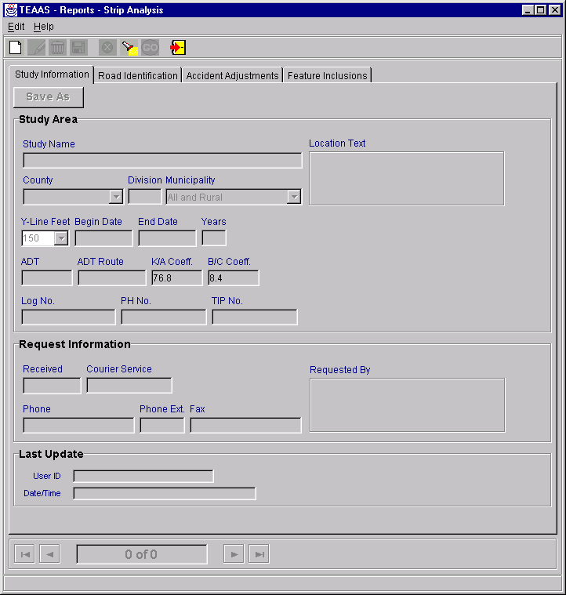
Strip Analysis Report: Study Information Tab

The Study Information tab collects information about the Study Area and the person or organization who requested the Study. The following table describes the requirements for each field.
Field | Req'd  to  Save | Req'd  for  Fiche | Req'd  for  Study | Field Requirements
Study Name | X |  |  | A unique name of up to 30-alphanumeric characters given to the Study criteria. Search is non case sensitive.
Location Text |  |  |  | A text description of up to 160 alphanumeric characters. Search is non case sensitive.
County |  | X | X | A County must be selected from the County combo box.
Municipality |  | X | X | To retrieve accidents for a specific municipality within the County, select the municipality name.  To retrieve all accidents occurring outside incorporated municipalities, within the specified County, select 'Rural.'  To retrieve all accidents occurring in the specified County, select 'All and Rural' (the default value).
Y-Line Feet |  | X | X | Select a value from the combo box or enter a whole number between 0 and 9999, inclusive. The default value is 0 feet.
Begin Date |  | X | X | Enter the beginning date for the range of accident dates to be retrieved. The format is MM/DD/CCYY. Leading zeroes for the month and day may be omitted.
End Date |  | X | X | Enter the ending date for the range of accident dates to be retrieved. The format is MM/DD/CCYY. Leading zeroes for the month and day may be omitted. End Date cannot be less than Begin Date.
ADT |  |  | X | The Average Daily Traffic (ADT) count must be entered in the range 1-999999.
ADT Route |  |  |  | The 8-digit code identifying the route on which the ADT was taken.
K/A Coeff |  |  | X | The K/A Coefficient in the format 99.9 must be entered. K/A Coefficient has a default value that will be retrieved from the FTV_MASTER_LOOKUP table. The default value should not be altered if no other value is known.
B/C Coeff |  |  | X | The B/C Coefficient in the format 99.9 must be entered. B/C Coefficient has a default value that will be retrieved from the FTV_MASTER_LOOKUP table. The default value should not be altered if no other value is known.
Log No. |  |  |  | The number assigned by the User to identify the Study. May be up to 11 alphanumeric characters. Search is non case sensitive.
PH No. |  |  |  | The number used by the Highway Safety Improvement Program to track potentially hazardous (PH) areas. May be up to 10 alphanumeric characters. This field is now a searchable filed and the search is non case sensitive.
TIP No. |  |  |  | The number assigned by the Division of Highways to track Transportation Improvement Program (TIP) projects. May be up to 10 alphanumeric characters. Search is non case sensitive.
Received |  |  |  | The date that the request for the Study was received may be entered in the format MM/DD/CCYY. Leading zeroes for the month and day may be omitted.
Courier Service |  |  |  | The courier address for the requestor may be entered, up to 10 alphanumeric characters.
Requested By |  |  |  | The person or organization requesting the Study may be entered, up to 60 alphanumeric characters.
Phone |  |  |  | The requestor's phone number may be entered, up to 13 characters. Parentheses and the hyphen character may be used in the phone number.
Phone Ext. |  |  |  | A Phone Extension with a maximum of 5 characters may be entered.
Fax |  |  |  | The requestor's fax number may be entered, up to 13 characters. Parentheses and the hyphen character may be used in the phone number.
User ID |  |  |  | User ID of the person who last updated the report. Search is non case sensitive.
Date/Time |  |  |  | Date and time the report was last updated.

Road Identification Tab
The Road Identification tab appears as displayed below.
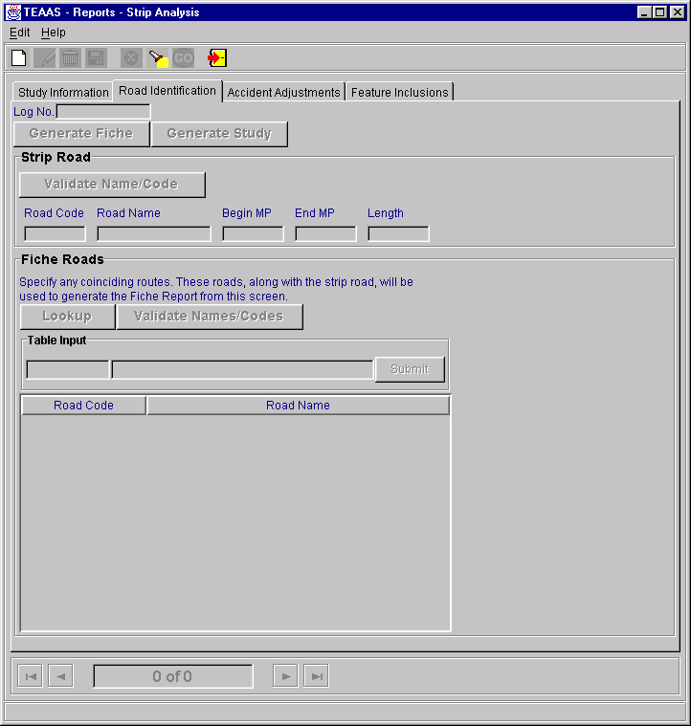
Strip Analysis Report: Road Identification Tab
The Road Identification tab contains two subsections: Strip Road and Fiche Roads. The use of each subsection is described below.

Strip Road
The entry in this section should correspond to the strip under Study. Enter either a Road Code or the Road Name, along with the corresponding milepost range for the strip. This road should represent the most continuous segment for the strip under Study.
It is recommended the User enter only a Road Code or Road Name to eliminate possible inconsistencies. In the first Table Input box, enter a valid 8-digit code identifying the physical roadway; or in the second Table Input box, enter a road name of up to 25 alphanumeric characters. Enter the Begin and End Milepost for the segment under Study.
Validate entries before generating the Study by clicking the Validate Strip Roads button. If validation is not explicitly selected by the User, it will occur when the Generate Study button is clicked. Road Codes may be overwritten by the system for those rows containing both a Road Code and Road Name. After the validation process has been completed, the Study may be generated by clicking the Generate Study button.
The following “TEAAS – Crash Lists” dialog box will appear and ask the User if they want to save the Crash ID list, or the Detailed Crash ID list.
TEAAS – Crash Lists dialog box
If no selection is desired, just click the OK button. If one or more of the files is desired, check the appropriate check box and click on the OK button.
If the “Save Crash ID List” dialog box were selected, the following “Save Crash ID List” dialog box will appear.
Save Crash ID List dialog box
Identify the directory in which to store the file, and click the Save button or Cancel button to skip. The data will be saved.
If the “Save Detailed Crash ID List” dialog box were selected, the following “Save Detailed Crash ID List” dialog box will appear.
Save Detailed Crash ID List dialog box
Identify the directory in which to store the file, and click the Save button or Cancel button to skip. The data will be saved.
If the “Save Collision Diagram data File” dialog box were selected, the following “Save Collision Diagram Data” dialog box will appear.
Save Collision Diagram Data dialog box
The Study will be created and will appear in view mode in e.Report Engine. The report may be viewed on the screen, printed, or saved to a file. Refer to Appendix D for an overview of the use of e.Report Engine.

Fiche Roads
At least one Road Code/Road Name is required to generate the Strip report. It is recommended the User enter only a Road Code or Road Name to eliminate possible inconsistencies. In the first Table Input box, enter a valid 8-digit code identifying the physical roadway; or in the second Table Input box, enter a road name of up to 25 alphanumeric characters.
After either a Road Code or Road Name has been entered, click the Submit button to add the selection to the Road Code/Road Name table. If there are coinciding routes for the physical roadway, input additional Road Codes or Road Names using the same procedure. All Road Codes/Road Names entered should relate to only one physical roadway.
To delete a row in the Road Code/Road Name table, highlight the row and strike the Delete key on the keyboard.
To modify a row in the Road Code/Road Name table, highlight the row and strike the Enter key on the keyboard. The record will appear in the Table Input section where modifications can be made. After modifications are made, click the Submit button to add the record back to the Road Code/Road Name table.
To retrieve Alternate Street Names for Secondary Route codes in the Road Code/Road Name table, click the Lookup button. The Secondary Route Names Lookup screen will list the Alternate Street Names for the Secondary Routes in the table. To add a Street Name to the Road Code/Road Name table, highlight the name and click the Include button. Multiple entries may be highlighted using the Ctrl or Shift key.
After all desired Road Codes, Road Names, and Secondary Route Alternate Street Names have been added to the Road Code/Road Name table, validate entries before generating the Fiche Report by clicking the Validate Names/Codes button. If validation is not explicitly selected by the User, it will occur when the Generate Fiche button is clicked. Road Codes may be overwritten by the system for those rows containing both a Road Code and Road Name. After the validation process has been completed, the Fiche Report may be generated by clicking the Generate Fiche button. The Fiche report will be created and will appear in view mode in e.Report Engine. The report may be viewed on the screen, printed, or saved to a file. Refer to Appendix D for an overview of the use of e.Report Engine.

Accident Adjustments Tab
The Accident Adjustments tab appears as displayed below.
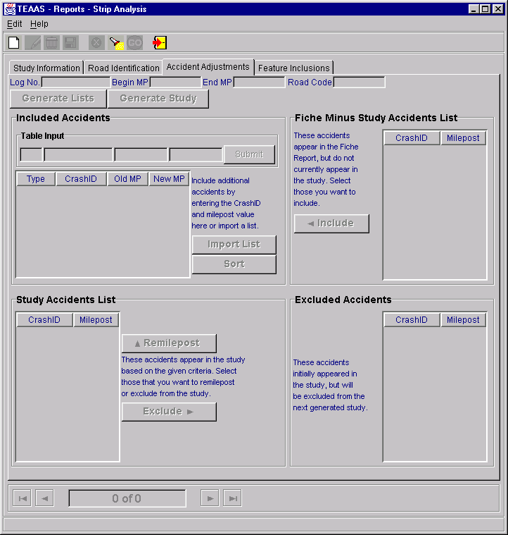
Strip Analysis Report: Accident Adjustments Tab
The Accidents Adjustments Tab contains four subsections: Fiche Minus Study Accidents List, Included Accidents, Study Accidents List, and Excluded Accidents. The use of each subsection is described below.
Inclusions and/or exclusions are not required to generate a Study; however, they allow the User to refine the next Study generated.

Fiche Minus Study Accidents List
The Fiche Minus Study Accidents List is populated only after the Generate Lists button has been clicked. The accidents appearing in this list are contained within the Fiche Report but do not currently appear in the Study. To include accidents in the next Study generated, highlight the Crash ID in the Fiche Minus Study Accidents List and click the Include button. The highlighted Crash ID will be copied to the Included Accidents table to the left. The Ctrl and Shift keys may be used to highlight multiple rows. Continue this process until all desired accidents have been selected and copied to the Included Accidents list. After all accident inclusion activity has been completed, a new Study may be generated by clicking the Generate Study button.

Included Accidents
The Included Accidents table may be populated in any combination of four ways:
- By including accidents from the Fiche Minus Study Accidents List, as described above.
- A specific Crash ID may be added to the Included Accidents list by entering a Crash ID and New MP in the Table Input field and clicking the Submit button.
- Multiple Crash IDs may be added from an existing text file by clicking the Import List button. A Get Import List dialog box will appear to allow the User to specify the text file to be imported. After the file name has been specified, click the OK button to import the file. The Crash IDs contained in the text file will appear in the Included Accidents table. Click the Cancel button on the Get Import List dialog box to cancel the import process. The text file must contain the Crash ID and New MP, separated by the pipe symbol ( | ), one accident per line. For example:
98023718|1.234
98024448|1.570
98044398|3.200
- By including accidents for remileposting from the Study Accident List. This process is described in the Study Accidents List subsection, below.
All accidents added to the Included Accidents table must be given a New MP within the range specified for the Strip Road. To modify a row in the Included Accidents table, highlight the row and strike the Enter key on the keyboard. The record will appear in the table input section where modifications can be made. After modifications are made, click the Submit button to add the record back to the Included Accidents table.
Crash IDs contained in the Included Accidents table may be deleted by highlighting the Crash ID in the Included Accidents table and striking the Delete key. The Ctrl and Shift keys may be used to highlight multiple rows.
The Crash IDs contained in the Included Accidents table will be validated to make sure that the Accident Date of the Crash ID is within the Study Date range. An error will be shown with the Crash ID. To clear this error, remove this Crash ID from the Included Accidents table and click the Generate Study button again,

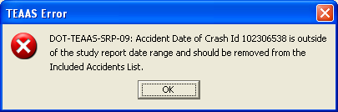
Error Message when the Crash ID Accident Date is not within the Study Date Range
Crash IDs contained in the Included Accidents table may be sorted (ascending) by clicking the Sort button.
After all accident inclusion activity has been completed, a new Study may be generated by clicking the Generate Study button.

Study Accidents List
The Study Accidents List is populated only after the Generate Lists button has been clicked. The accidents appearing in this table are contained in the Study.
To remilepost specific accidents for the next Study generated, highlight the Crash ID in the Study Accidents List and click the Remilepost button. The highlighted Crash ID will be copied to the Included Accidents table above. The Ctrl and Shift keys may be used to highlight multiple rows. Continue this process until all desired Crash IDs have been selected and copied to the Included Accidents list.
To exclude Crash IDs from the next Study generated, highlight the Crash ID in the Study Accidents List and click the Exclude button. The highlighted Crash ID will be copied to the Excluded Accidents table to the right. The Ctrl and Shift keys may be used to highlight multiple rows. Continue this process until all desired Crash IDs have been selected and copied to the Excluded Accidents list.
After all accident inclusion and exclusion activity has been completed, a new Study may be generated by clicking the Generate Study button.
Note: Modifications to the milepost value do not update the true milepost value for that Crash ID. Rather, the value is modified only for purposes of the study in progress.

Excluded Accidents
The Excluded Accidents table can be populated only by excluding accidents in the manner described in the Study Accidents List subsection above. Crash IDs contained in the Excluded Accidents table may be deleted by highlighting the Crash ID in the Excluded Accidents table and striking the Delete key. The Ctrl and Shift keys may be used to highlight multiple rows. After all exclusion activity has been completed, a new Study may be generated by clicking the Generate Study button.

Feature Inclusions Tab
The Feature Inclusions tab appears as displayed below.
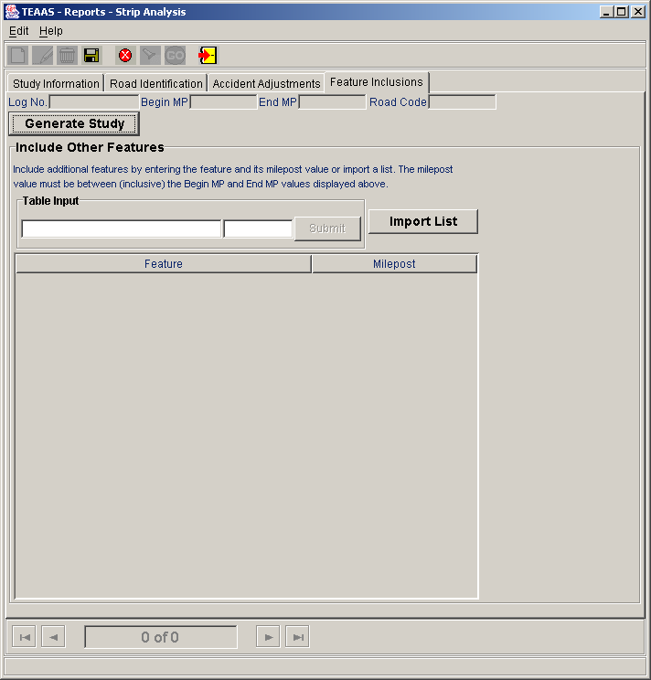
Strip Analysis Report: Feature Inclusions Tab
The Feature Inclusions tab allows the User to include Features that have not been inventoried on the Strip Road. Include additional features by entering the feature and its milepost value or import a list. The milepost value must be between (inclusive) the Begin MP and End MP values of the study route.
Enter the Feature text and Milepost in the Table Input field and click the Submit button. The milepost must be in the range specified for the Strip Road. Repeat this process until all desired additional Features are added to the Include Other Features table.
To modify a row in the Include Other Features table, highlight the row and strike the Enter key on the keyboard. The record will appear in the table input section where modifications can be made. After modifications are made, click the Submit button to add the record back to the Include Other Features table.
Multiple Features may be added from an existing text file by clicking the Import List button. A Get Import List dialog box will appear to allow the User to specify the text file to be imported. After the file name has been specified, click the Import button to import the file. The Features contained in the text file will appear in the Included Accidents table. Click the Cancel button on the Get Import List dialog box to cancel the import process. The text file must contain Feature Name and MP, separated by the pipe symbol ( | ), one feature per line. For example:
Restaurant|1.234
Fire Station|11.570
Strip Mall|20.999
Features contained in the Include Other Features table may be deleted by highlighting the Feature in the Include Other Features table and striking the Delete key. The Ctrl and Shift keys may be used to highlight multiple rows. After all Feature inclusion activity has been completed, a new Study may be generated by clicking the Generate Study button.

Creating a New Strip Analysis Study
The Strip Analysis Report screen appears in view mode when it is initially launched from the Application Browser. Click the New icon on the toolbar to begin a new Strip Analysis Study. When modifying an existing Study, either save the Study, or cancel changes, then click the New icon. Refer to the Study Information Tab, Road Identification Tab, Accident Adjustments Tab, and Feature Inclusions subsections for descriptions of input requirements.

Saving a New Strip Analysis Study
After all desired information and criteria have been entered, click the Save icon on the toolbar. If business rule conditions are not satisfied, a message will indicate the problem encountered. If all conditions are satisfied, the new Study is saved and displayed on the screen in view mode.

Searching for a Strip Analysis Study
Existing studies may be used as a starting point for creating a new Study. Click the Search icon on the toolbar. The Study Name, Location Text, Log No., PH No., TIP No., County, and User ID fields will be enabled for search criteria to be entered. After search criteria are entered, click the Go icon on the toolbar to retrieve all studies satisfying the search criteria. The navigation bar may be used to view the Studies returned by the search. Note that the report cannot be generated without first clicking the Modify icon on the toolbar. Please refer to the Modifying a Strip Analysis Study subsection below.

Modifying a Strip Analysis Study
When an existing Study is displayed on the screen in view mode, the User must click the Modify icon on the toolbar to have the ability to generate the report, regardless of whether the Study criteria will be altered. The User may modify the criteria, generate the report, and close the Study without saving changes.
When saving modifications, the following rules apply:
- The User who originally created the Study may save changes to that Study Name by clicking the Save icon on the toolbar.
- The User who originally created the Study may save the modified criteria as another Study Name by clicking the Save As button on the Study Information Tab.
- A User who didn't create the Study can save the modified criteria as another Study Name by clicking either the Save icon on the toolbar, or by clicking the Save As button on the Study Information Tab.

Deleting a Strip Analysis Study
An existing Study may only be deleted by the original creator of the Study, either after conducting a search to retrieve the Study or immediately after saving the Study. To delete a displayed Study, click the Delete icon on the toolbar. A confirmation dialog box will appear. Click the Yes button to proceed with the deletion or the No button to cancel the deletion.

Canceling a Strip Analysis Study Operation
The New, Modify, and Search operations may be canceled before Save or Go actions are invoked by clicking the Cancel icon on the toolbar. Cancel will return the Strip Analysis Report screen to its previous state. For example, if a Study is being modified, clicking Cancel will revert the record to its previous values, displaying it in view mode.

Closing the Strip Analysis Report Screen
The Strip Analysis Report screen may be closed at any point except while the creation of the report is in progress. To close the Strip Analysis Report screen, click the Close icon on the toolbar.

Generate Collision Diagram File

Generate Collision Diagram File Overview
The Generate Collision Diagram File all a user to submit a list of crash ids and have a text file returned with the necessary information required to work with TSU’s collision diagram program.
To access the Generate Collision Diagram File screen, select the Generate Reports button on the Application Browser, select Generate Collision Diagram File from the list box, and click the Open button.
Function Button | Function Name | Sub-Function
 | Generate Reports | Generate Collision Diagram File

The screen that appears is comprised of a Crash Id List data entry area and four buttons.
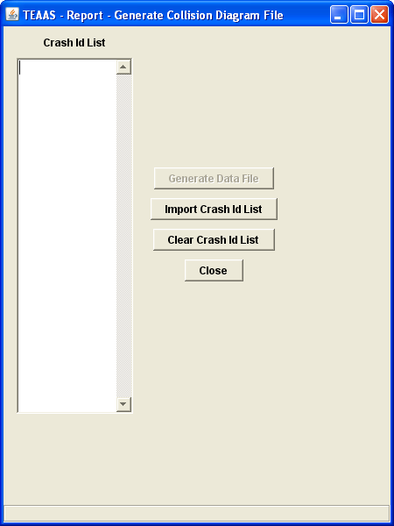
Generate Collision Data File

The following table describes the requirements for each field.
Field | Field Requirements
Crash Id List | This field is used as a data entry field. Users can insert one Crash Id per line. Each Crash Id is validated to ensure that that it is well formed and that there are no duplicates/ A well formed Crash Id is a number that is 8 or 9 digits long.
Generate Data File | Generates a file that contains Collision Data. The user will be prompted for a name and location to save the file.
Import Crash Id List | .Imports a crash id list from a text file. Each Crash Id is on its own line.
Clear Crash Id List | Clear the Crash Id List area.
Close | Closes the Generate Collision Data File window.

Generating a Collision Diagram Data File
The Crash Id List text area will allow entry of crash ids by hand or you can import a list of crash ids from the Import Crash Id List button. There should only be one crash id per line in the text field or in the crash id list that the user will be importing. Importing again will prompt the user if there are Crash Ids in the Crash Id list text area, a pop-up will be shown. Selecting Yes will clear the current list that is shown and the new list will take its place.
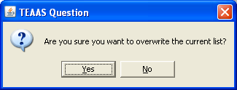
Prompt when overwriting the current Crash Id List
Each crash id will be checked while it is being entered and after the Generate Data File button will be selected. If there are any errors in the crash id list, an error message will be shown with the error(s) found and will abort the process. The user will then be able to fix the list in the Crash Id List text area or fix the error in the file and re-import the list and try again.
Selecting the Clear Crash Id List button will show a pop-up asking to the user if they want to clear the Crash Id List, selecting the Yes button will clear the contents of the Crash Id List text area.
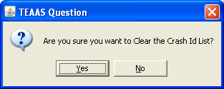
Prompt when clearing the Crash Id List
Selecting the Close button will show a pop-up asking to the user if they want to close the window, selecting the Yes button will close the window.
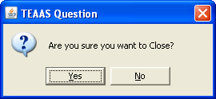
Prompt when closing Generating Collision Diagram File Application
When the Generate Data File button is selected, the crash ids will be checked, if all are valid, a Collision Diagram Crash Data file will be generated, then prompts user to save the file.
Save Collision Diagram Data dialog box
If there are any duplicate Crash Ids that are in the list, the user will be prompted to save these duplicates in a file. If any Crash Ids in the list return no data, the user will be prompted to save them in a file.
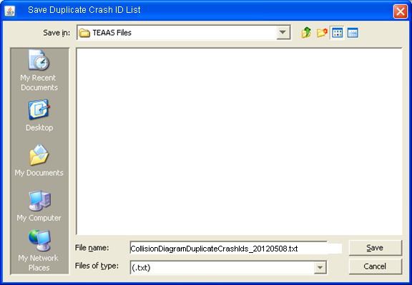
Save Duplicate Crash Id List dialog box

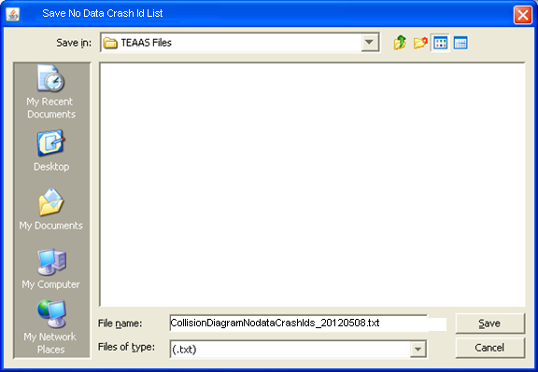
Save No data Crash Id List dialog box

Users will also be able to create the Collision Diagram Data File from the Strip and Intersection Analysis Reports. See the Strip Analysis and Intersection Analysis sections for more information.

Sliding Scale
The following table directs the reader to appropriate Sliding Scale subsections.
SLIDING SCALE  Subsections |  |  | Roles
SLIDING SCALE  Subsections | SA | PDM | SDM | TQU | PQU | PRU | DCU | FDEU | OU | DEOU | DOU | ROU | TEOU | SSU | OA | OER | FU | SDEOU
Sliding Scale Screen Overview |  |  |  |  |  |  |  |  |  |  |  |  |  | X
Searching for a Sliding Scale Study |  |  |  |  |  |  |  |  |  |  |  |  |  | X
Adding a New Sliding Scale Study |  |  |  |  |  |  |  |  |  |  |  |  |  | X
Modifying an Existing Sliding Scale Study |  |  |  |  |  |  |  |  |  |  |  |  |  | X
Deleting an Existing Sliding Scale Study |  |  |  |  |  |  |  |  |  |  |  |  |  | X
Canceling a Sliding Scale Screen Operation |  |  |  |  |  |  |  |  |  |  |  |  |  | X
Launching the Sliding Scale Report |  |  |  |  |  |  |  |  |  |  |  |  |  | X
Viewing the Sliding Scale Report |  |  |  |  |  |  |  |  |  |  |  |  |  | X
Clearing the Sliding Scale Report |  |  |  |  |  |  |  |  |  |  |  |  |  | X
Closing the Sliding Scale Screen |  |  |  |  |  |  |  |  |  |  |  |  |  | X

Sliding Scale Screen Overview
The Sliding Scale screen is used to search for specific crash data and is conducted on a specific mile posted state inventoried route. This search is called a “Study” and it is initiated at the mile posted beginning of route with a user-defined segment length to define the boundaries of the search. This segment is then shifted by a user-defined increment as it searches the TEAAS database for matching data, and returns specific information, which is added to the Sliding Scale report for the current Study. If the specified accident criteria are not met then the scale will be adjusted down the route until new data matching the criteria are found, thus restarting the analytical process. When the process has completed a summarized roadway and accident statistics report will be available for viewing.
To access the Sliding Scale screen, select the General Reports button on the Application Browser, select Sliding Scale Report from the list box, and click the Open button.
Function Button | Function Name | Sub-Function
 | Generate Reports | Sliding Scale Report

The screen that follows is displayed.
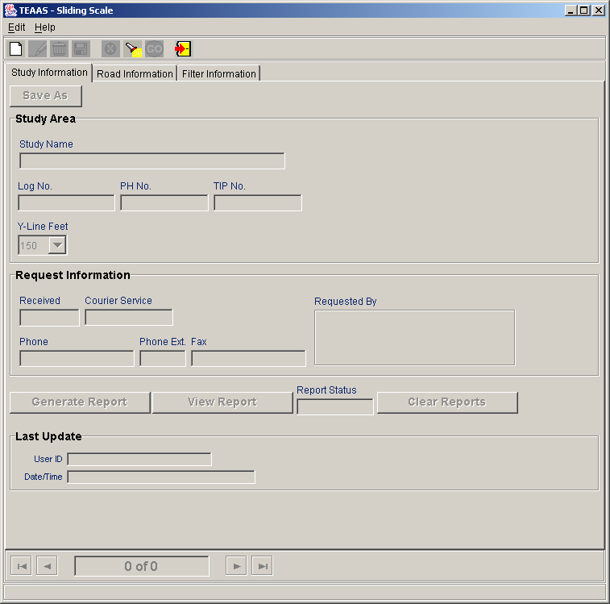Sliding Scale Screen – Study Information Panel
The screen that follows is the second panel in the Sliding Scale data entry screens.
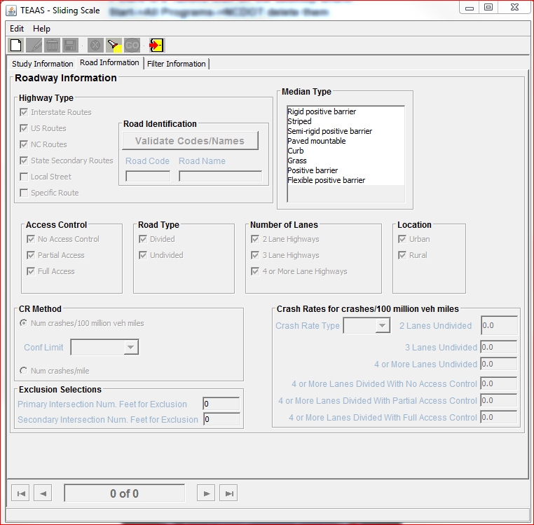
Sliding Scale Screen – Road Information Panel
The screen that follows is the third panel in the Sliding Scale data entry screens
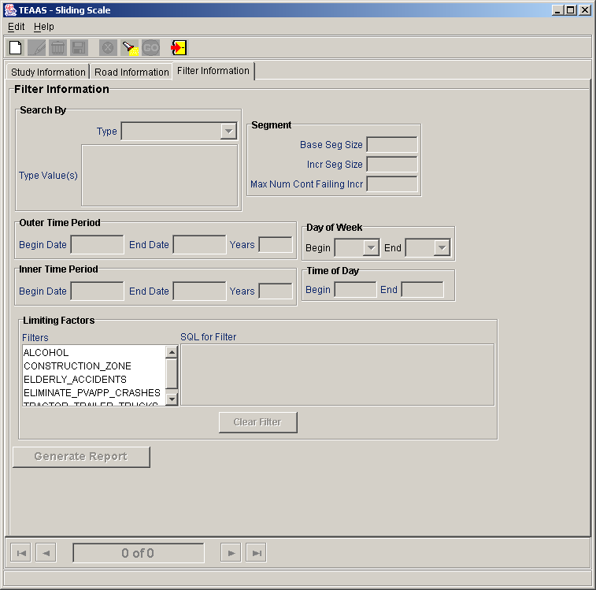Sliding Scale Screen – Filter Information Panel

Searching for an Sliding Scale Study
To search for Sliding Scale studies, click the Search icon on the toolbar. A blank screen will be presented for entering search criteria. The following table describes the search criteria allowed.
Field | Search Criteria
Study Name | Enter a specific Study Name. Wildcard characters may be used to search for one or more studies with like names. Refer to Appendix C for a description on the use of wildcard characters. Leave Study Name empty if this field is not part of the search criteria. Search is not case sensitive.
Log No. | Enter a specific Log No. value or leave empty if this field is not part of the search criteria. Search is not case sensitive.
Tip No. | Enter a specific Tip No. value or leave empty if this field is not part of the search criteria. Search is not case sensitive.
User ID | Enter a specific User ID. Wildcard characters may be used to search for one or more User Id’s with like names. Refer to Appendix C for a description on the use of wildcard characters. Leave User ID empty if this field is not part of the search criteria. Search is not case sensitive.

After all desired search criteria have been entered, click the Go icon on the toolbar. A dialog box will appear indicating the number of records returned. Click the OK button on the dialog box to view the records retrieved. Returned records are displayed in view mode.
If no records are returned, a dialog box will appear indicating such. If records were expected to be retrieved, verify that the search criteria are correct. A new search may be executed by adjusting the search criteria and clicking the Go icon.
It is recommended that the search criteria be as specific as possible to prevent the retrieval of too many records, which could contribute to local memory concerns and slower system performance. Currently, TEAAS will display a maximum of 500 records for any given search, although more than 500 records may actually meet the search criteria.

Adding a New Sliding Scale Study
To add a new Sliding Scale study, click the New icon on the toolbar. A blank screen will be presented for entering a new record. The following table describes the requirements for each field.
Field | Field Requirements
Study Info Panel
Study Name | A Study Name must be specified. This is a required field. Maximum of 30 characters.
Log No. | A Log Number can be entered. Maximum of 11 characters
PH No. | A PH Number can be entered. Maximum of 10 alphanumeric characters.
Tip No. | A Tip Number can be entered. Maximum of 10 alphanumeric characters.
Y- Line Feet | Feet from the intersection may be entered. Default: 150 May select 50 or 100 or write in a new value. The maximum value for this field is 150.
Received | The date that the request for the Study was received may be entered in the format MM/DD/CCYY. Leading zeroes for the month and day may be omitted.
Courier Service | The courier address for the requestor may be entered, up to 10 alphanumeric characters.
Phone | The requestor's phone number may be entered. Parentheses and the hyphen character may be used in the phone number.
Phone Ext. | A Phone Extension may be entered. Maximum of 5 characters.
Fax | The requestor's fax number may be entered. Parentheses and the hyphen character may be used in the phone number.
Requested By | The person or organization requesting the Study may be entered, up to 60 alphanumeric characters.
User ID | This field is automatically populated with the user information supplied when the use logged into the application.
Date/Time | This field is automatically populated with current date and time when the user performs a save.
Road Info Panel
Highway Type | A minimum of one Highway Type must be selected This is a required field. Default Checkboxes: Interstate Routes, US Routes, State Routes, State Secondary Routes
Road Code | If Specific Route is selected for Highway Type, the road code must be supplied by the user when generating a study. Maximum of 8 digits Format “99999999”
Road Name | If Specific Route is selected for Highway Type, the road name may be supplied by the user when generating a study. Maximum of 100 characters
Median Type | The median type may be selected from the list of available choices in the Pre-Populated Multi-selection list that will be retrieved from the FTV_MASTER_LOOKUP table.
Access Control | A minimum of one Access Control type must be selected. This is a required field. Default All Checkboxes are selected.
Road Type | One Road Type must be selected. This is a required field. Default All Checkboxes are selected.
Number of Lanes | A minimum of one Number of Lanes type must be selected. This is a required field. Default All Checkboxes are selected.
Location | One Location Type must be selected. This is a required field. Default All Checkboxes are selected
CR Method | By default the Num. Crashes/100 million vehicle miles method is selected and Conf Limit.combo box is enabled. If Conf Limit is selected, a selection from the combo box must be made from the list of available choices in the Pre-Populated list that will be retrieved from the FTV_MASTER_LOOKUP table. This is a required field  Selecting Num. Crashes/mile radio button disables Conf Limit combo box.
Crash Rate Type | One Crash Rate Type must be selected from the list of available choices in the Pre-Populated list that will be retrieved from the FTV_MASTER_LOOKUP table. This is a required field.
2 Lanes Undivided | If this road type has been enabled, a value must be provided. Maximum of 6 characters - Format “999.99”
3 Lanes Undivided | If this road type has been enabled, a value must be provided. Maximum of 6 characters - Format “999.99”
4 or More Lanes Undivided | If this road type has been enabled, a value must be provided. Maximum of 6 characters - Format “999.99”
4 or More Lanes Divided With No Access Control | If this road type has been enabled, a value must be provided. Maximum of 6 characters - Format “999.99”
4 or More Lanes Divided With Partial Access Control | If this road type has been enabled, a value must be provided. Maximum of 6 characters - Format “999.99”
4 or More Lanes Divided With Full Access Control | If this road type has been enabled, a value must be provided. Maximum of 6 characters - Format “999.99”
Exclusion Selections | The Primary and Secondary number of feet for exclusion for the study may be supplied in the text boxes provided. When values are provided, any accidents occurring within the specified number of feet from a primary or secondary intersection will be excluded from the study results. Maximum of 3 characters per exclusion – Format “999”.
Filter Info Panel
Search By Type | The Search By Type must be selected from the list of available choices in the Pre-Populated list that will be retrieved from the FTV_MASTER_LOOKUP table. This is a required field.
Search By Type Value(s) | The Search By Type Value(s) is dependent on the Search By Type that was selected. The Search By Type Value(s) must be selected from the list of available choices in the Pre-Populated list that will be retrieved from the FTV_MASTER_LOOKUP table. This is a required field.
Base Seg Size | The Base Segment Size must be provided to conduct a study. This is a required field. Maximum of 6 characters per exclusion – Format “999.99”.
Incr Seg Size | The Increment Segment Size must be provided to conduct a study. This is a required field. Maximum of 6 characters per exclusion – Format “9.99”.
Max. Num of Cont Failing Incr | The Max. Number of Continuous Failing Increments must be provided to conduct a study. This is a required field. Maximum of 3 characters per exclusion – Format “999”.
Outer Time Period | The Outer Time Period dates must be supplied. The Begin Date and End Date should both be entered in mm/dd/yyyy format. This is a required field.
Inner Time Period | The Inner Time Period dates may be supplied. The Begin Date and End Date should both be entered in mm/dd/yyyy format.
Day of Week | The day of the week may be supplied. The begin and end days may be selected from the combo boxes.
Time of Day | The time of day may be supplied. The begin and end time may be selected from the combo boxes. Maximum of 4 characters for the begin and end time – Format “9999”, military clock.
Limiting Factors | One of the limiting factors provided in the list may be selected. The resulting SQL for the selections made will populate in the SQL for Filter box next to the Limiting Factors list.

After all information has been added, click the Save icon on the toolbar. If business rule conditions are not satisfied, a message will indicate the problem encountered. If all conditions are satisfied, the new Sliding Scale Study is saved and displayed on the screen in view mode.

Modifying an Existing Sliding Scale Study
An existing Sliding Scale Study may be modified when the study is displayed on the screen, either after conducting a search or immediately following a save. To modify a displayed study, click the Modify icon on the toolbar. After changes are made, click the Save icon on the toolbar. All business rule conditions are verified before the modified record is saved. If all conditions are satisfied, the modified Sliding Scale Study is saved and displayed on the screen in view mode.

Deleting an Existing Sliding Scale Study
An existing Sliding Scale Study may be deleted when the record is displayed on the screen, either after conducting a search or immediately following a save. To delete a displayed study, click the Delete icon on the toolbar. A confirmation dialog box will appear. Click the Yes button to proceed with the deletion or the No button to cancel the deletion. If the deleted study was the only record previously displayed on the screen, the screen will be cleared after the delete. If multiple studies were displayed, the next study will now be displayed. The study count at the bottom of the Sliding Scale screen will be adjusted accordingly after the deletion.

Applying Filters to a Sliding Scale Study
The Limiting Factors section allows for filters to be selected to filter the study results based on the selected criteria. The list of available filters will display in the Filters list box. The list of available filters comes from the FTV_SLDG_SCL_FLTR table. These filters are comprised of the type code values found in DMV Form 349. New Filters can be added when TSSMS user-provided and tested SQL queries are provided to the Crash/TEAAS support and are added to the FTV_SLDG_SCL_FLTR table. The steps to apply a filter to a study would be the following:
1. Select one of the listed filters in the ‘Filters’ list box.
2. When a selection is made in the ‘Filters’ list box, the corresponding SQL query associated with the selected filter will appear in the ‘SQL for Filter’ text area. .
3. If at any time the user wishes to clear the SQL statement and corresponding selections in the ‘Filters’ list box, this can be accomplished by pressing the ‘Clear Filter’ button
Submitting a Filter:
The query provided by TSSMS should produce a list of crash ids. TSSMS should notify the Crash/TEAAS Team that the Outer Date Range should be used. The query provided by TSSMS will be tested and then inserted into the FTV_SS_FILTERS table if it is ok.
The query will be available after the server has been restarted.

Launching the Sliding Scale Report
The Sliding Scale report may be launched from the Sliding Scale screen by clicking the Generate Report button after an existing Sliding Scale record appears in modify mode. The report will take some time to generate and will be generated after regular business hours.

Checking the Status of a Sliding Scale Study
The status of a study can be checked by first searching for the study then selecting the Modify button and checking the Report Status field. Selecting the Cancel button and selecting the Modify button will refresh the Report Status field.

Viewing the Sliding Scale Report
The Sliding Scale Report may be viewed from the Sliding Scale screen by clicking the View Report button after an existing Sliding Scale record appears and is in the modify mode. The status of the report must be Complete before it can be viewed. The status is available on the Sliding Scale screen in the Report Status field. A pop, as shown below, appears. Make a selection and click OK. A Sliding Scale Report for that selection is displayed.
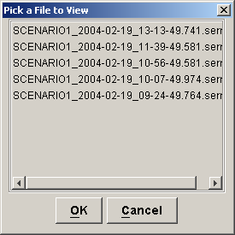

Clearing the Sliding Scale Report
The Sliding Scale Report may be cleared from the Sliding Scale screen by clicking the Clear Reports button after an existing Sliding Scale record appears in modify mode.

Closing the Sliding Scale Screen
To close the Sliding Scale screen, click the Close icon on the toolbar. If a New or Modify operation is in progress, the User will be asked to confirm they want to close without saving. Click the Yes button to close without saving or the No button to return to the operation in progress.

Fiche, intersection, and strip reports code index
The following table directs the reader to appropriate Fiche, Intersection, and Strip Reports Code Index subsections.
FICHE, INTERSECTION, AND STRIP REPORTS  CODE INDEX  Subsections |  |  | Roles
 | SA | PDM | SDM | TQU | PQU | PRU | DCU | FDEU | OU | DEOU | DOU | ROU | TEOU | SSU | OA | OER | FU | SDEOU
Fiche, Intersection, and Strip Reports Code Index Overview |  |  |  | X | X

Fiche, Intersection, and Strip Reports Code Index Overview
The Fiche, Intersection, and Strip Reports Code Index serves as a legend for the Crash DMV-349 codes that appear on the Fiche, Intersection, and Strip reports.
To access the Fiche, Intersection, and Strip Reports Code Index Report, select the Generate Reports button on the Application Browser, select Fiche, Intersection, and Strip Reports Code Index from the list box, and click the Open button.
Function Button | Function Name | Sub-Function
 | Generate Reports | Fiche, Intersection, and Strip Reports Code Index

The Fiche, Intersection, and Strip Reports Code Index are viewed through e.Report Engine. The report may be viewed on the screen, printed, or saved to a file. Refer to Appendix D for an overview of the use of e.Report Engine.

Features report
The following table directs the reader to appropriate Features Report subsections.
FEATURES REPORT Subsections |  |  | Roles
FEATURES REPORT Subsections | SA | PDM | SDM | TQU | PQU | PRU | DCU | FDEU | OU | DEOU | DOU | ROU | TEOU | SSU | OA | OER | FU | SDEOU
Features Report Overview |  | X | X | X | X |  |  |  |  |  |  |  |  |  |  |  | X

Features Report Overview
The Features Report identifies all Boundaries, Intersections, Mile Markers, Railroad Crossings, and Structures for a given County, Inventoried Route, and Begin Milepost.
To access the Features Report, select the Generate Reports button on the Application Browser, select Features Report from the list box, and click the Open button.
Function Button | Function Name | Sub-Function
 | Generate Reports | Features Report

The Features report may also be launched from the Inventoried Routes, Intersections, Boundaries, Structures, Mile Markers, or Railroad Crossings screens by clicking the Features Report button after an existing record appears in view mode. The report will take the displayed County, Inventoried Route, and Begin Milepost as its selection criteria.
The Features Report is viewed through e.Report Engine. The report may be viewed on the screen, printed, or saved to a file. Refer to Appendix D for an overview of the use of e.Report Engine.

Highest order segments report
The following table directs the reader to appropriate Highest Order Segments Report subsections.
HIGHEST ORDER SEGMENTS REPORT  Subsections |  |  | Roles
HIGHEST ORDER SEGMENTS REPORT  Subsections | SA | PDM | SDM | TQU | PQU | PRU | DCU | FDEU | OU | DEOU | DOU | ROU | TEOU | SSU | OA | OER | FU | SDEOU
Highest Order Segments Report Overview |  | X | X | X | X |  |  |  |  |  |  |  |  |  |  |  | X

Highest Order Segments Report Overview
The Highest Order Segments Report identifies all Highest Order Segments for a given County, Inventoried Route, and Begin Milepost.
To access the Highest Order Segments Report, select the Generate Reports button on the Application Browser, select Highest Order Segments Report from the list box, and click the Open button.
Function Button | Function Name | Sub-Function
 | Generate Reports | Highest Order Segments Report

The Highest Order Segments Report may only be generated by clicking the HO Segments Report button if an existing Inventoried Route record appears in view mode. It may also be launched directly from the Inventoried Routes screen without first having to select it through the Generate Reports function on the Application Browser.
The Highest Order Segments Report is viewed through e.Report Engine. The report may be viewed on the screen, printed, or saved to a file. Refer to Appendix D for an overview of the use of e.Report Engine.

Ordinance exception report: On ROad/ho Route
The following table directs the reader to appropriate Ordinance Exception Report: On Road/HO Route subsections.
ORDINANCE EXCEPTION REPORT:  ON ROAD/HO SEGMENT Subsections |  |  | Roles
ORDINANCE EXCEPTION REPORT:  ON ROAD/HO SEGMENT Subsections | SA | PDM | SDM | TQU | PQU | PRU | DCU | FDEU | OU | DEOU | DOU | ROU | TEOU | SSU | OA | OER | FU | SDEOU
Ordinance Exception Report: On Road/HO Route Overview |  |  |  | X |  |  |  |  |  |  |  |  |  |  |  | X

Ordinance Exception Report: On Road/HO Route Overview
The Ordinance Exception Report: On Road/HO Route identifies all ordinances with a route ID which does not correspond to either the beginning or ending Highest Order Route ID for the ordinance.
To access the Ordinance Exception Report: On Road/HO Route, select the Generate Reports button on the Application Browser, select Ordinance Exception Report: On Road/HO Route from the list box, and click the Open button.
Function Button | Function Name | Sub-Function
 | Generate Reports | Ordinance Exception Report: On Road/HO Route

The Ordinance Exception Report: On Road/HO Route is viewed through e.Report Engine. The report may be viewed on the screen, printed, or saved to a file. Refer to Appendix D for an overview of the use of e.Report Engine.

Ordinance exception report: overlap
The following table directs the reader to appropriate Ordinance Exception Report: Overlap subsections.
ORDINANCE EXCEPTION REPORT:  OVERLAP Subsections |  |  | Roles
ORDINANCE EXCEPTION REPORT:  OVERLAP Subsections | SA | PDM | SDM | TQU | PQU | PRU | DCU | FDEU | OU | DEOU | DOU | ROU | TEOU | SSU | OA | OER | FU | SDEOU
Ordinance Exception Report: Overlap Overview |  |  |  | X |  |  |  |  |  |  |  |  |  |  |  | X

Ordinance Exception Report: Overlap Overview
The Ordinance Exception Report: Overlap identifies all ordinances with a route with a beginning or ending milepost value that overlaps with other ordinances within the same County with the same route ID and type code.
To access the Ordinance Exception Report: Overlap, select Generate Reports button on the Application Browser, select Ordinance Exception Report: Overlap from the list box, and click the Open button.
Function Button | Function Name | Sub-Function
 | Generate Reports | Ordinance Exception Report: Overlap

The Ordinance Exception Report: Overlap is viewed through e.Report Engine. The report may be viewed on the screen, printed, or saved to a file. Refer to Appendix D for an overview of the use of e.Report Engine.

Ordinance exception report: no milepost
The following table directs the reader to appropriate Ordinance Exception Report: No Milepost subsections.
ORDINANCE EXCEPTION REPORT:  NO MILEPOST Subsections |  |  | Roles
ORDINANCE EXCEPTION REPORT:  NO MILEPOST Subsections | SA | PDM | SDM | TQU | PQU | PRU | DCU | FDEU | OU | DEOU | DOU | ROU | TEOU | SSU | OA | OER | FU | SDEOU
Ordinance Exception Report: No Milepost Overview |  |  |  | X |  |  |  |  |  |  |  |  |  |  |  | X

Ordinance Exception Report: No Milepost Overview
The Ordinance Exception Report: No Milepost identifies all ordinances that either the begin point or the end point could not be mileposted.
To access the Ordinance Exception Report: No Milepost, select Generate Reports button on the Application Browser, select Ordinance Exception Report: No Milepost from the list box, and click the Open button.
Function Button | Function Name | Sub-Function
 | Generate Reports | Ordinance Exception Report: No Milepost

The screen that follows is displayed.
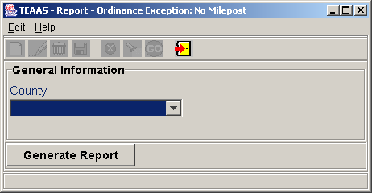
Enter Parameters Values Screen
Select county code from the combo box for which you want to search and press the Generate Report button.
The Ordinance Exception Report: No Milepost is viewed through e.Report Engine. The report may be viewed on the screen, printed, or saved to a file. Refer to Appendix D for an overview of the use of e.Report Engine.

Highest Order Segment Gap Report
The following table directs the reader to appropriate Highest Order Segment Gap Report subsections.
HIGHEST ORDER SEGMENT GAP REPORT Subsections |  |  | Roles
HIGHEST ORDER SEGMENT GAP REPORT Subsections | SA | PDM | SDM | TQU | PQU | PRU | DCU | FDEU | OU | DEOU | DOU | ROU | TEOU | SSU | OA | OER | FU | SDEOU
Highest Order Segment Gap Report Overview |  |  |  | X

Highest Order Segment Gap Report Overview
The Highest Order Segment Gap Report identifies all inventoried routes that do not have a highest order segment identified, or have a gap with no highest order segment identified.
To access the Highest Order Segment Gap Report, select Generate Reports button on the Application Browser, select Highest Order Segment Gap Report from the list box, and click the Open button.
Function Button | Function Name | Sub-Function
 | Generate Reports | Highest Order Segment Gap Report

The Highest Order Segment Gap Report is viewed through e.Report Engine. The report may be viewed on the screen, printed, or saved to a file. Refer to Appendix D for an overview of the use of e.Report Engine.

city-wide ACCIDENT ReportS
The following table directs the reader to appropriate City-Wide Accident Reports subsections.
CITY-WIDE ACCIDENT REPORTS  Subsections |  |  | Roles
CITY-WIDE ACCIDENT REPORTS  Subsections | SA | PDM | SDM | TQU | PQU | PRU | DCU | FDEU | OU | DEOU | DOU | ROU | TEOU | SSU | OA | OER | FU | SDEOU
Accident Types and Violations |  |  |  |  |  | X
Age and Sex of Driver |  |  |  |  |  | X
Alcohol, Ambulance and Vision |  |  |  |  |  | X
Environmental Conditions |  |  |  |  |  | X
High Accident Intersections |  |  |  |  |  | X
Injuries and Restraint Usage |  |  |  |  |  | X
Month, Day and Hourly Summary |  |  |  |  |  | X
Severity at High Accident Intersections |  |  |  |  |  | X

City-Wide Accident Reports Overview
The City-Wide Accident Reports allows users to generate various reports for a selected city. The Accident Types and Violations report is used to determine which accident types and violations occurred for a given municipality during a specific period of time. The Age and Sex of Driver report is used to determine the age and sex of the driver involved in an accident for a given municipality during a specific period of time. The Alcohol, Ambulance and Vision report is used to determine the involvement of alcohol, percentage of ambulance requests and percentage of accidents where the driver’s vision was obstructed for a given municipality during a specific period of time. The Environmental Conditions report is used to determine the light, road and weather conditions when an accident occurred in a given municipality during a specific period of time. The High Accident Intersections report is used to determine the high accident intersections and their accident types for a given municipality during a specific period of time. The Injuries and Restraint Usage report is used to determine the driver and right front passenger’s restraint usage during an accident for a given municipality during a specific period of time. The Month, Day and Hourly Summary report is used to determine the percentage of crashes that occurred during a given month, day or hour for a given municipality during a specific period of time. The Severity at High Accident Intersections report indicates the severity of accidents that occurred at intersections within a given municipality where there have been a high number of accidents over a specific period of time.
To access the City-Wide Accident Reports, select Generate Public Reports button on the Application Browser, select City-Wide Accident Reports from the list box, and click the Open button.
Function Button | Function Name | Sub-Function
 | Generate Public Reports | City-Wide Accident Reports

The City-Wide Accident Reports is viewed through e.Report Engine. The report may be viewed on the screen, printed, or saved to a file. Refer to Appendix D for an overview of the use of e.Report Engine.

cOUNTY-wide ACCIDENT ReportS
The following table directs the reader to appropriate County-Wide Accident Reports subsections.
COUNTY-WIDE ACCIDENT REPORTS  Subsections |  |  | Roles
COUNTY-WIDE ACCIDENT REPORTS  Subsections | SA | PDM | SDM | TQU | PQU | PRU | DCU | FDEU | OU | DEOU | DOU | ROU | TEOU | SSU | OA | OER | FU | SDEOU
Accident Types and Violations |  |  |  |  |  | X
Age and Sex of Driver |  |  |  |  |  | X
Alcohol, Ambulance and Vision |  |  |  |  |  | X
Environmental Conditions |  |  |  |  |  | X
High Accident Intersections |  |  |  |  |  | X
Injuries and Restraint Usage |  |  |  |  |  | X
Month, Day and Hourly Summary |  |  |  |  |  | X
Severity at High Accident Intersections |  |  |  |  |  | X

County-Wide Accident Reports Overview
The County-Wide Accident Reports allows users to generate various reports for a selected county. The Accident Types and Violations report is used to determine which accident types and violations occurred for a given county during a specific period of time. The Age and Sex of Driver report is used to determine the age and sex of the driver involved in an accident for a given county during a specific period of time. The Alcohol, Ambulance and Vision report is used to determine the involvement of alcohol, percentage of ambulance requests and percentage of accidents where the driver’s vision was obstructed for a given county during a specific period of time. The Environmental Conditions report is used to determine the light, road and weather conditions when an accident occurred in a given county during a specific period of time. The High Accident Intersections report is used to determine the high accident intersections and their accident types for a given county during a specific period of time. The Injuries and Restraint Usage report is used to determine the driver and right front passenger’s restraint usage during an accident for a given county during a specific period of time. The Month, Day and Hourly Summary report is used to determine the percentage of crashes that occurred during a given month, day or hour for a given county during a specific period of time. The Severity at High Accident Intersections report indicates the severity of accidents that occurred at intersections within a given county where there have been a high number of accidents over a specific period of time.
To access the County-Wide Accident Reports, select Generate Public Reports button on the Application Browser, select County-Wide Accident Reports from the list box, and click the Open button.
Function Button | Function Name | Sub-Function
 | Generate Public Reports | County-Wide Accident Reports

The County-Wide Accident Reports is viewed through e.Report Engine. The report may be viewed on the screen, printed, or saved to a file. Refer to Appendix D for an overview of the use of e.Report Engine.

MILEPOST iTEMS
The following table directs the reader to appropriate Milepost Items subsections.
MILEPOST ITEMS Subsections |  |  | Roles
MILEPOST ITEMS Subsections | SA | PDM | SDM | TQU | PQU | PRU | DCU | FDEU | OU | DEOU | DOU | ROU | TEOU | SSU | OA | OER | FU | SDEOU
Milepost Items Screen Overview | X

Milepost Items Screen Overview
The Milepost Items screen is used to initiate mileposting of the entire set of items contained within the TEAAS database.
To access the Milepost Items screen, select the System Administration button on the Application Browser, select Milepost Items from the list box, and click the Open button.
Function Button | Function Name | Sub-Function
 | System Administration | Milepost Items

The screen that follows is displayed.
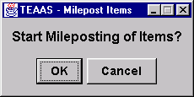
Milepost Items Screen

To begin the Milepost Items process, click the OK button. To cancel the Milepost Items process, click the Cancel button. When the Milepost Items process is initiated, a status window is displayed which tracks the progress. While in progress, Milepost Items cannot be canceled. When completed, a dialog box will inform the User that the process has completed successfully.

MILEPOST Ordinances
The following table directs the reader to appropriate Milepost Ordinances subsections.
MILEPOST ORDINANCES Subsections |  |  | Roles
MILEPOST ORDINANCES Subsections | SA | PDM | SDM | TQU | PQU | PRU | DCU | FDEU | OU | DEOU | DOU | ROU | TEOU | SSU | OA | OER | FU | SDEOU
Milepost Ordinances Screen Overview | X

Milepost Ordinances Screen Overview
The Milepost Ordinances screen is used to initiate mileposting of the entire set of ordinances contained within the TEAAS database.
To access the Milepost Ordinances screen, select Ordinances button on the Application Browser, select Milepost Ordinances from the list box, and click the Open button.
Function Button | Function Name | Sub-Function
 | Ordinances | Milepost Ordinances

The screen that follows is displayed.
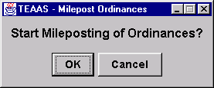
Milepost Ordinances Screen

To begin the Milepost Ordinances process, click the OK button. To cancel the Milepost Ordinances process, click the Cancel button. When the Milepost Ordinances process is initiated, a status window is displayed to track the progress. While in progress, Milepost Ordinances cannot be canceled. When completed, a dialog box will inform the User that the process has completed successfully.

GIS Data File Creation/Export
Users can use this feature by clicking on a new button called “Special Export…” next to the button “Export To Excel”.

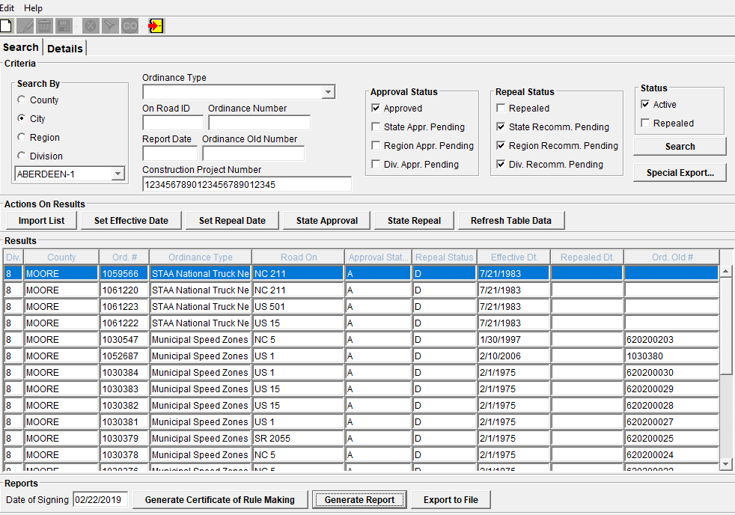 A new screen will pop up to allow users to search by ordinances by the same criteria as in the Ordinance Search screen except for ordinance types. A shortcut will be provided to allow users to choose a group of ordinance types by group name from a dropdown. Ordinance types belonging to the selected group will be automatically populated in a list box called Selected Ordinance Types. There will be a second list box called Available Ordinance Types in the same row as the first and between them are three buttons to allow users to move the ordinance types between the list boxes. The last criterion consists of status checkboxes Active and Repealed (similar to one on the Ordinance Search screen).
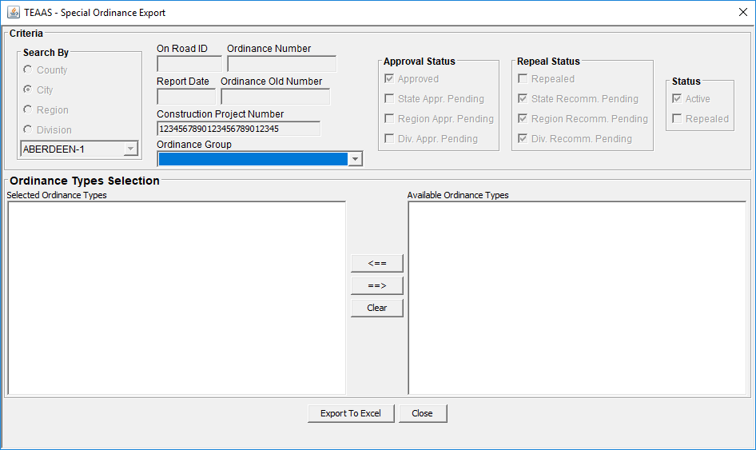
Users can type a new group name in the text field or use one of the buttons to import existing group names from database and into the list box. From the list box, they can remove unwanted group names. An ordinance type needs not be a part of a group name. However, whatever names remaining in the list box will be associated with the ordinance type.
The search results will not be displayed in the UI, but a popup dialog will be created to display the number of ordinances available for export. The dialog will also have an OK button and a Cancel button. Users can proceed to export by clicking the OK button. Apache POI software will be used to generate the Excel file.
The search results will not be restricted to 2000 records. The On Road fields will contain HO route segment information and that means there might be multiple HO segments per ordinance. The number of field exported will be fixed:
- County
- County Number
- Road On
- Road On Code
- Begin Milepost
- End Milepost
- HO Segment Begin Milepost
- HO Segment End Milepost
- Ordinance Number
- Ordinance Type
- City
- Effective Date
- Ordinance Description
- Ordinance Detailed Description
- Car Speed Limit
- Truck Speed Limit

- System Contact Information
The following table lists the appropriate contacts for requests and issues relating to TEAAS.
To | Primary Contact | Secondary Contact
Establish New Users | TEAAS Support  Raleigh  TEAAS_Support@ncdot.gov  919-814-4962 | DOT Help Desk  Raleigh  DOTHelp@ncdot.gov  919-707-7000
Maintain User Passwords | TEAAS Support  Raleigh  TEAAS_Support@ncdot.gov  919-814-4962 | DOT Help Desk  Raleigh  DOTHelp@ncdot.gov  919-707-7000
Maintain User Roles | TEAAS Support  Raleigh  TEAAS_Support@ncdot.gov  919-814-4962 | DOT Help Desk  Raleigh  DOTHelp@ncdot.gov  919-707-7000
Report hardware problems | Local LAN Technician | DOT Help Desk  Raleigh  DOTHelp@ncdot.gov  919-707-7000
Report software problems | DOT Help Desk  Raleigh  DOTHelp@ncdot.gov  919-707-7000 | Local LAN Technician

- Alternate System Controls
TEAAS has been designed to allow alternate methods of invoking most commands. The following table describes alternate methods for the toolbar icons discussed throughout this document.
Function | Toolbar Icon | Menu Option | Alt Command | Ctrl  Command
Cancel |  | Edit→Cancel | Alt+E+Alt+L | Ctrl+L
Close |  | Edit→Close | Alt+E+C | N/A
Delete |  | Edit→Delete | Alt+E+D | Ctrl+D
Go |  | Edit→Go | Alt+E+G | Ctrl+G
Help About | N/A | Help→About | Alt+H+A | Ctrl+A
Modify |  | Edit→Modify | Alt+E+M | Ctrl+M
New |  | Edit→New | Alt+E+N | Ctrl+N
Save |  | Edit→Save | Alt+E+S | Ctrl+S
Search |  | Edit→Search | Alt+E+R | Ctrl+R

- Wildcard Searching
The following describes the use of the asterisk (*) and question mark (?) wildcard characters available in performing searches within TEAAS.
Wildcard Character | Description | Examples
Wildcard Character | Description | Input | Results
* | The asterisk character is used to represent any character or group of characters. | * | Returns all possible values.
* |  | * Avenue | Returns all Street Names ending with the string ' Avenue'. For example, First Avenue and Carolina Avenue would be returned.
* |  | Main* | Returns all Street Names beginning with the string 'Main'. In this example, Main Street, Maine Street, and Mainsail Point all would be returned.
? | The question mark is used to represent any single character. Unlike the asterisk, when using the question mark, all positions must be present for the search to be performed correctly. | Davi? | Returns all Street Names of five characters in length, beginning with the string 'Davi'. This example would return David, Davie, Davin, and Davis.
? |  | 2?000070 | Returns all variations of eight-digit codes for US 70, excluding couplets. In this example, 20000070, 21000070, 22000070, 27000070, and 29000070 would be returned.
% | The % % allows you to match any string of any length (including zero length). | David% | Returns all Street Names of 5 or more characters beginning with the string ‘David’. This example would return David, David Barker, David Caldwell Dr ...

- Operating Actuate Formula One E.Report Designer
TEAAS Reports are produced and viewed using Actuate Formula One e.Report Designer (e.Report Engine), which may be used to navigate through the report in view mode, print the report, or save the report to a file.
e.Report Engine Toolbar Button | Function
 | Export to a file format. A dialog box is presented to allow the User to choose the export format (PDF, DHTML, HTML, Excel, CSV, XML, and RTF). User is prompted to identify the directory and file name for the export file. The JOI and EMAIL export formats may not work.
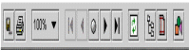 | Print report. Only an entire report may be printed through e.Report Engine. Within the print report screen, depending on the type of printer, the name of the printer, number of copies, paper size, paper source, and print mode may be specified. e.Report Engine also allows you to print specific range of pages.
 | Image resizing. Allows the User to enlarge or reduce the image on the screen.
 | Navigation buttons. The arrow buttons navigate through the pages of the report. The center button permits navigation to a specific page number.
 | Refresh. Only applicable for the Features Report. To utilize, the Features Report button on the Inventoried Routes screen must be clicked first (while the report is still open), then the Refresh button on the e.Report Engine window.
 | Table of contents. Displays a list of the report's sections and permits navigation directly to a specific section.

